**SECTION 17) AWS Serverless Lambda**

<https://www.baeldung.com/java-aws-lambda>

<https://docs.aws.amazon.com/lambda/latest/dg/welcome.html>

**Serverless : server is there but we don’t we cant see them**

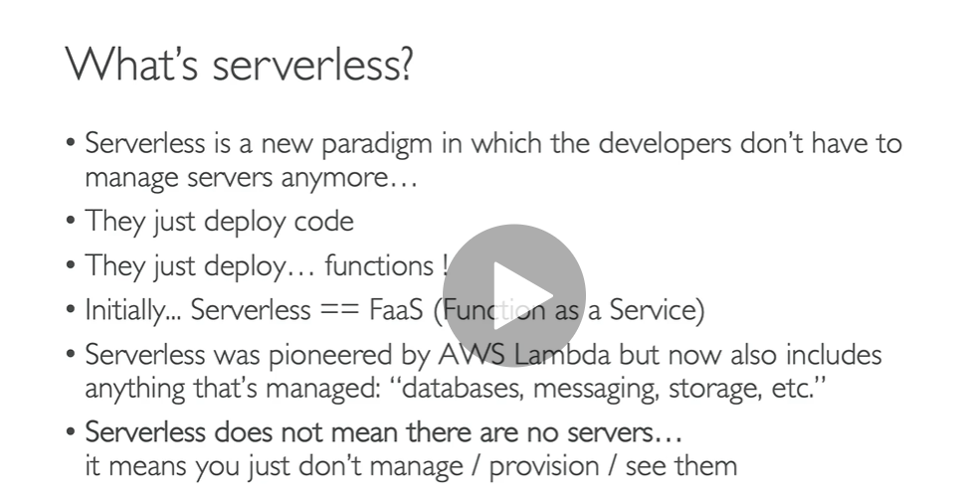

**Cognito : where user identity is stored**

**User will get static content from s3 and from cognito identity will match then it invoked api gateway and from there lambda function and it will invoke dynamo db**

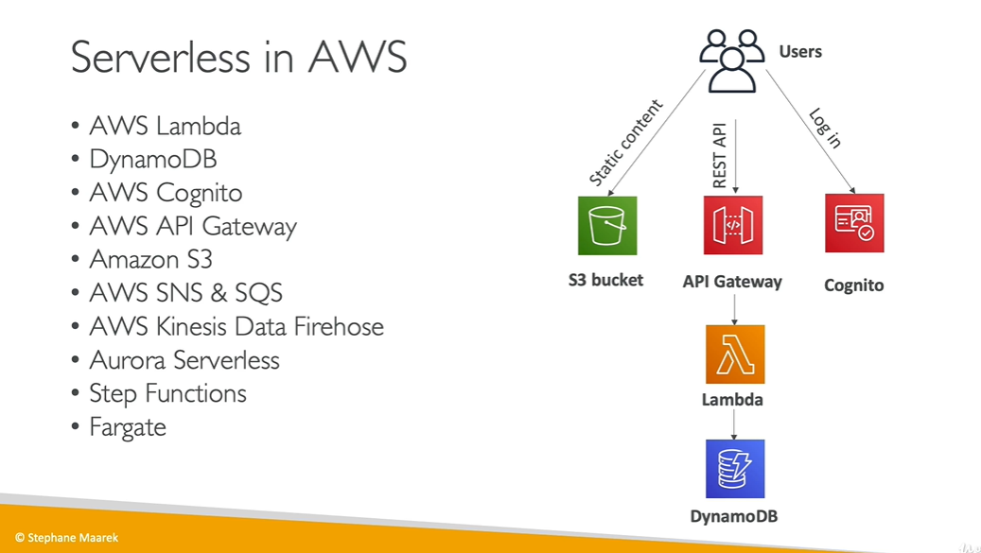

**AWS Lambda Overview**

**Lambda function cab be integrate with many service**

**Run on demand :**

**We don’t need to manage server**

**Important:-**

**AWS Lambda** is a serverless compute service that runs your code in response to events and automatically manages the underlying compute resources for you. You can use **AWS Lambda** to extend other **AWS** services with custom logic, or create your own back-end services that operate at **AWS** scale, performance, and security

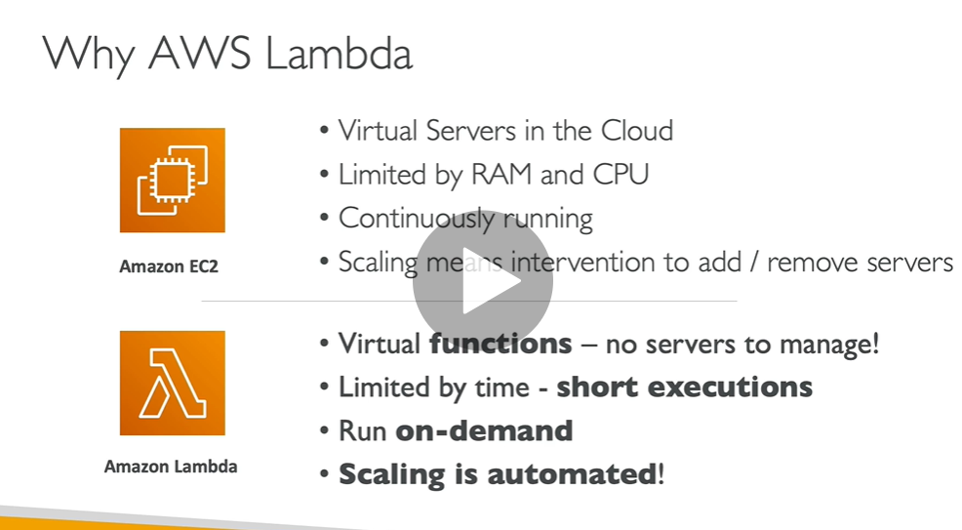

**Note :**

**How much time lambda is running we need to pay for that time only**

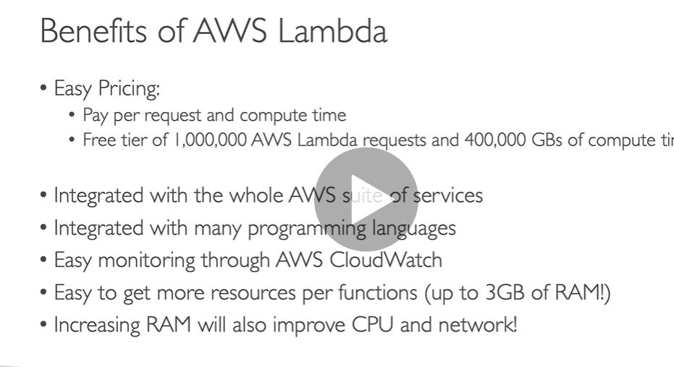

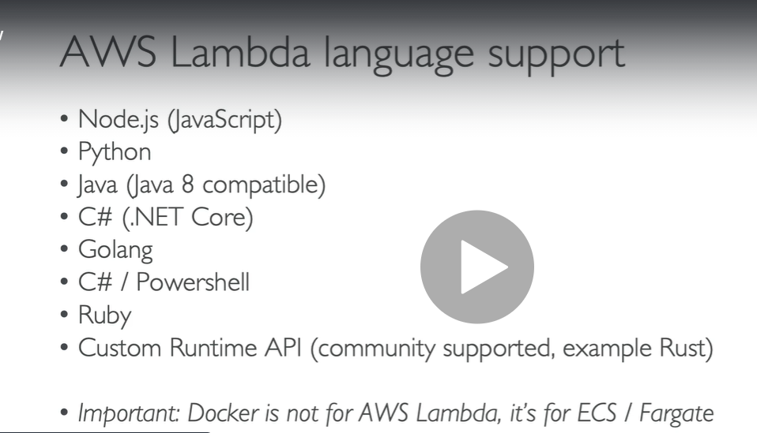

Api gateway : to create rest api and they will invoke our lambda function

Dynamo db : lambda function will trigger when something happened to database

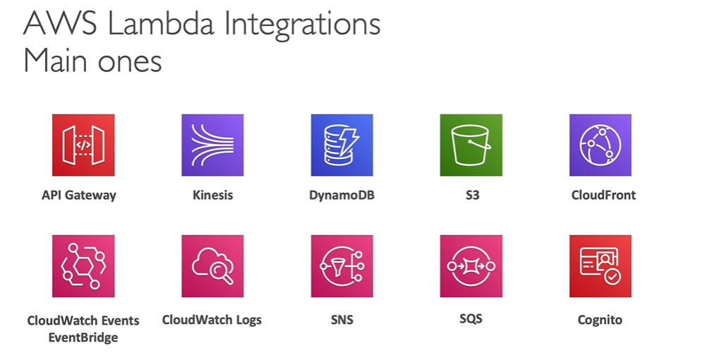

Due to lambda want to upload image in another s3 bucket or dynamo db

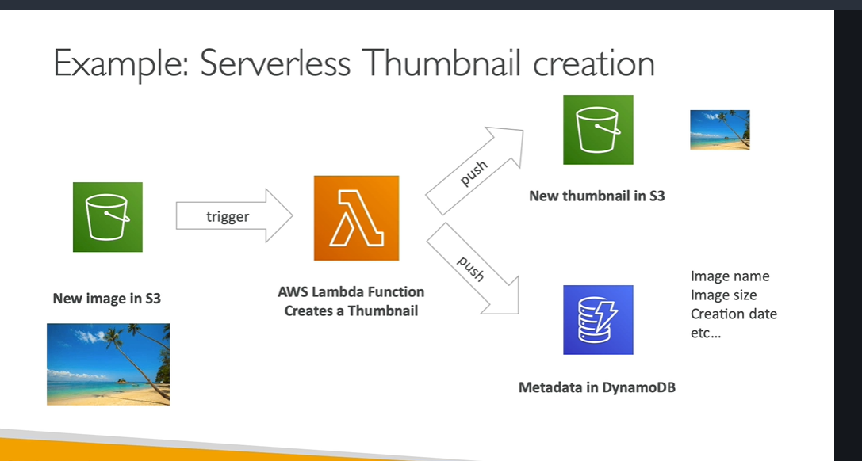

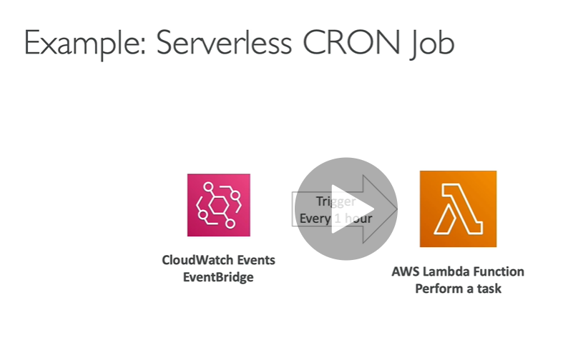

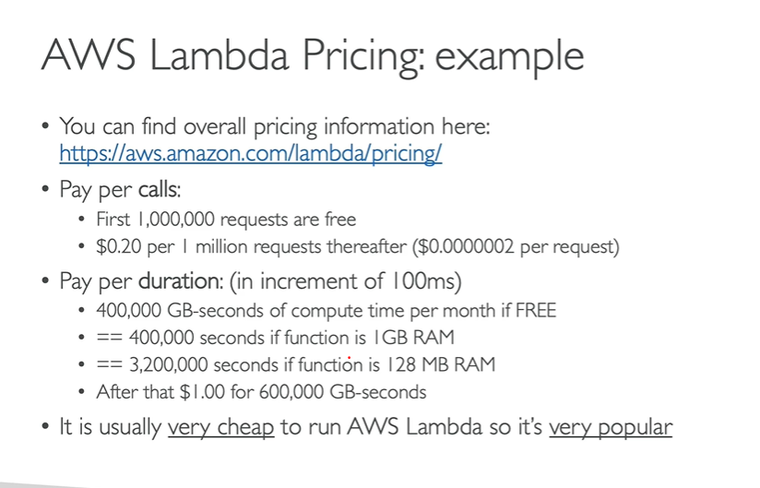

AWS Lambda hands on

[AWS Lambda](https://docs.aws.amazon.com/lambda/latest/dg/welcome.html) is a serverless computing service provided by Amazon to reduce the configuration of servers, OS, Scalability, etc. **AWS Lambda is capable of executing code on AWS Cloud.**

In AWS Lambda the code is executed based on the response of events in AWS services such as add/delete files in S3 bucket, HTTP request from Amazon API gateway, etc. However, a Lambda can only be used to execute background tasks.

AWS Lambda is a compute service that lets you run code without provisioning or managing servers. AWS Lambda runs your code only when needed and scales automatically, from a few requests per day to thousands per second. You pay only for the compute time you consume - there is no charge when your code is not running. With AWS Lambda, you can run code for virtually any type of application or backend service - all with zero administration. AWS Lambda runs your code on a high-availability compute infrastructure and performs all of the administration of the compute resources, including server and operating system maintenance, capacity provisioning and automatic scaling, code monitoring and logging. All you need to do is supply your code in one of the [languages that AWS Lambda supports](https://docs.aws.amazon.com/lambda/latest/dg/lambda-runtimes.html).

You can use AWS Lambda to run your code in response to events, such as changes to data in an Amazon S3 bucket or an Amazon DynamoDB table; to run your code in response to HTTP requests using Amazon API Gateway; or invoke your code using API calls made using AWS SDKs. With these capabilities, you can use Lambda to easily build data processing triggers for AWS services like Amazon S3 and Amazon DynamoDB, process streaming data stored in Kinesis, or create your own back end that operates at AWS scale, performance, and security.

You can also build serverless applications composed of functions that are triggered by events and automatically deploy them using CodePipeline and CodeBuild. For more information, see [AWS Lambda applications](https://docs.aws.amazon.com/lambda/latest/dg/deploying-lambda-apps.html).

**Lambda function we can execute with trigger**

Lambda response to events.

It scale up or down automatically as traffic increase or decrease

Lambda :) Run code without thinking our server

**Step**:-

Search lambda

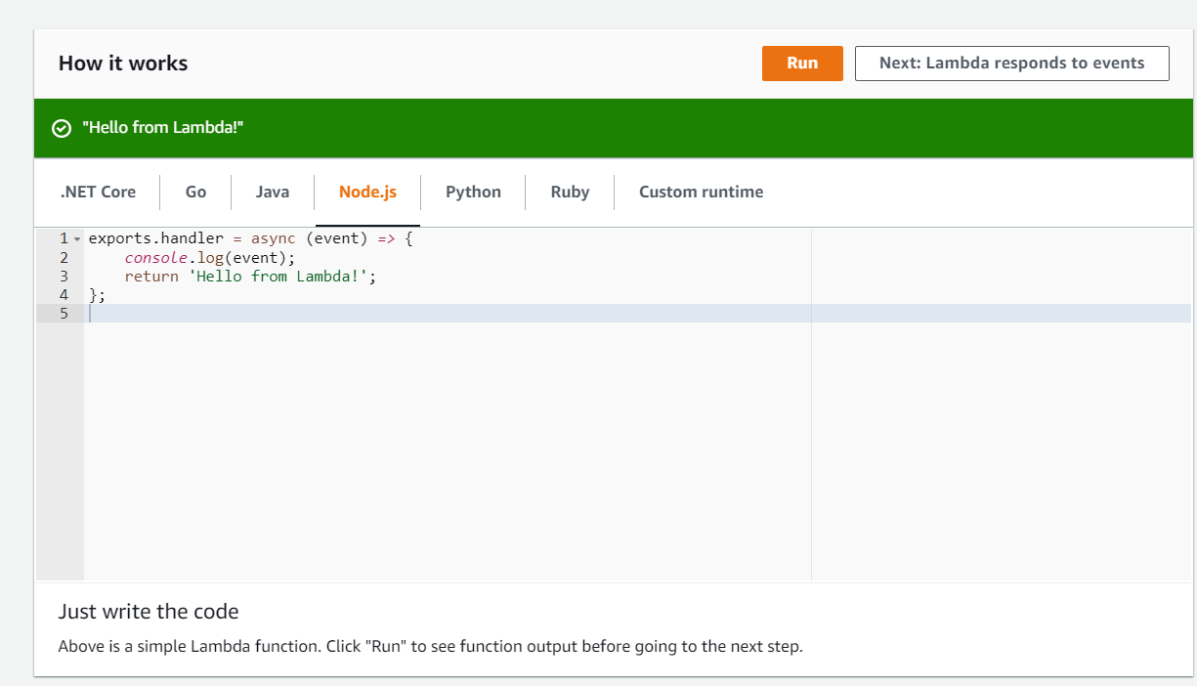

**Click lambda responds to events**

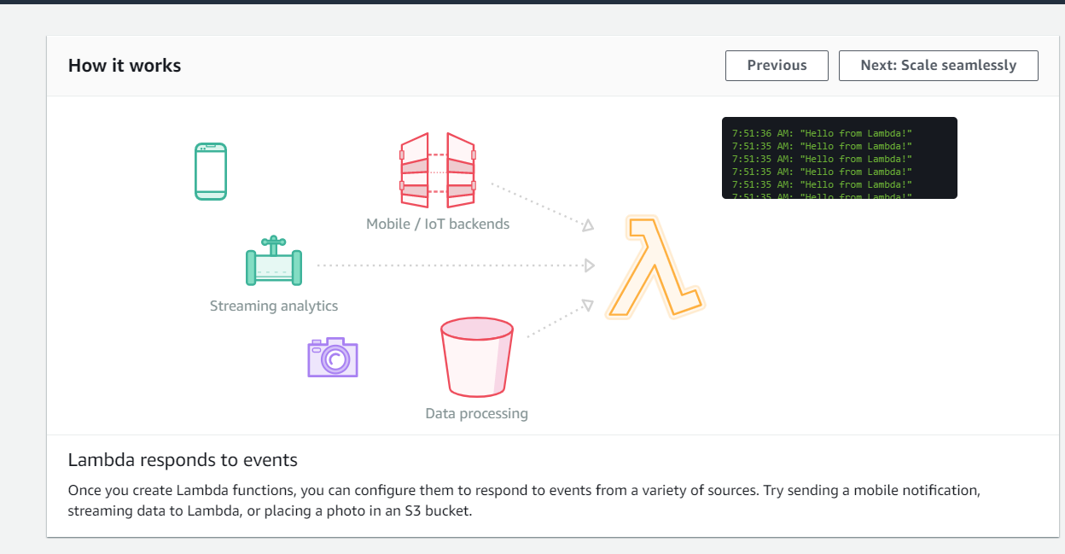

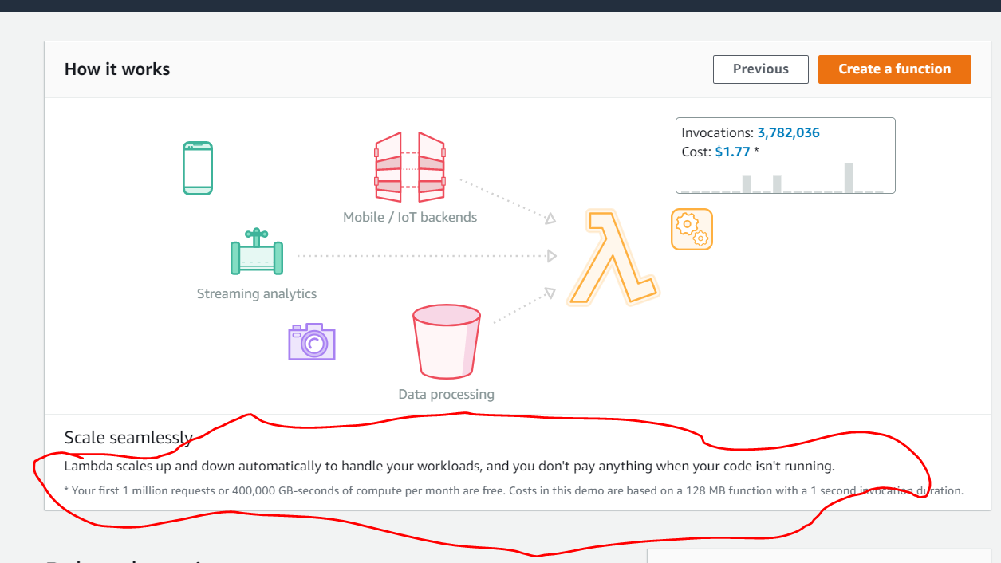

**Click to create a function**

**Three ways to create a lambda function**

**It will use given below blueprint**

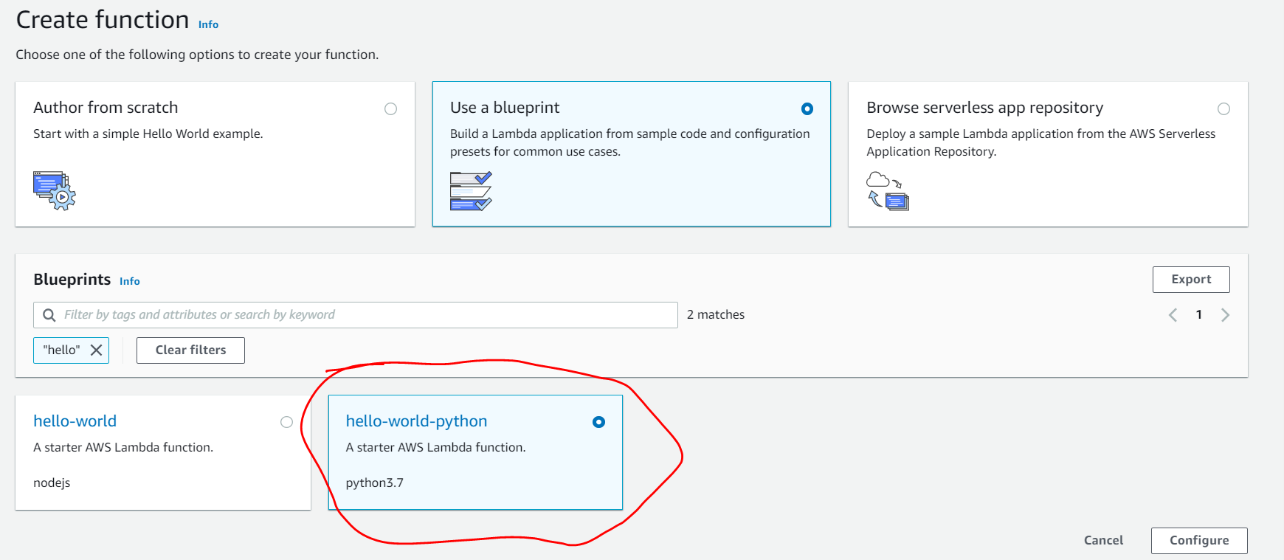

**Note : we must use iam role to lambda function which lambda function will use to**

**Integration with other service**

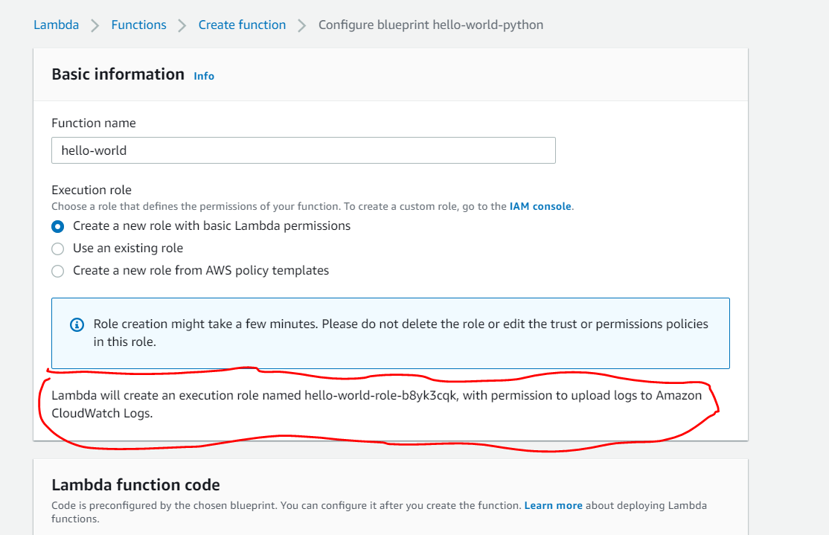

**We are going to play with and run this function**

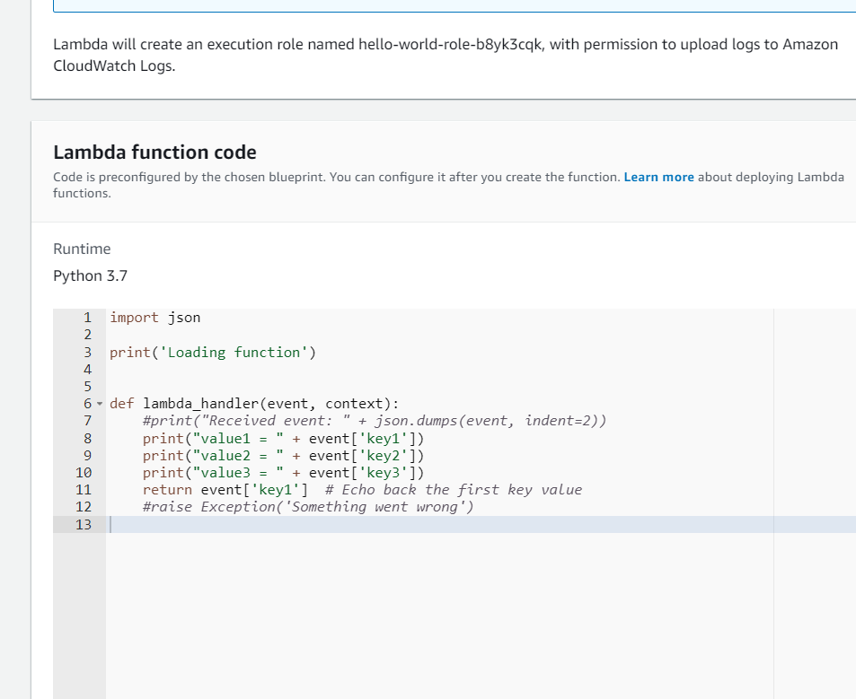

**Click create function**

**Function is created now . We can invoke this function and test it .**

**Click on test**

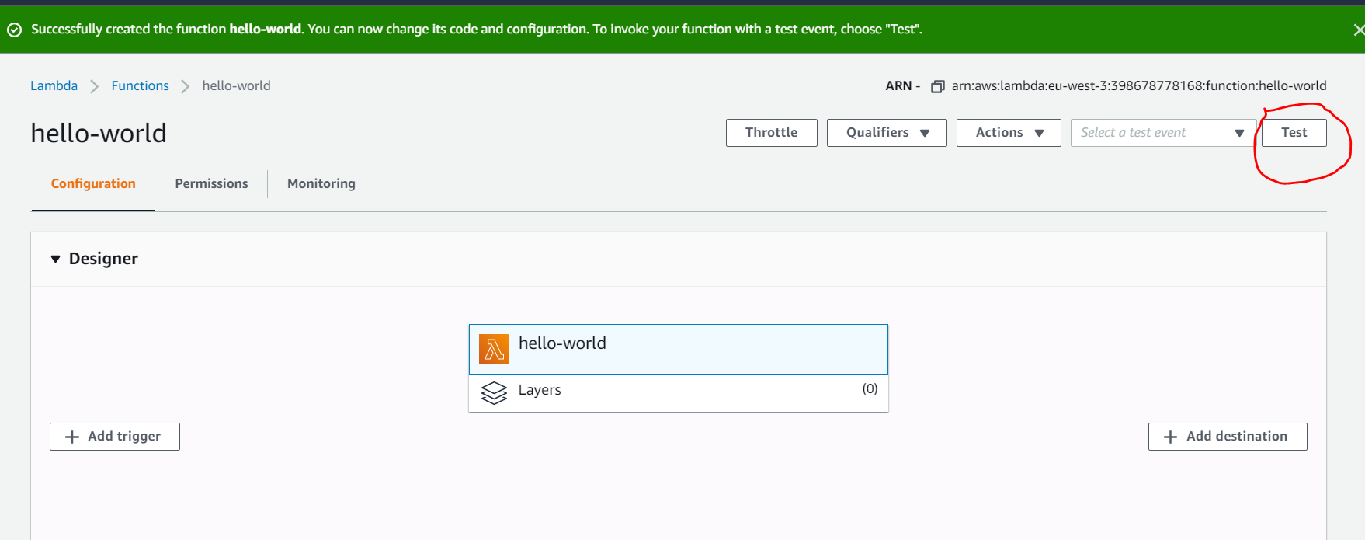

**Create test event**

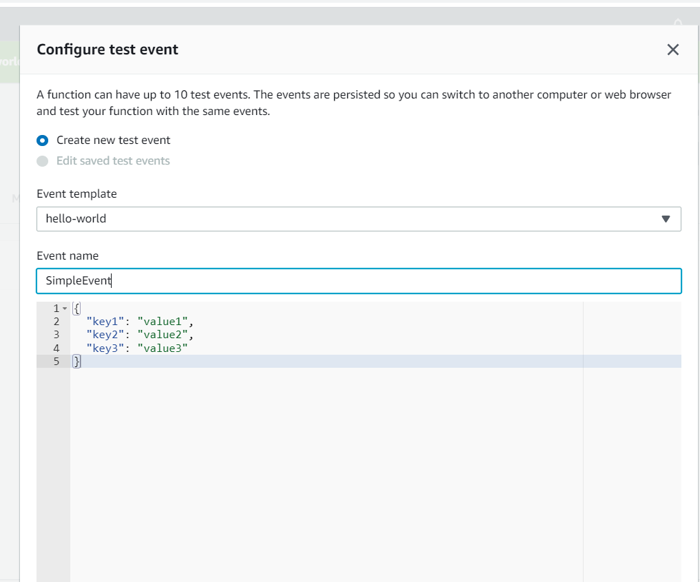

**Again click on test**

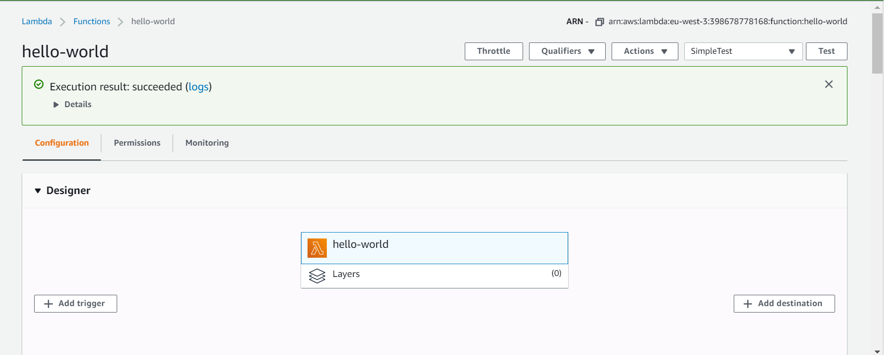

**Click on details:**

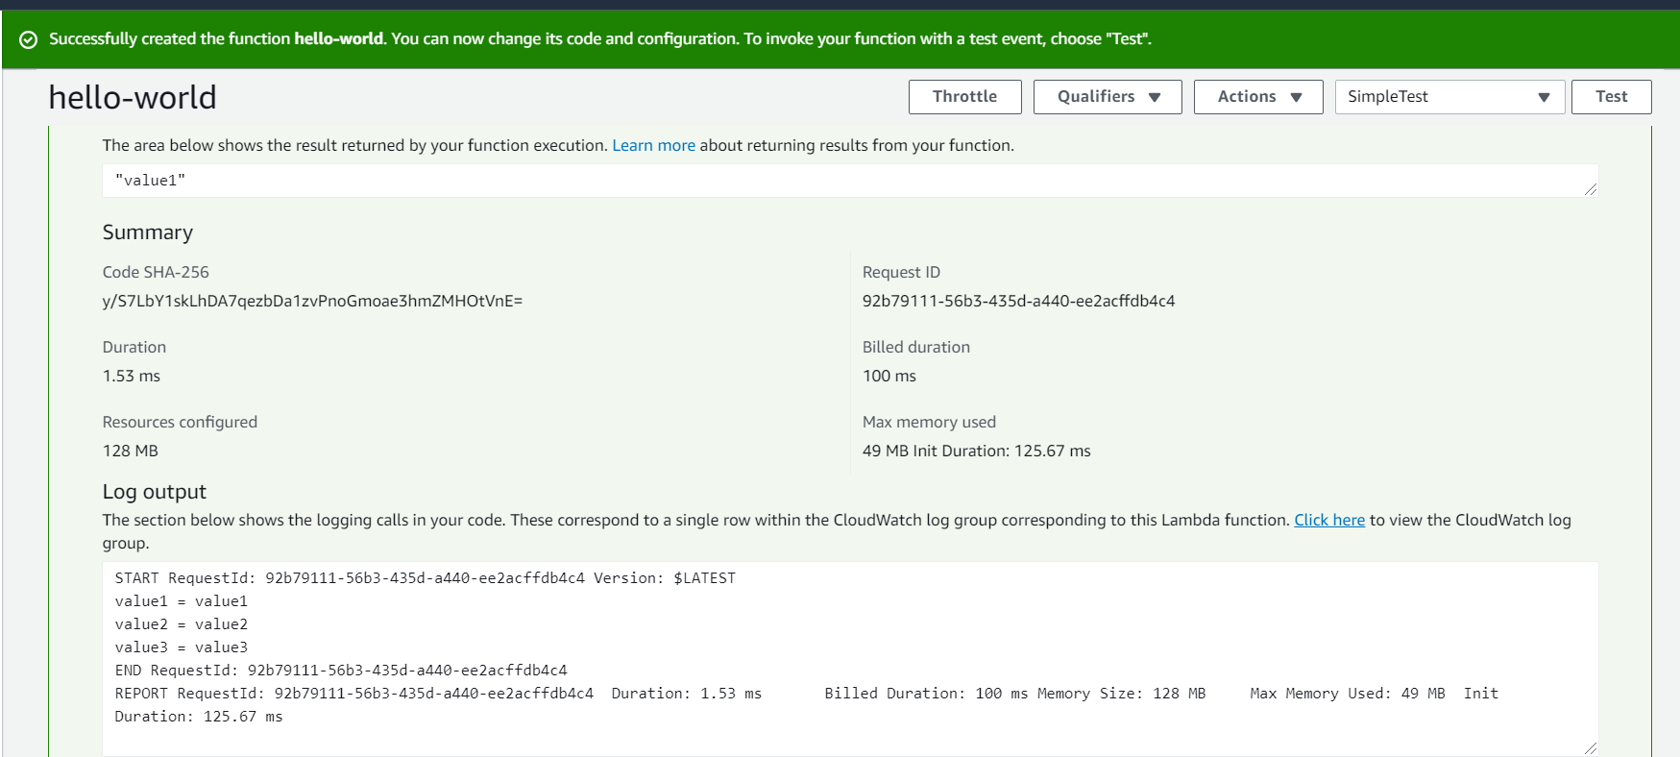

**And above log is coming from cloudwatch**

**Click on click here**

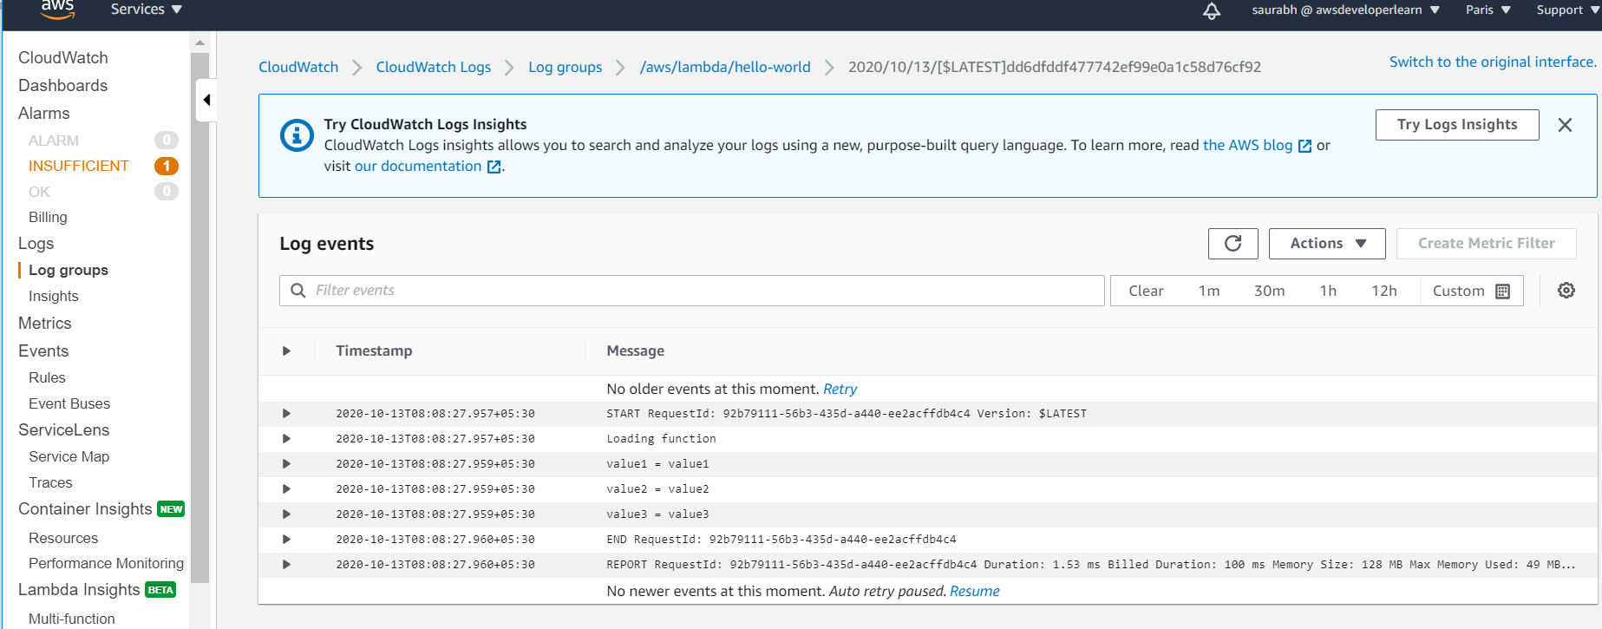

**Note :-**

**We can use use cloudwatch logs to debug our lambda function**

**How lambda interact with cloudwatch**

**Click on permission and check it**

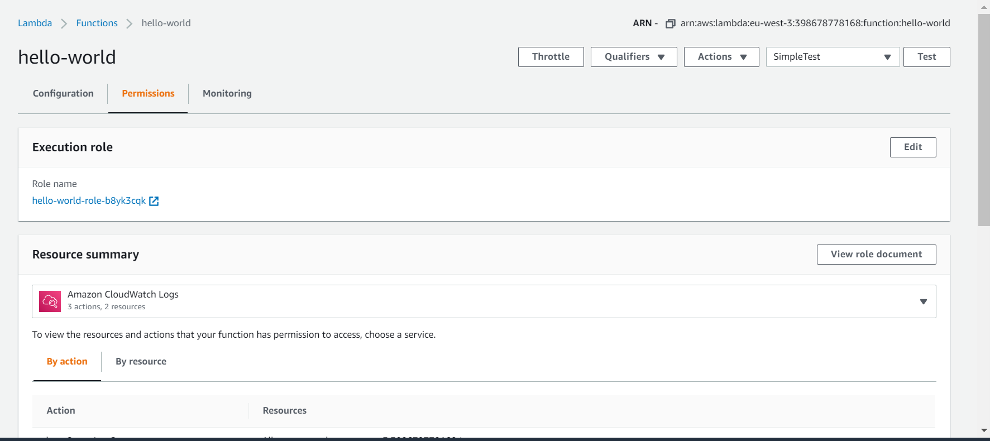

**Iam role attached click on it we will get**

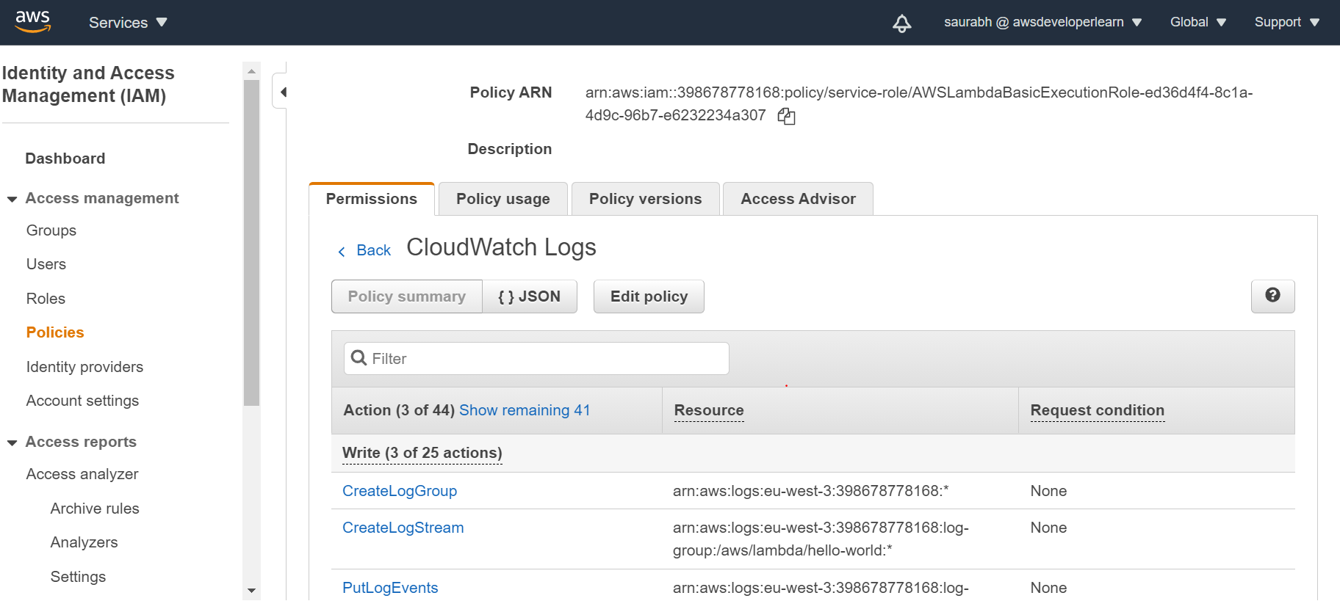

**Lambda synchronous invocation**

**Note :**

**We can call lambda function when we uploadling file in s3 bucket**

**Any time error will come client has figure it out what to do**

**Synchronous: means direct invocation you wait for result**

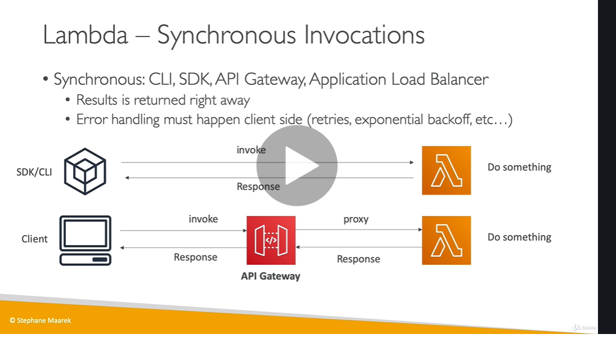

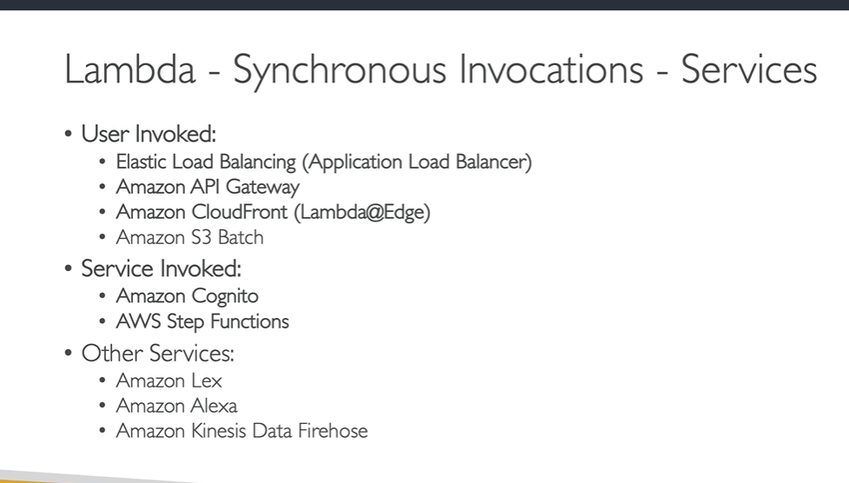

When you invoke a function synchronously, Lambda runs the function and waits for a response. When the function execution ends, Lambda returns the response from the function's code with additional data, such as the version of the function that was executed.

You can invoke Lambda functions directly [with the Lambda console](https://docs.aws.amazon.com/lambda/latest/dg/getting-started-create-function.html#get-started-invoke-manually), the Lambda API, the AWS SDK, the AWS CLI, and AWS toolkits. You can also configure other AWS services to invoke your function, or you can configure Lambda to read from a stream or queue and invoke your function.

When you invoke a function, you can choose to invoke it synchronously or asynchronously. With [synchronous invocation](https://docs.aws.amazon.com/lambda/latest/dg/invocation-sync.html), you wait for the function to process the event and return a response. With [asynchronous](https://docs.aws.amazon.com/lambda/latest/dg/invocation-async.html) invocation, Lambda queues the event for processing and returns a response immediately. For asynchronous invocation, Lambda handles retries and can send invocation records to a [destination](https://docs.aws.amazon.com/lambda/latest/dg/invocation-async.html#invocation-async-destinations).

To use your function to process data automatically, add one or more triggers. A trigger is a Lambda resource or a resource in another service that you configure to invoke your function in response to lifecycle events, external requests, or on a schedule. Your function can have multiple triggers. Each trigger acts as an client invoking your function independently. Each event that Lambda passes to your function only has data from one

Lambda synchronous events hands on

To invoke lambda function using cli

aws lambda list-functions --region eu-west-3

**# WINDOWS POWERSHELL ( run as administrator)**

aws lambda invoke --function-name hello-world --cli-binary-format raw-in-base64-out --payload '{\"key1\": \"value1\", \"key2\": \"value2\", \"key3\": \"value3\" }' --region eu-west-2 response.json

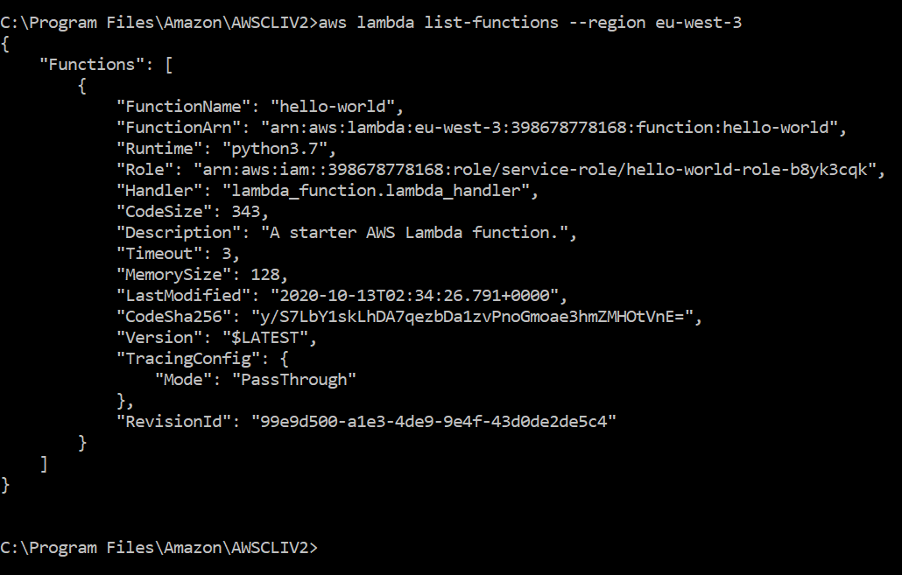

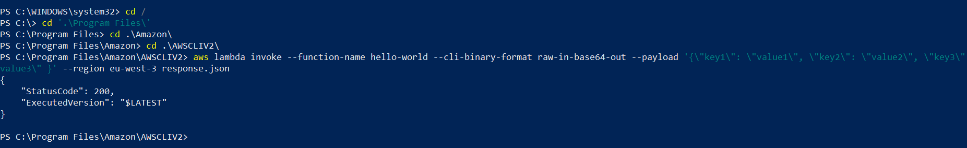

Lambda and application load balancer

Requirement : to invoke lambda function from ALB

People want to use lambda function through internet then we need to allow through http or https

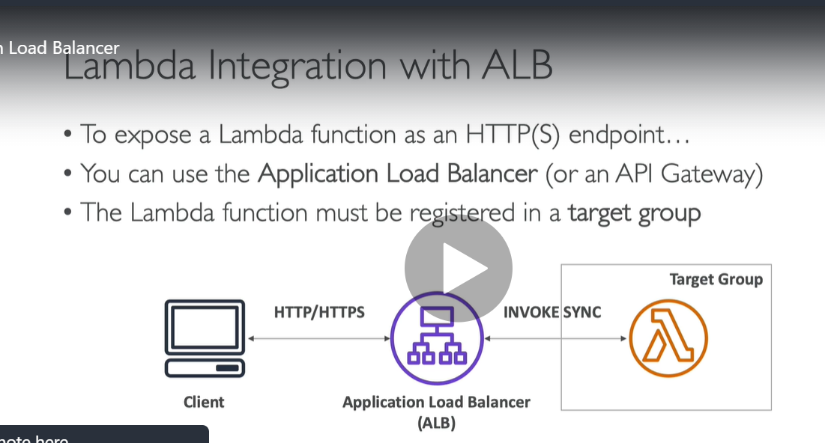

Question :

**How does ALB convert http to lambda function**

**Http will convert to json**

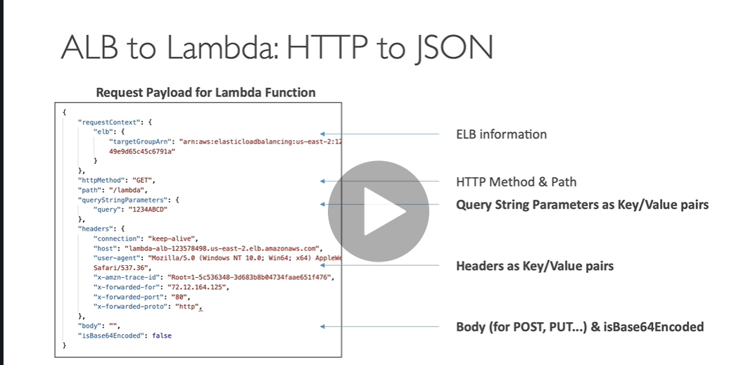

**Similarly lambda function will return something(json document) and ALB will back convert json document to http**

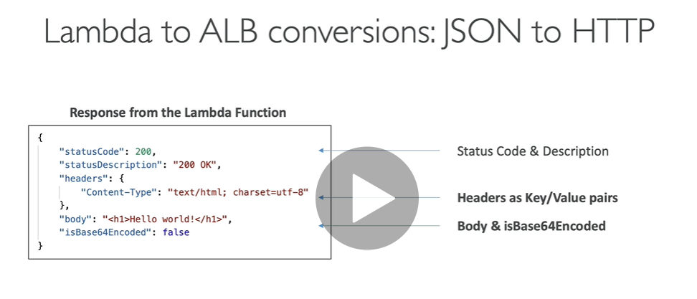

Imp)

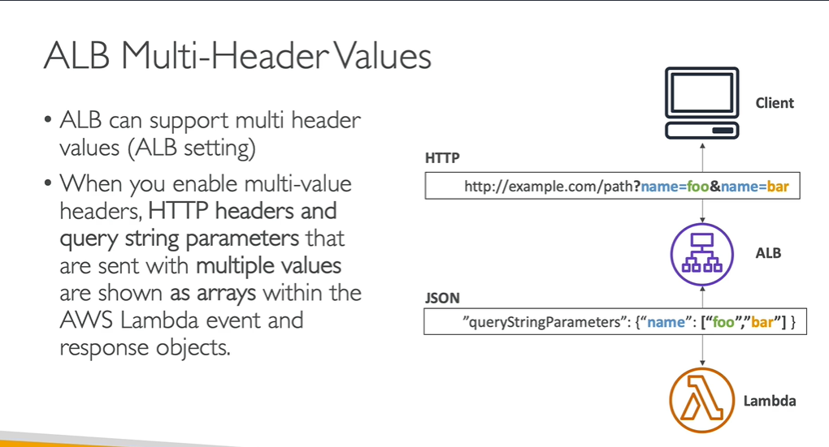

**Lambda and application load balancer hands on**

**First create lambda then ALB and linked lambda to ALB in target group**

**Step 1)**

**Click function and create it**

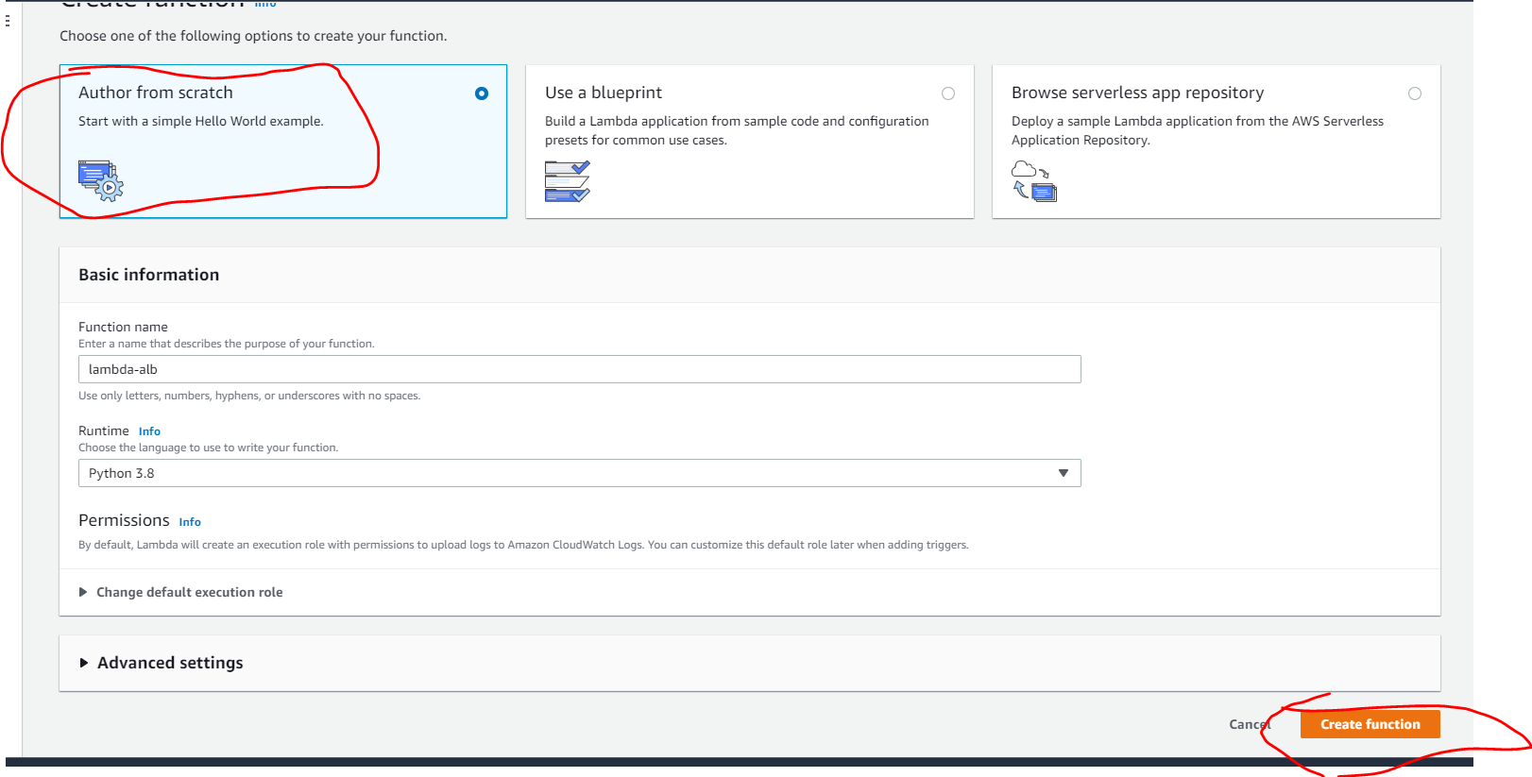

**Step 2) create ALB go to ec2**

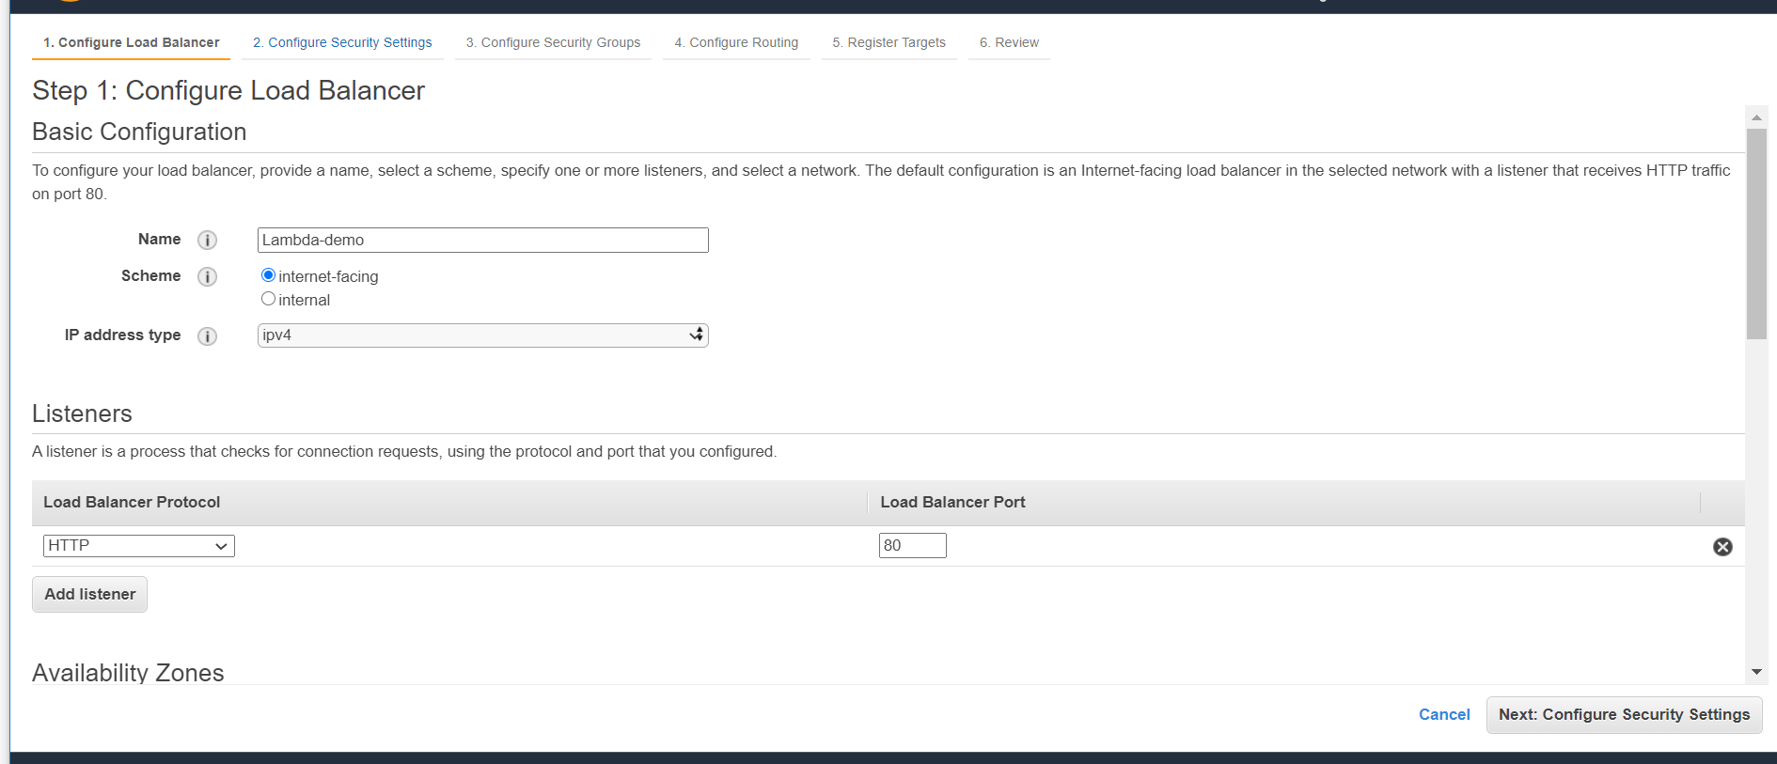

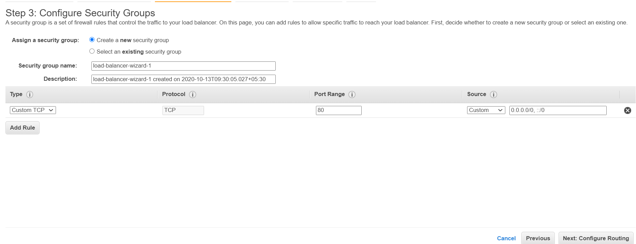

**Health check to invoke a lambda function whether it is working**

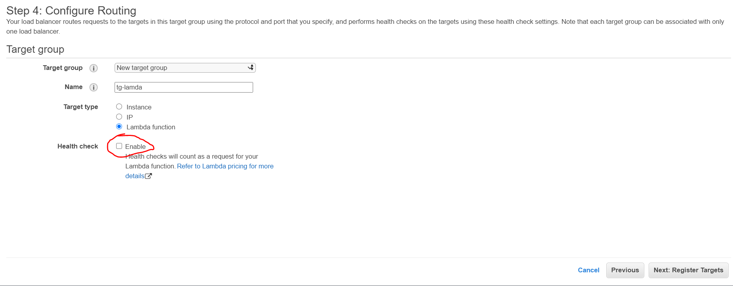

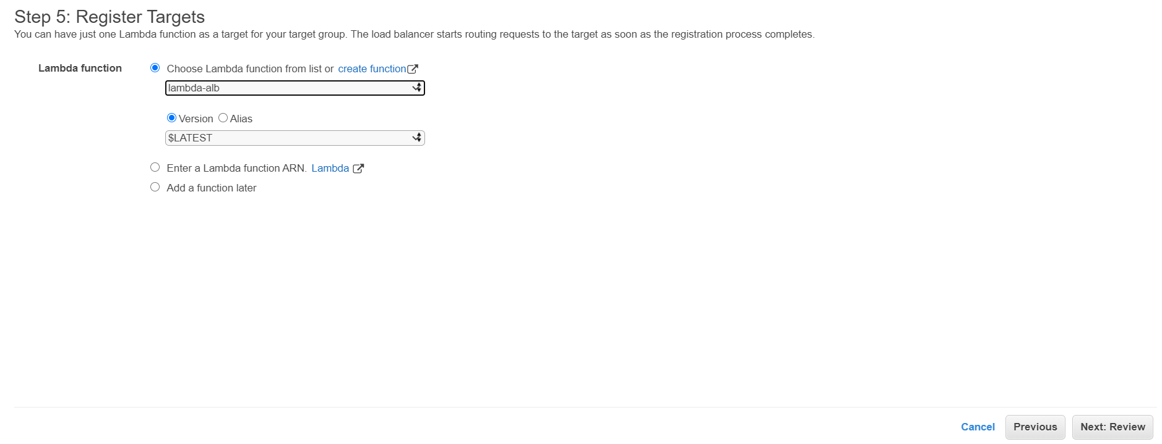

**This will create a load balancer and target group**

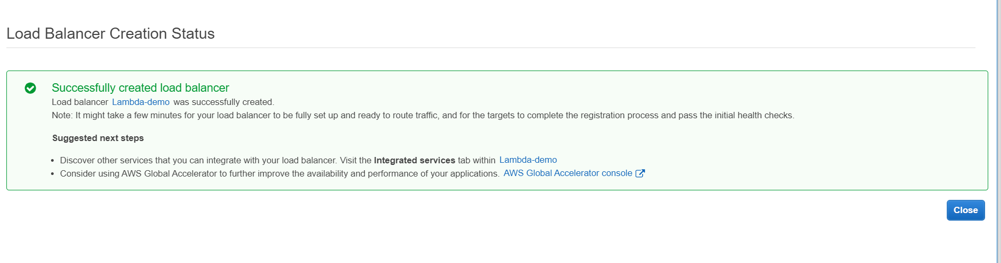

**Test it**

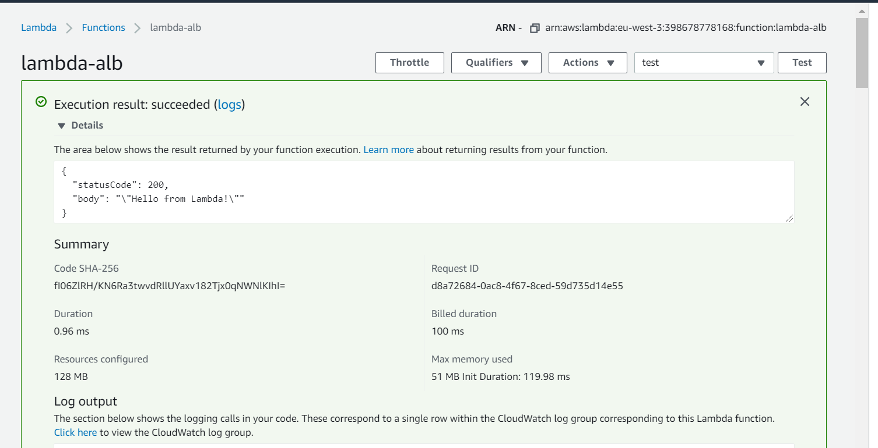

**Enter alb url**

<http://lambda-demo-1140326890.eu-west-3.elb.amazonaws.com/>

Response will get downloaded

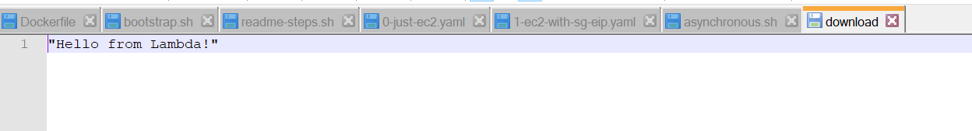

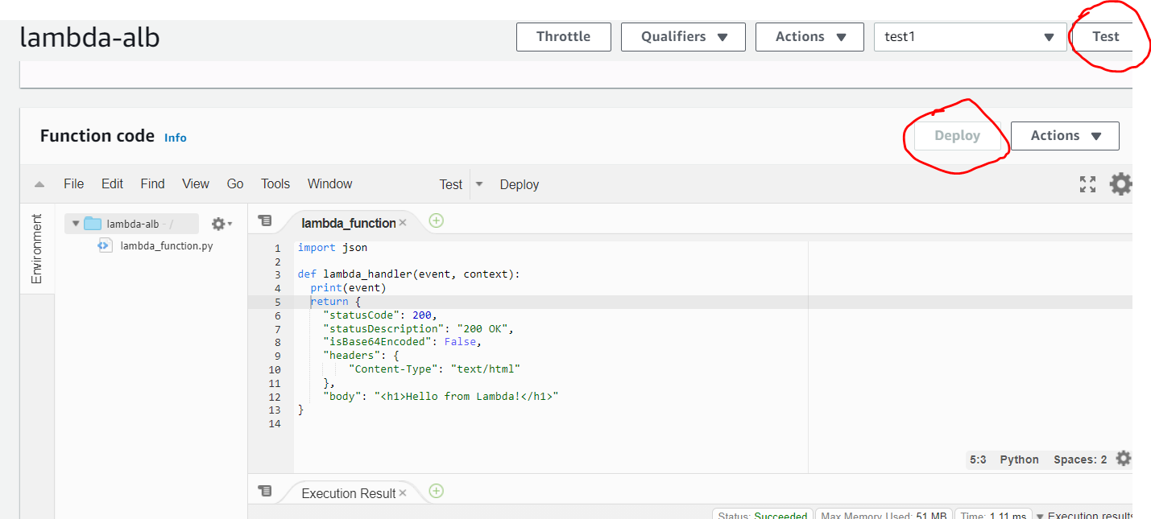

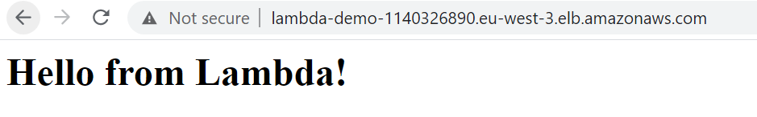

Note : by writing event in code we are getting info in cloudwatch about request from ALB

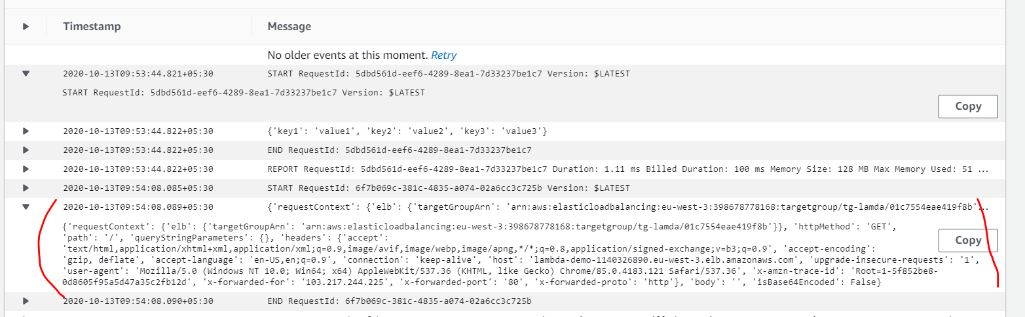

Multi header support

Go in target group of load balancer and click edit attributes to enable multi header support

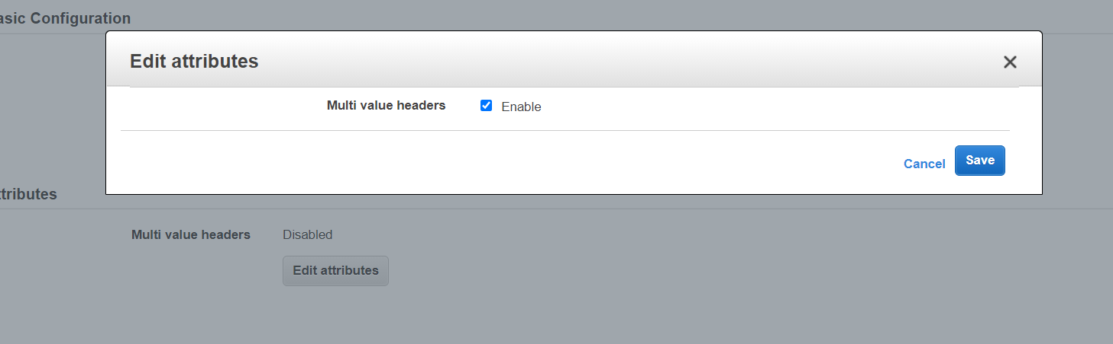

<http://lambda-demo-1140326890.eu-west-3.elb.amazonaws.com/?name=foo&name=bar>

![Machine generated alternative text:
CloudWatch 
Dashboards 
Alarms 
ALARM 
INSUFFICIENT 
OK 
Billing 
Logs 
I Log groups 
Insights 
Metrics 
Events 
Rules 
Event Buses 
ServiceLens 
Service Map 
Traces 
Container Insights 
Resources 
Performance Monitoring 
Lambda Insights 
Multi-function 
23.348+as : 
2828-1e-13T1a: 18 : e7.714+85 : 
2828-1e-13T1a: 18 : e7.718+85 : 
2828-1e-13T1a: 18 : e7.719+85 : 
2828-1e-13T1a: 18 : e7.719+85 : 
2828-1e-13T1a: 11 : 14.549+as : 
2828-1e-13T1a: 11 : 14. ss3+as : 
2828-1e-13T1a: 11 : 14. ss4+as : 
2828-1e-13T1a: 11 : 14. ss4+as : 
2828-1e-13T1a: 11 : ss. : 
2828-1e-13T1a: 11 : ss. 396+as : 
2828-1e-13T1a: 11 : ss. 396+as : 
2828-1e-13T1a: 11 : ss. 396+as : 
2828-1e-13T1a: 12 : 22.462+as : 
2828-1e-13T1a: 12 : 22.465+as : 
REPORT Requestld: 
START Requestld: 
requestContext ' 
f28b2476-d7SS-4e83-923d-6e8c6ca28S6e Duration: e. 97 ms Billed Duration: lee ms Memory Size: 128 MB Max Memory Used: 
fSbf7B66-2d84-48c2-ba3S-e3cfa77edS64 version: SLATEST 
('elb'• 
'targetGroupArn ' . 
' arn : aws : elasticloadbalancing : eu-west-3 : 398678778168 : targetgroup/tg- lamda/a1c7SS4eae41gf8b ... 
END Requestld: fSbf7B66-2d84-48c2-ba3S-e3cfa77edS64 
REPORT Requestld: fSbf7866-2d84-48c2-ba3S-e3cfa77edS64 Duration: e.gs ms Billed Duration: lee ms Memory Size: 128 MB Max Memory Used: 
START Requestld: 8e7c01c-4e32-487e-gd54-b4e8724casgs version: SLATEST 
requestContext ' 
('elb'• 
'targetGroupArn ' . 
' arn : aws : elasticloadbalancing : eu-west-3 : 398678778168 : targetgroup/tg- lamda/a1c7SS4eae41gf8b ... 
END Requestld: 8e7c01c-4e32-487e-gd54-b4e8724casgs 
REPORT Requestld: 8e7c01c-4e32-487e-gd54-b4B8724cesgs Duration: 1.11 ms Billed Duration: lee ms Memory Size: 128 MB Max Memory used: 
START Requestld: dfce8ef2-eeee-4ecs-8981-74912da89344 version: SLATEST 
keyl ' • 
'valuel', 
'key2' • 
value2 
, 'key3' 
'value3 
END Requestld: dfce8ef2-eaee-4ecs-8981-74912da89344 
REPORT Requestld: dfce8ef2-eeee-4ecS-8g81-74912da89344 Duration: I.e4 ms Billed Duration: lee ms Memory Size: 128 MB Max Memory Used: 
START Requestld: 83229cag-b81s-43cb-b7e3-e86943dabf43 version: SLATEST 
52 . 
52 . 
requestContext ' 
('elb'• 
'targetGroupArn ' . 
' arn : aws : elasticloadbalancing : eu-west-3 : 398678778168 : targetgroup/tg- lamda/a1c7SS4eae41gf8b ... 
'targetGroupArn ' 
arn:aws : elasticloadbal cing:eu-west-3 : 398678778168 : targetgroup/tg-1amdaÆ1c7SS4eae41gf8b ' n, 
' httpMethod ' 
'GET', 
Copy 
requestContext ' 
('elb'• 
path' 
' multi ValueQuerySt ringParameters ' 
o. 
multi ValueHeaders 
' accept 
text/html, application/xhtml+xml , application/xml;q 
. g, image/ avif,ima 
/webp, image/ apng, '/' ; q:a. 8, application/ signed -exchange; v—b3 ;q-e. g ' ) , 
accept-encoding 
C'gzip, deflate'), 
accept-language 
cache-contro 
'max-age-e'), 
connection ' 
C' keep-alive'), 
host ' 
lambda-demo-114e3268ge. eu -west- 
3.elb.amazonaws.com'), 
upgrade-insecure-requests 
' user-agent ' 
'Mozilla/s.e (Windows NT le.e; Win64; x64) ApplewebKit/S37.36 (KHTML, like Gecko) Chrome/gs.a.4183.121 
safari/S37.36'), 
x-amzn-trace-id ' 
' Root-I-sasye2e-21ee96dc3a2ecea81bd8fggf ' ) 
, x-forwarded-for' . 
C' 10.217.244.225'), 
x-forwarded- port 
' x-forwarded-proto ' 
C 'http• 
128 MB Max Memory Used: 
52 . 
' body' : 
' is8ase64Encoded ' : 
False) 
1.11 ms Billed Duration: 
lee ms Memory Size: 
2828-1e-13T1a: 12 : 22.465+as : 
2828-1e-13T1a: 12 : 22.465+as : 
END Requestld: 83229ceg-b81s-43cb-b7e3-e86943dabf43 
REPORT Requestld: 83229cag-b81s-43cb-b7e3-e86943dabf43 Duration: 
No newer events at this moment. Auto retry paused. Resume ](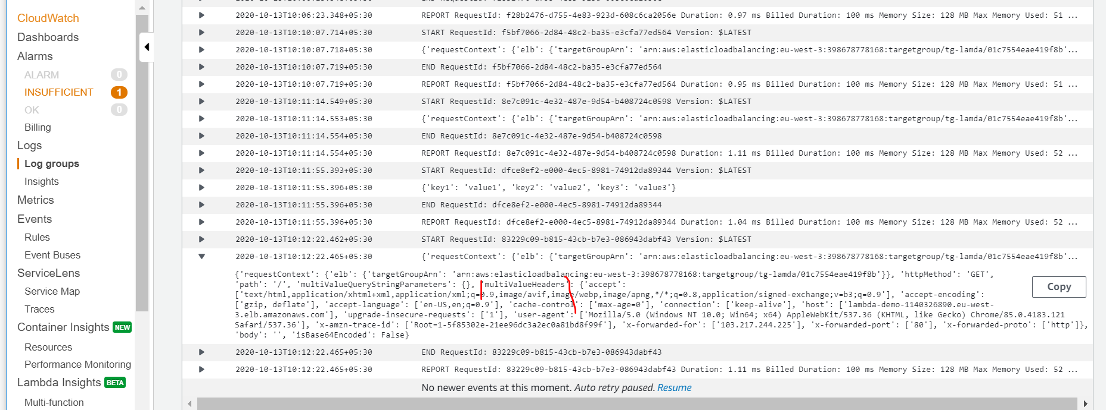)

**How ALB invoke lambda function**

**Note : in target group of ALB add lambda function**

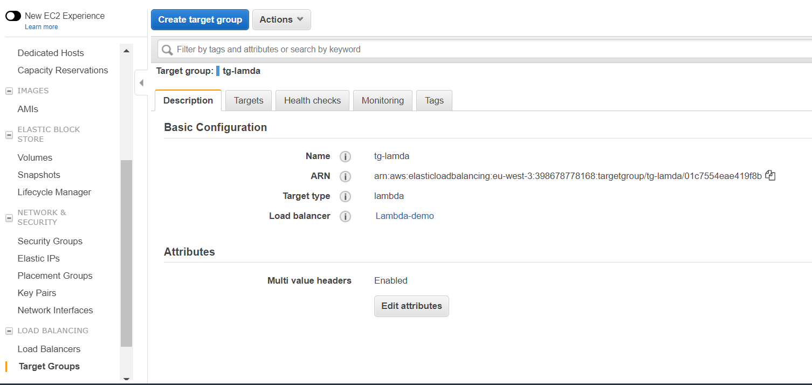

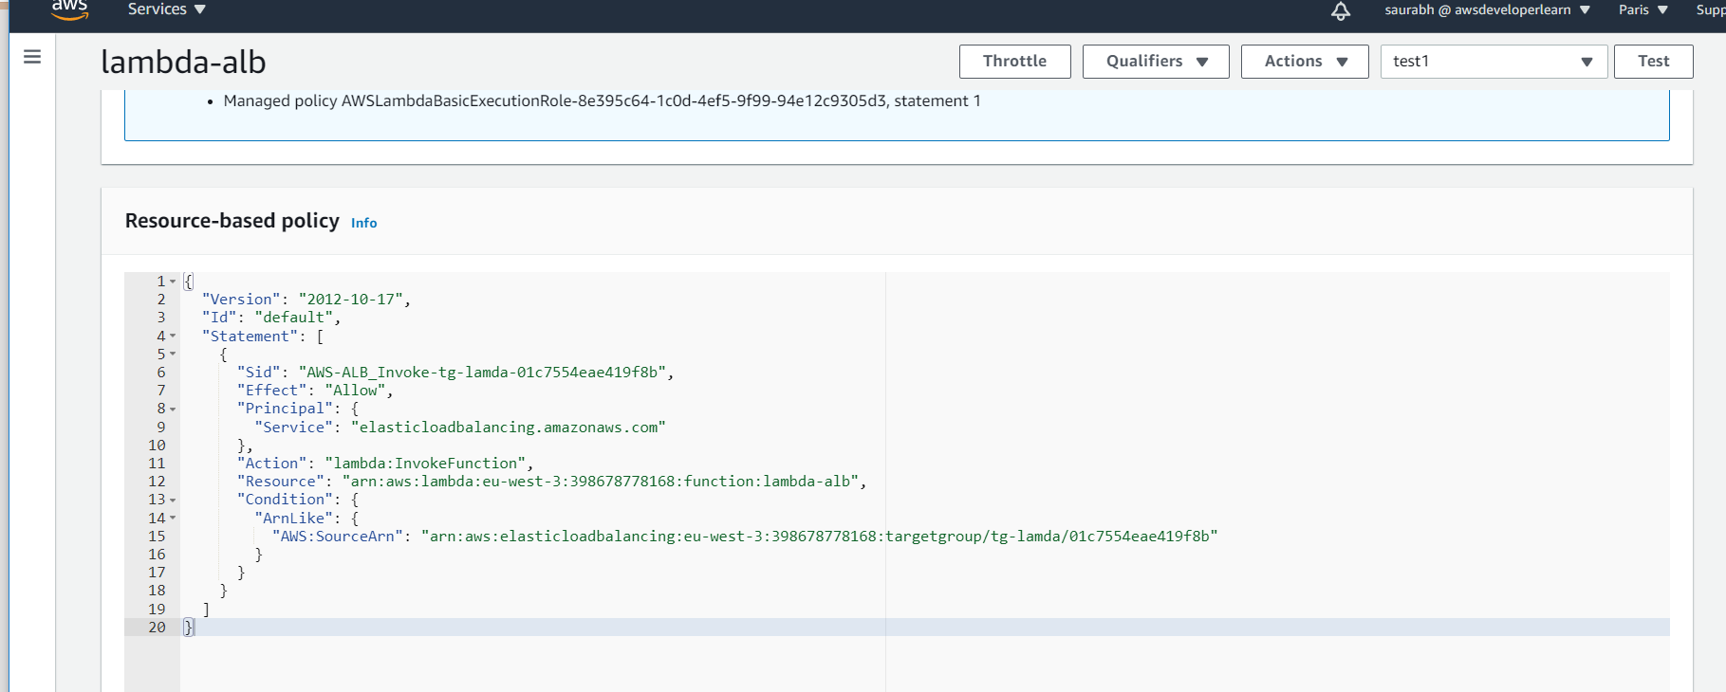

**AWS Lambda @ Edge overview ( synchronous type)**

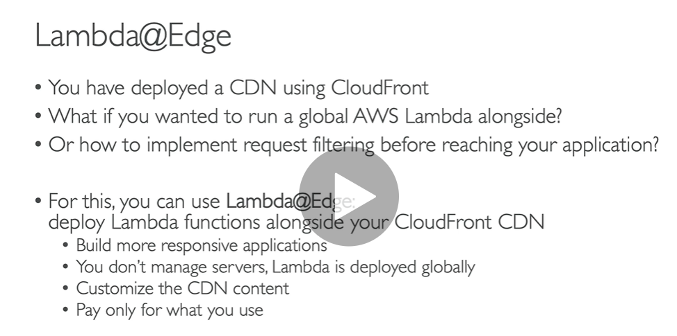

**Lambda**@**Edge** is a feature of Amazon CloudFront that lets you run code closer to users of your application, which improves performance and reduces latency. ... With **Lambda**@**Edge**, you can enrich your web applications by making them globally distributed and improving their performance — all with zero server administration.

Using @Edge we can modify these four types of request

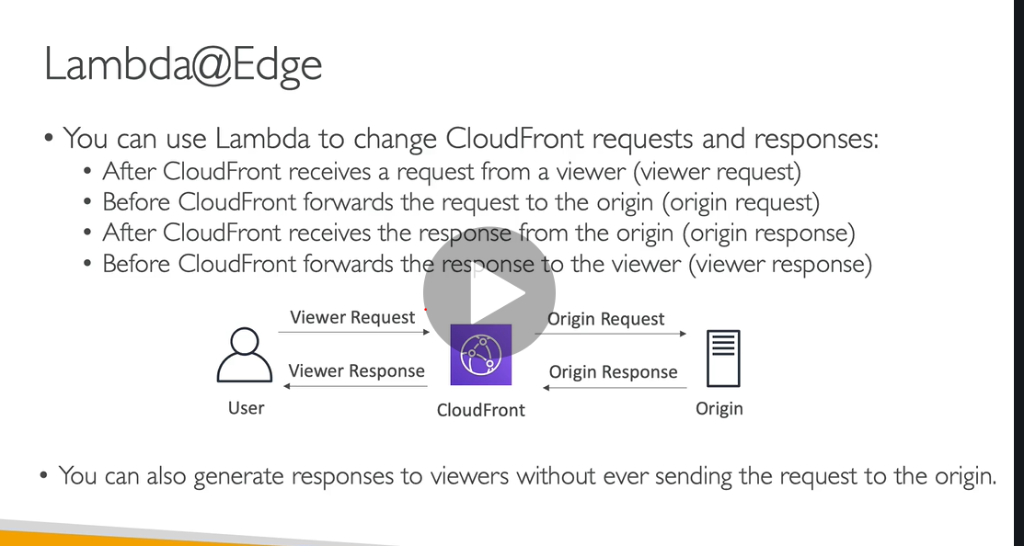

Static website hoisted on s3

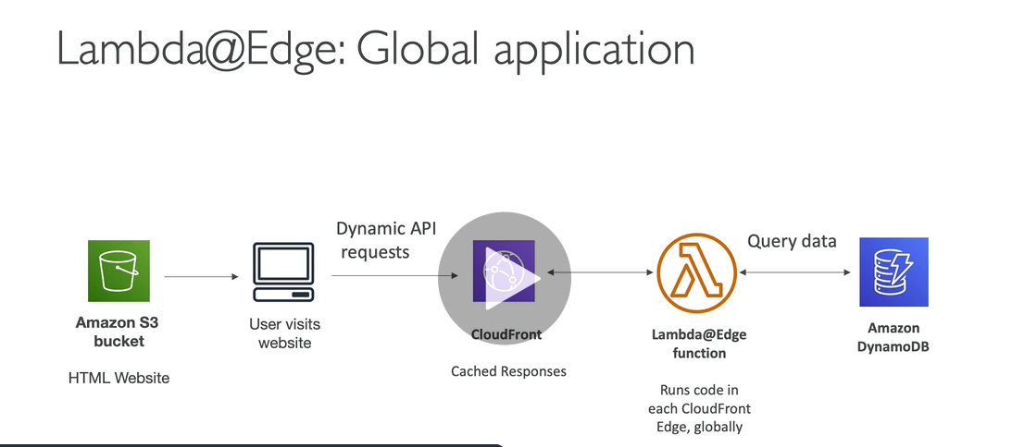

**Dynamo DB** : global database for server side application

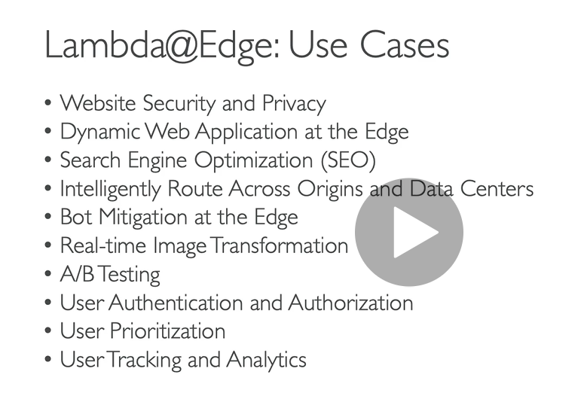

**No demo for this**

**Lambda Asynchronous Invocation and DLQ**

**Idempotent : in case of retries result will be same**

**We use asynchronous if we don’t need to wait for the result**

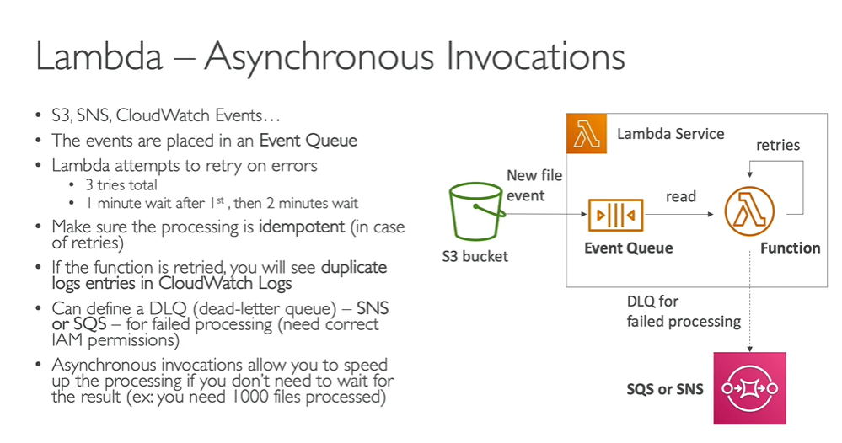

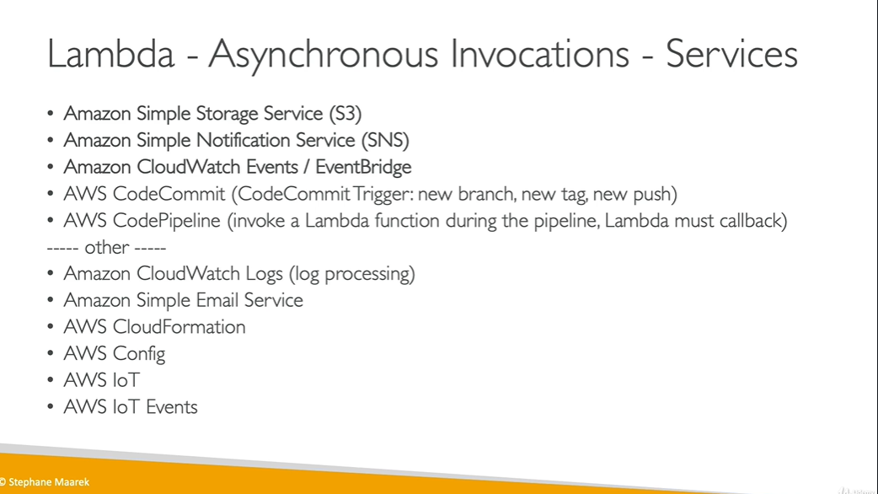

**Lambda Asynchronous Invocation Hands on**

**Requirement :**

**to invoke a function asynchronous we will not wait for result.**

**If exception is there it will not show**

**We will integrate with DLQ and send exception message there**

**Asynchronous invoke from cli**



aws lambda invoke --function-name hello-world --cli-binary-format raw-in-base64-out --payload '{\"key1\": \"value1\", \"key2\": \"value2\", \"key3\": \"value3\" }' --invocation-type Event --region eu-west-3 response.json

After running above code **We don’t know function is succeeded or not, we do not wait for the result to come to us**

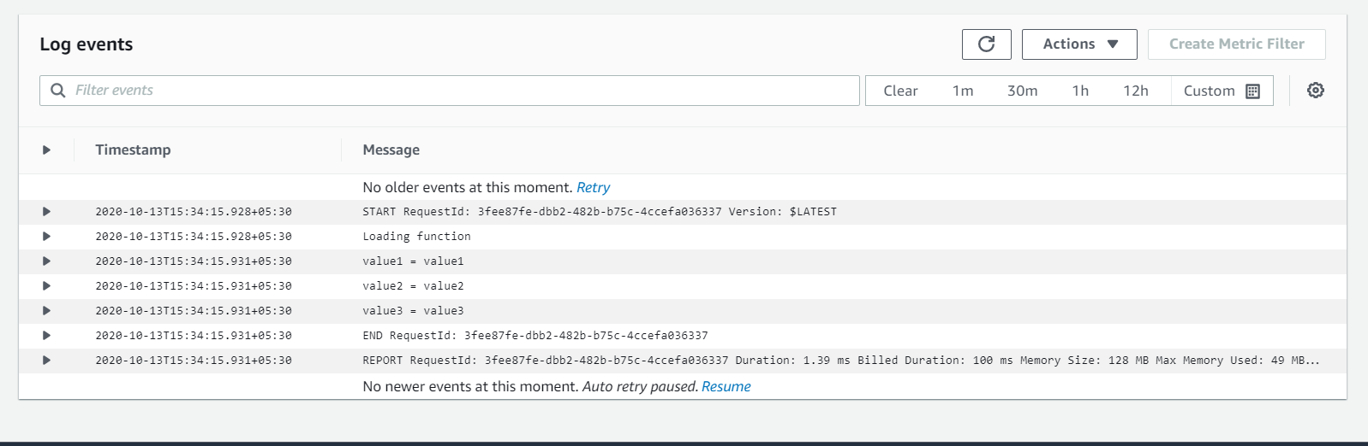

**Second scenario**

**Run synchronously execution get failed but if we run asynchronously we will not get to know about it**

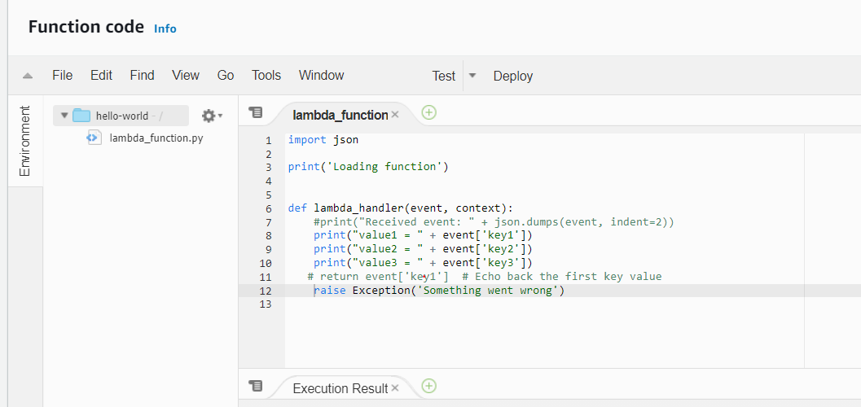

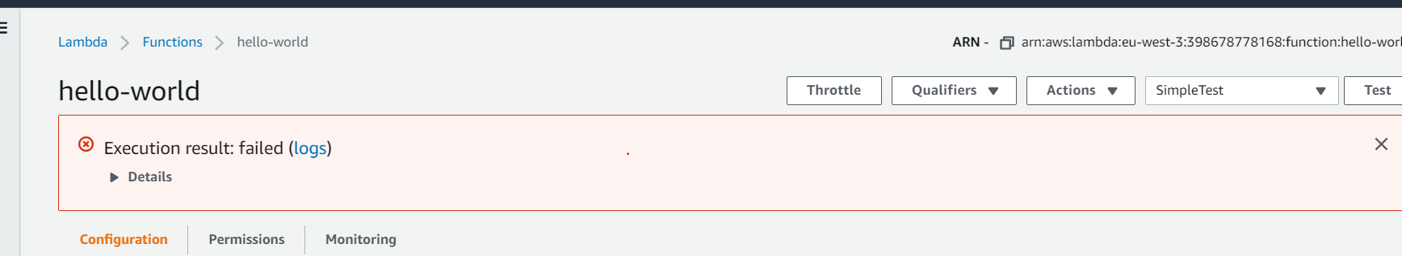

**Set up DLQ(dead letter queue)**

**Created dlq lambda**

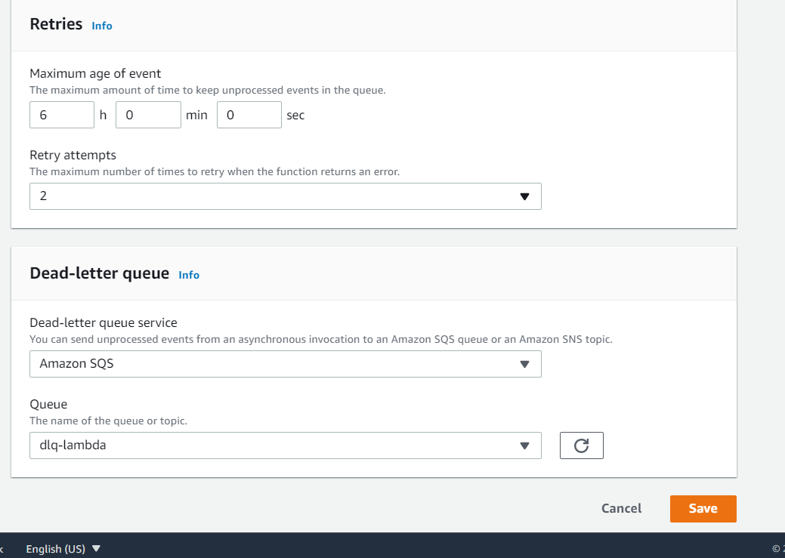

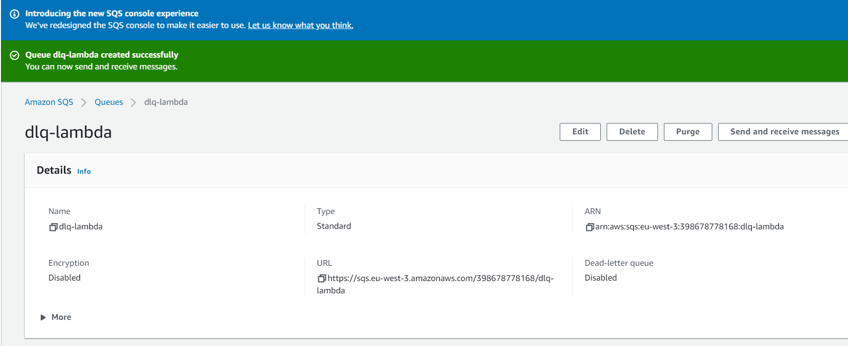

**Attach policy to hello-world**

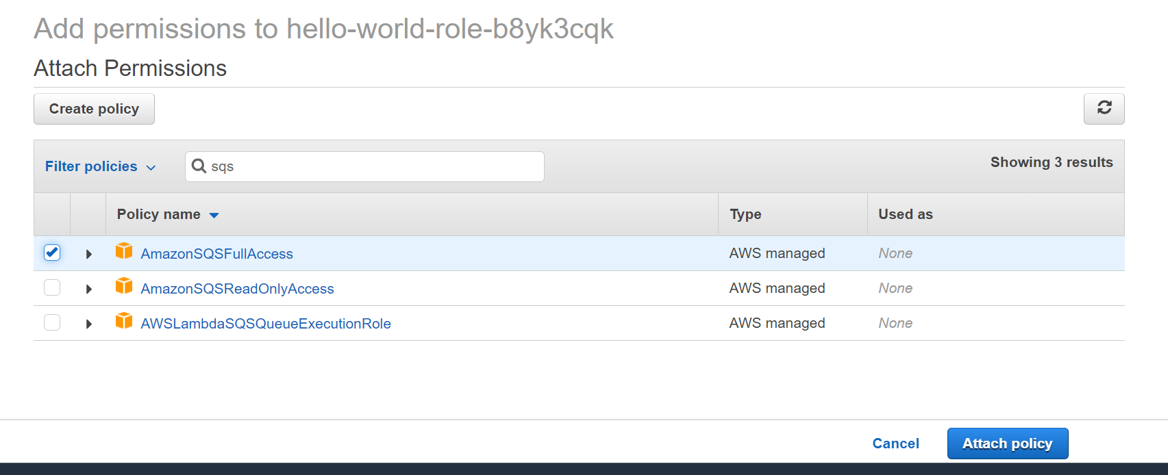

**Run the lambda function**



**One message available**

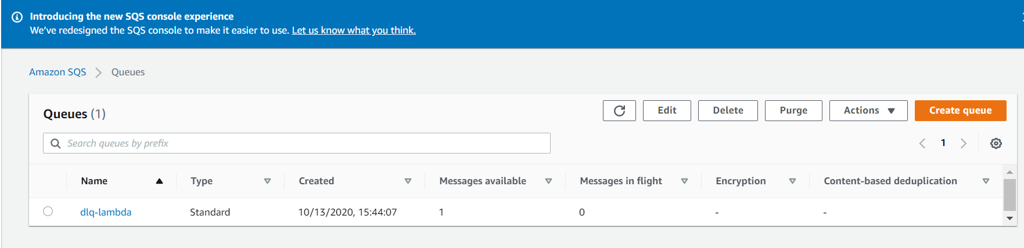

**Lambda and cloudwatch Events / Events bridge**

**Requirement : how to integrate cloudwatch Events / Events bridge to lambda**

**To do in dmeo**

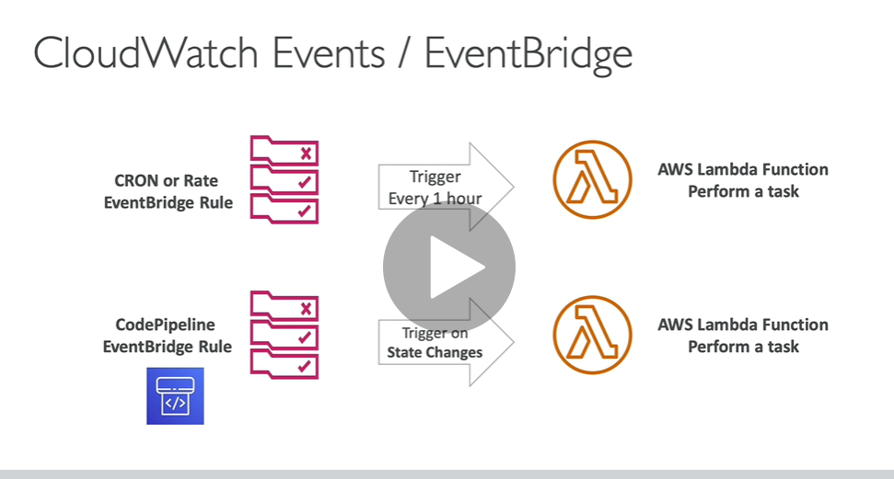

**Event bridge with lambda demo**

**Serverless event bus that connects application data from your own apps, SaaS, and AWS services.**

**Step 1) create function**

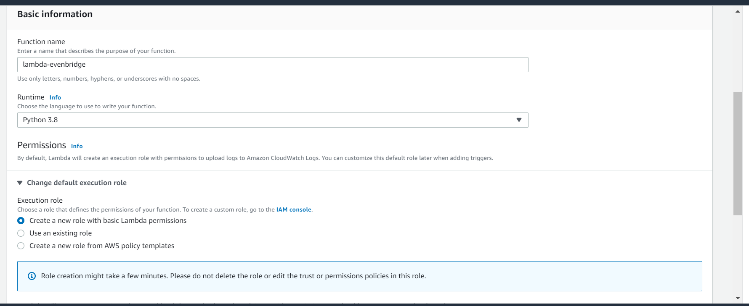

**Step 2) search service event bridge**

**Note:) with event bridge we are able to do serverless cron**

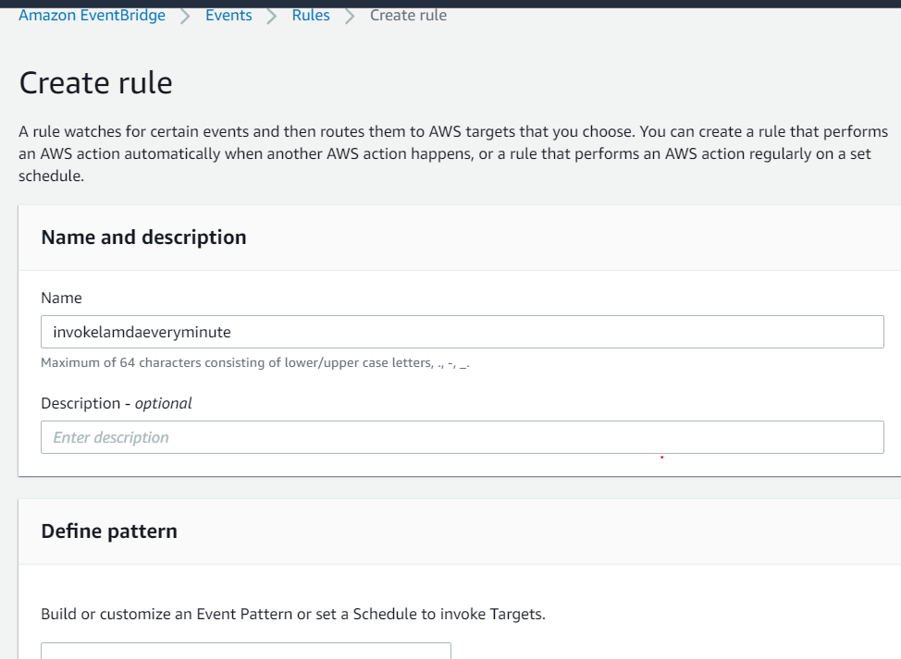

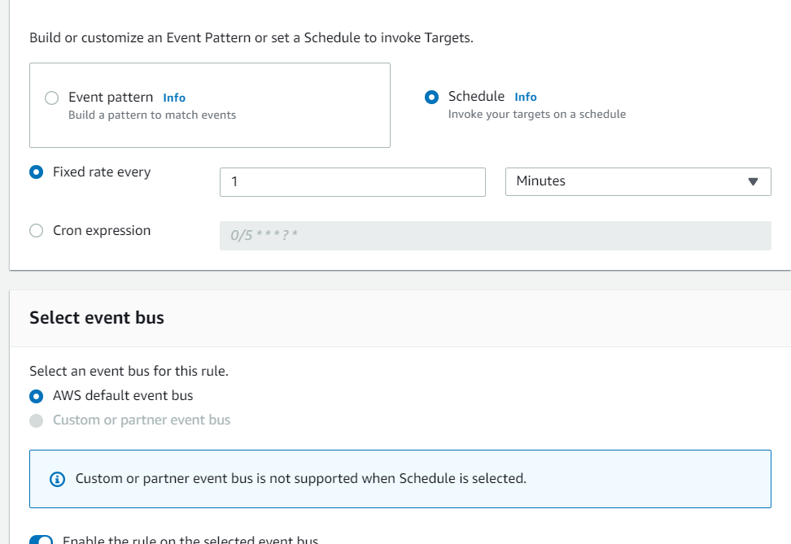

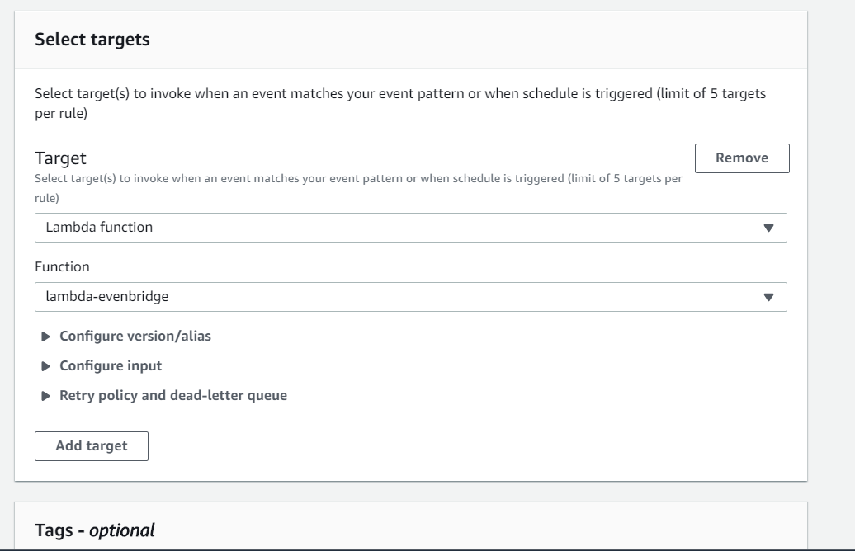

**Note: this is going to be asynchronous invocation of our lambda function every one minute**

**Rule is created**

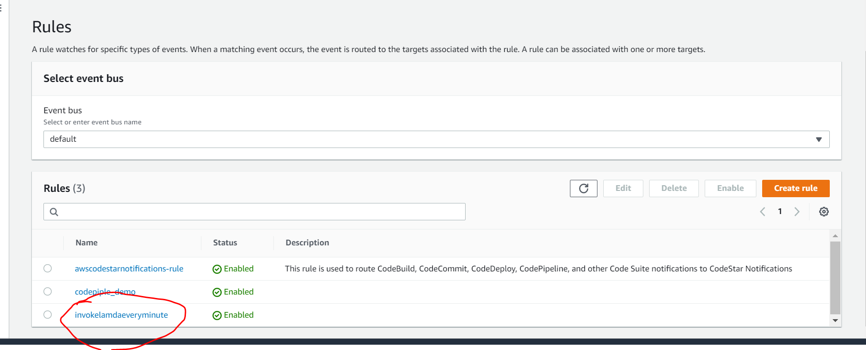

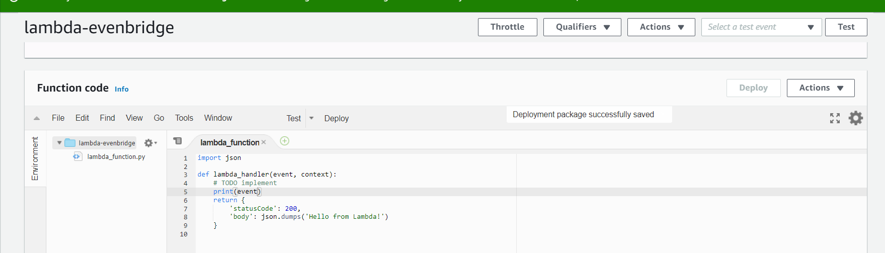

**Initially :**

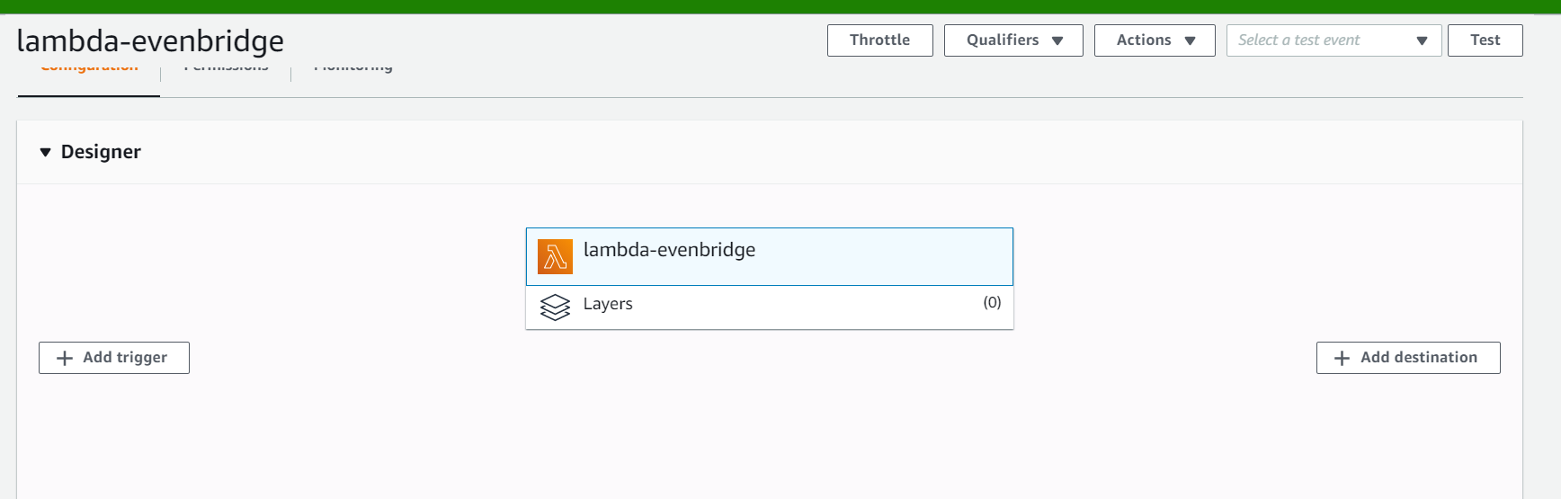

**Then event bridge will invoked lambda function\\**

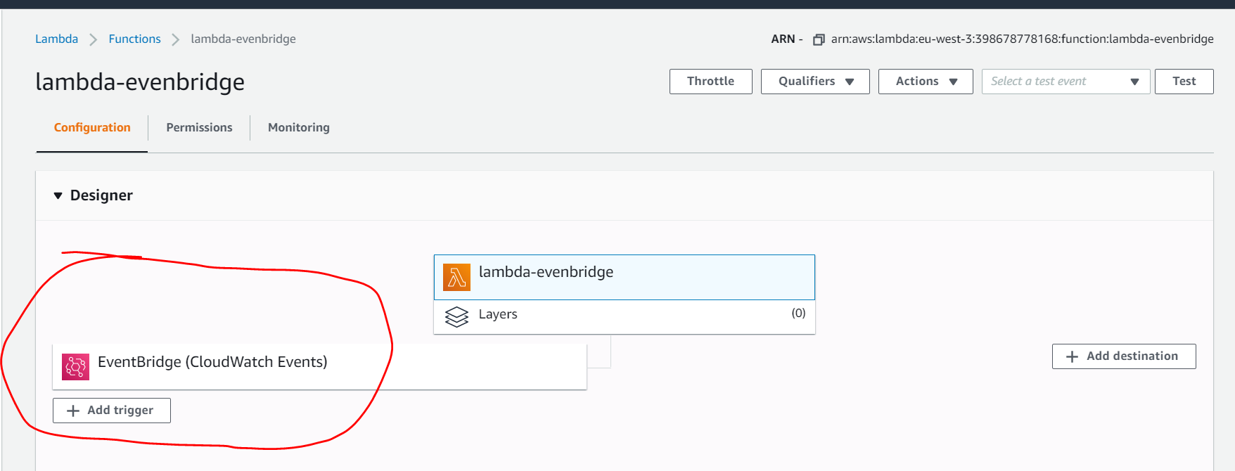

**Note : resource based policy is created**

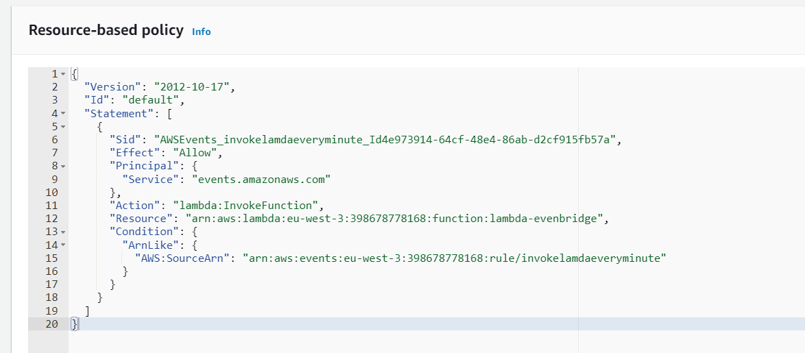

**To check whether cron occur just check in cloudwatch**

![Machine generated alternative text:
Log events 
Q Filter events 
Message 
There are older events to load. Load more. 
START Requestld: 6+3889cf-c1e2-416s-9234-fa8ef92a1c4a version: 
SLATEST 
1m 
30m 
Actions 
12h 
aus . events 
Custom 
account 
Timestamp 
: 43. ss7+as : 
: 45 : 43.561+as : 
Eversion ' 
18-13T11:14: 
C version' 
'id': 
' 29S2f31a-de2S -e261- bf98-d12S19243123 ' 
'398. . 
Cop 
, 'detail-type': 'Scheduled Event' , 
source 
'time' . 
aws. events 
' account' 
' 398678778168 , 
' 29S2f31a-de2s-e261-bf98-d12S19243123 , 
• 282e- 
' detail -type 
'Scheduled Event 
source 
' region': 
' eu-west-3 ' 
resources 
' arn : aws : events : eu-west-3 : 398678778168 : rule/ invokelamdaeveryminute ' , 
'detail': 
2828-1e-13T16. 
2828-1e-13T16. 
2828-1e-13T16 
2828-1e-13T16 
2828-1e-13T16 
2828-1e-13T16 
2828-1e-13T16. 
2828-1e-13T16. 
2828-1e-13T16. 
2828-1e-13T16. 
2828-1e-13T16 
2828-1e-13T16 
2828-1e-13T16 
.47. 
.47. 
.47. 
.47. 
END Requestld: 6+3889cf-c1e2-41€s-9234-fa8ef92a1c4a 
REPORT Requestld: 6+3889cf-c1e2-416s-9234-fa8ef92a1c4a Duration: I.es ms Billed Duration: 
START Requestld: 88db6b26-1da6-4eS3-gb43-16a4fad8bcse version: SLATEST 
• 43.562+as : 
• 43.562+as : 
• 43.567+as : 
• 43.572+as : 
• 43.572+as : 
• 43.8B8+as : 
• 43.812+as : 
• 43.813+as : 
• 43.813+as : 
• 43.851+as : 
• 43. : 
• 43. : 
lee ms 
Event ' 
lee ms 
Event ' 
lee ms 
Event ' 
51... 
Memory Size: 128 MB Max Memory Used: 
' Scheduled 
source 
aus . events 
account 
C version' 
'id': 
fe2644es-7792 -628e-73B6-81e8a278e78a ' 
, detail-type ' 
'398... 
51... 
END Requestld: 88db6b26-1da6-4eS3-gb43-16a4fad8bcse 
REPORT Requestld: 88db6b26-1da6-4eS3-gb43-16a4fad8bc8e Duration: e. 91 ms Billed Duration: 
START Requestld: 4ae2e4S8-db73-446s-a2ef-decSb143fe12 version: SLATEST 
Memory Size: 128 MB Max Memory Used: 
' Scheduled 
source 
aus . events 
account 
C version' 
'id': 
' 954d1122-4ef2-277a-gf24-2b3768cdb832 , 
' detail-type ' 
'398... 
END Requestld: 4ae2e4S8-db73-44€s-a2ef-decSb143fa12 
REPORT Requestld: 
START Requestld: 
52... 
'398... 
4ae2e4S8-db73-446S-a2ef-decSb143fe12 Duration: 1.24 ms Billed Duration: 
S2easyg-1f67-4fa2-gdd2-cd7a8e8d21€e version: SLATEST 
Memory Size: 128 MB Max Memory Used: 
' Scheduled 
source 
aus . events 
account 
C version' 
END Requestld: 
'id': 
' 54b7f11d-468e-eb37 ' 
, detail-type ' 
S2easyg-1f67-4fa2-gdd2- cd7a8e8d216e ](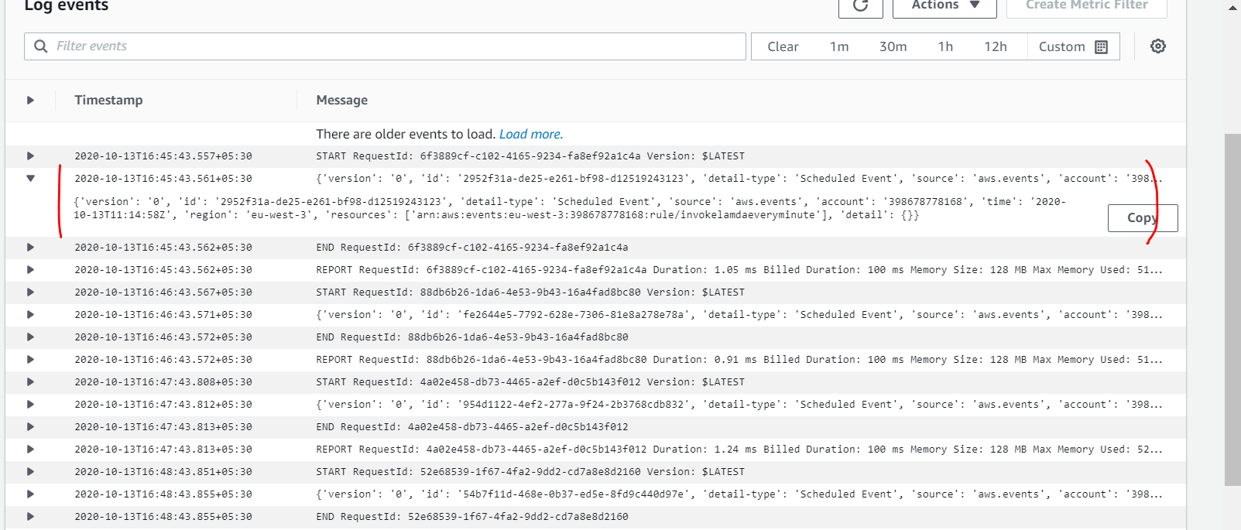)

**Lambda and s3 event notification**

**Integration of s3 event with lambda**

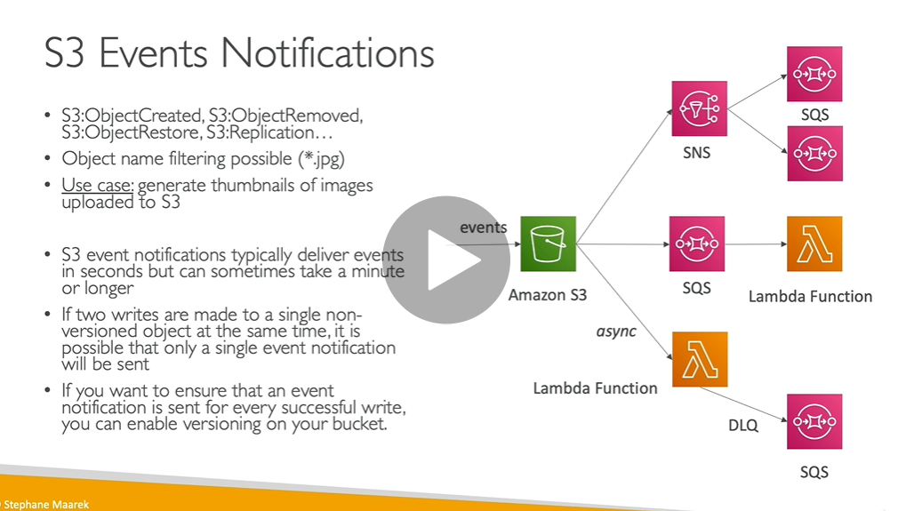

**Hands on**

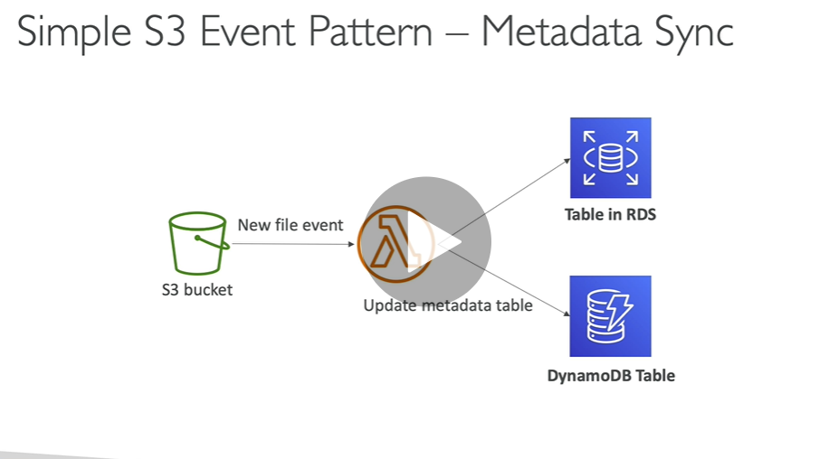

**Step 1 :) create lambda-s3 function**

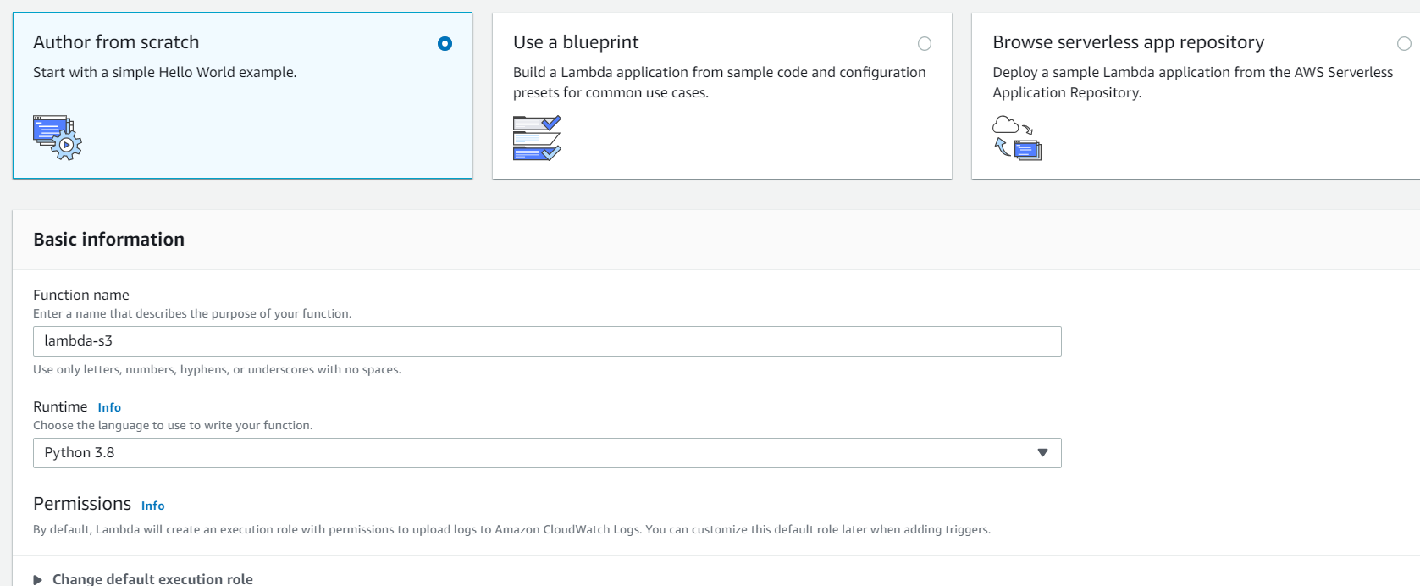

**Step 2) create bucket**

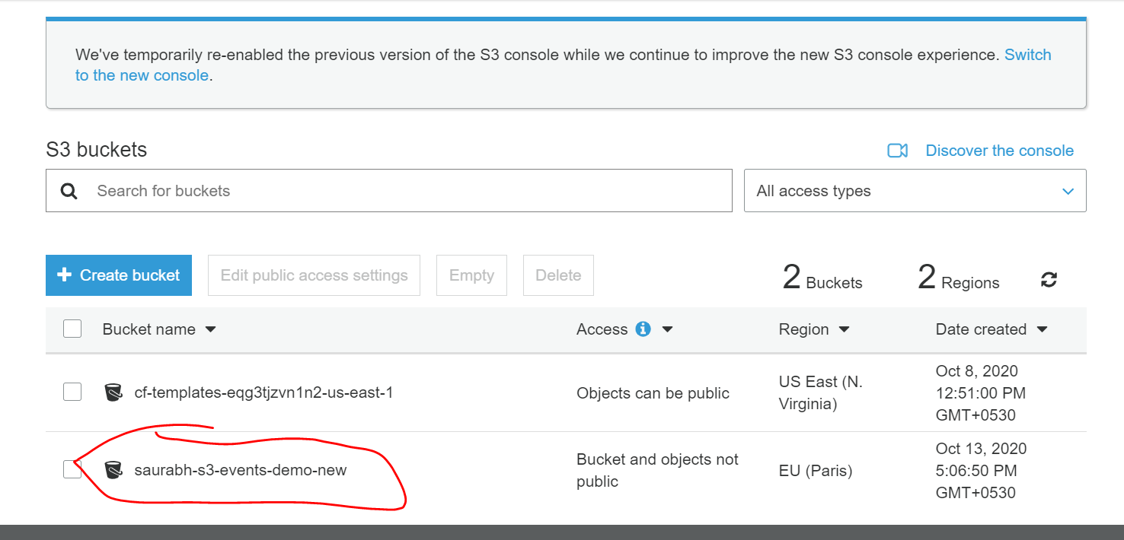

**Requirement allow a bucket to trigger lambda function**

**Step 3) go to bucket /properties/events/add notification**

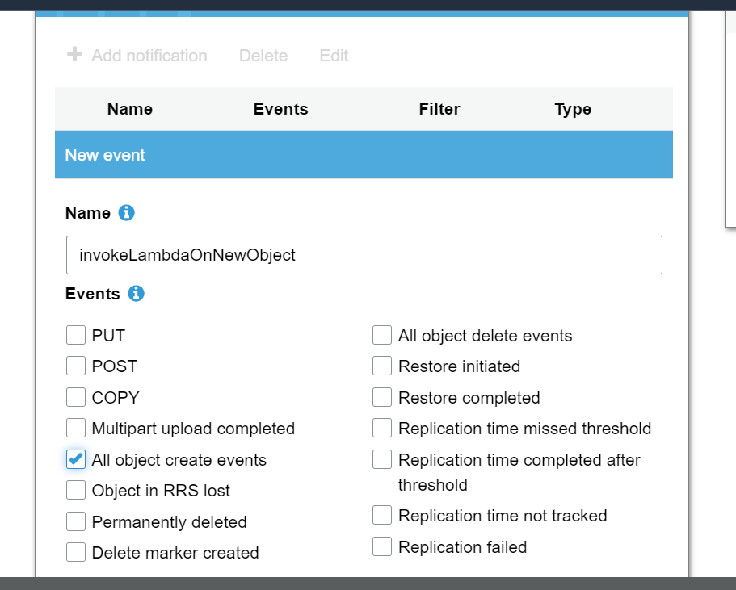

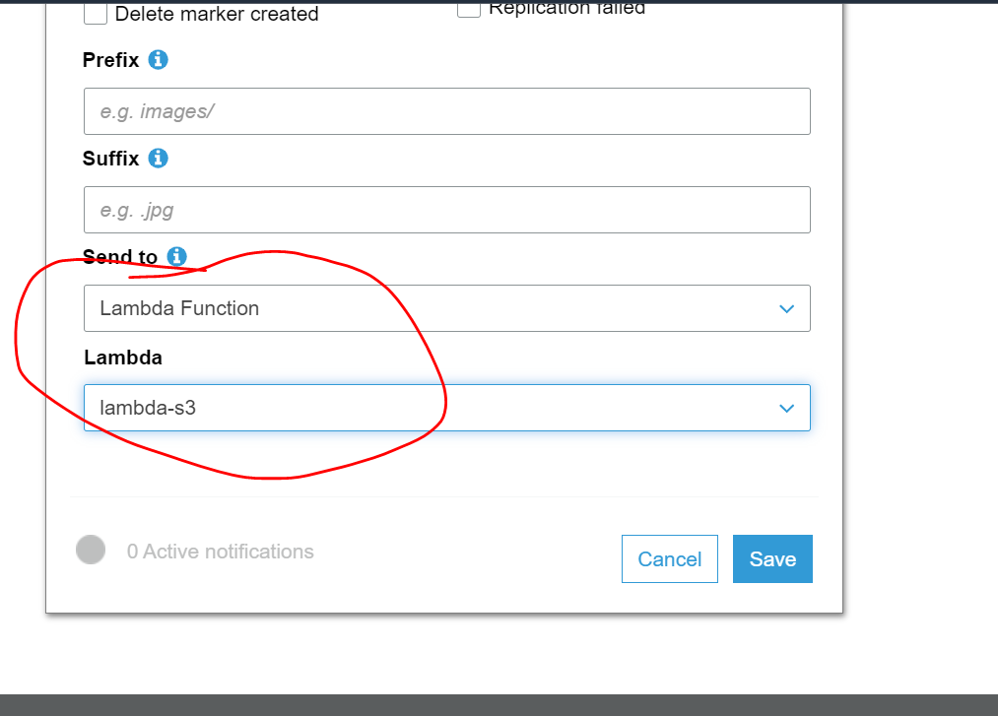

**Now we are seeing s3 as a source to invoke lambda function**

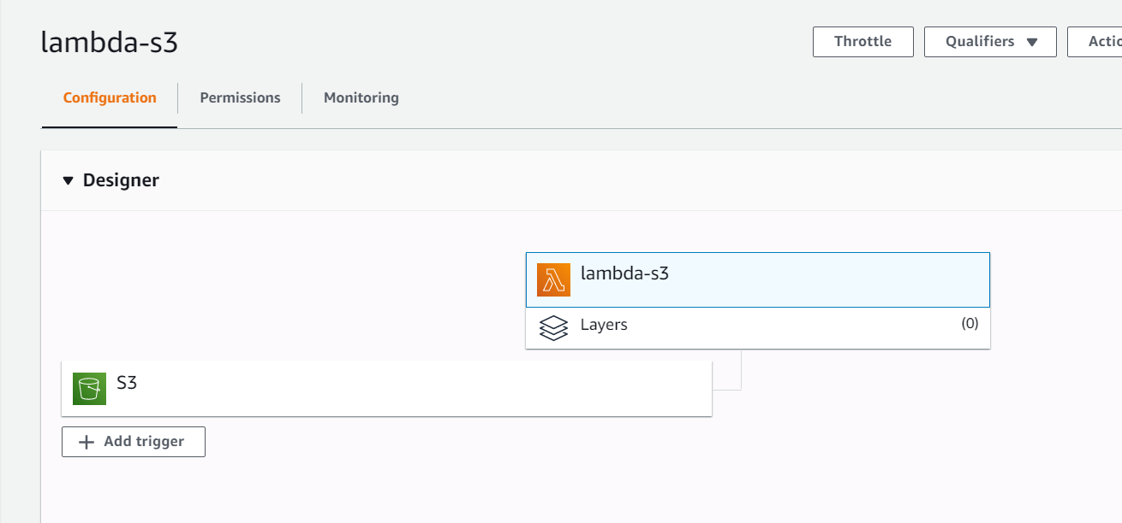

**Change code to see event**

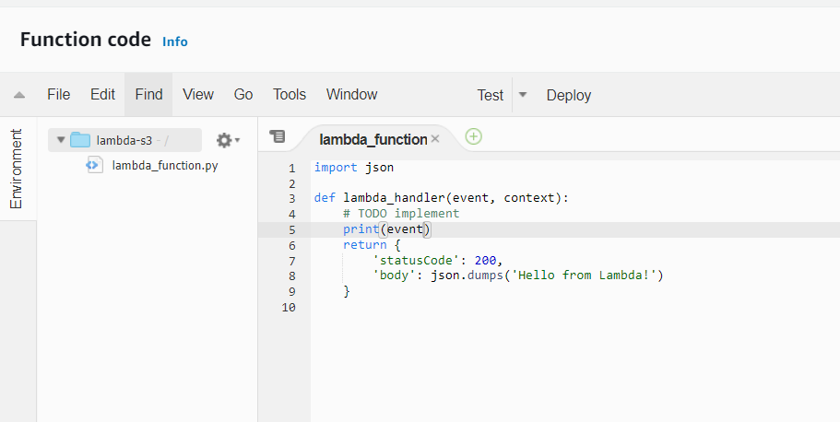

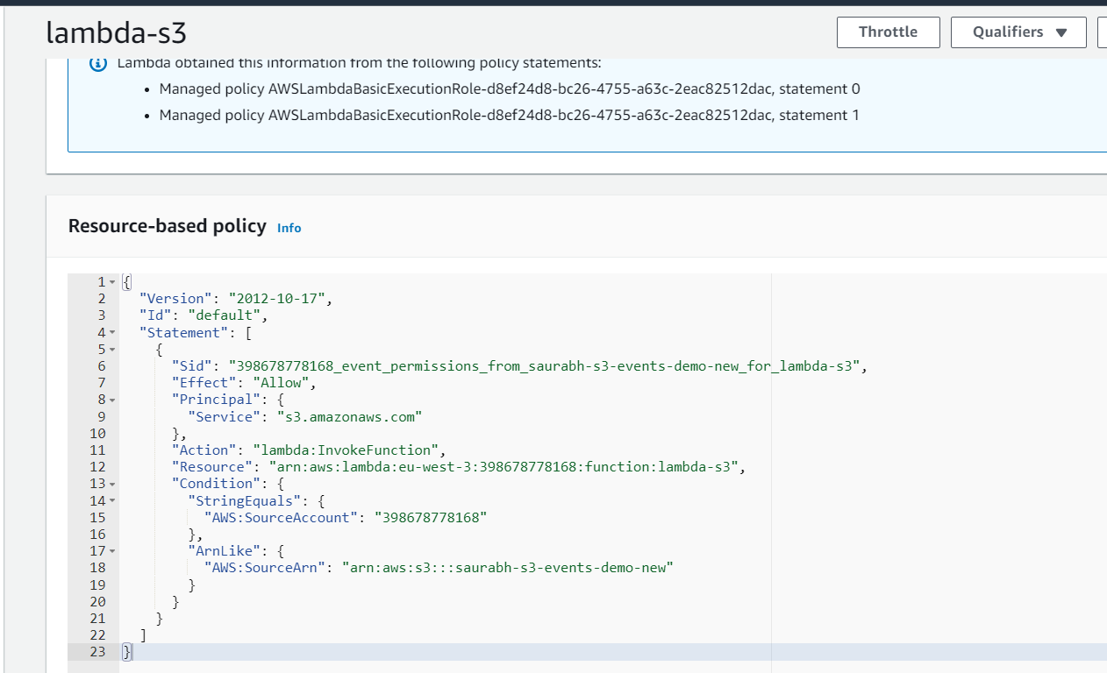

**Upload some image is s3 and check in from monitoring section/ cloudwatch that lambda function is trigger or not**

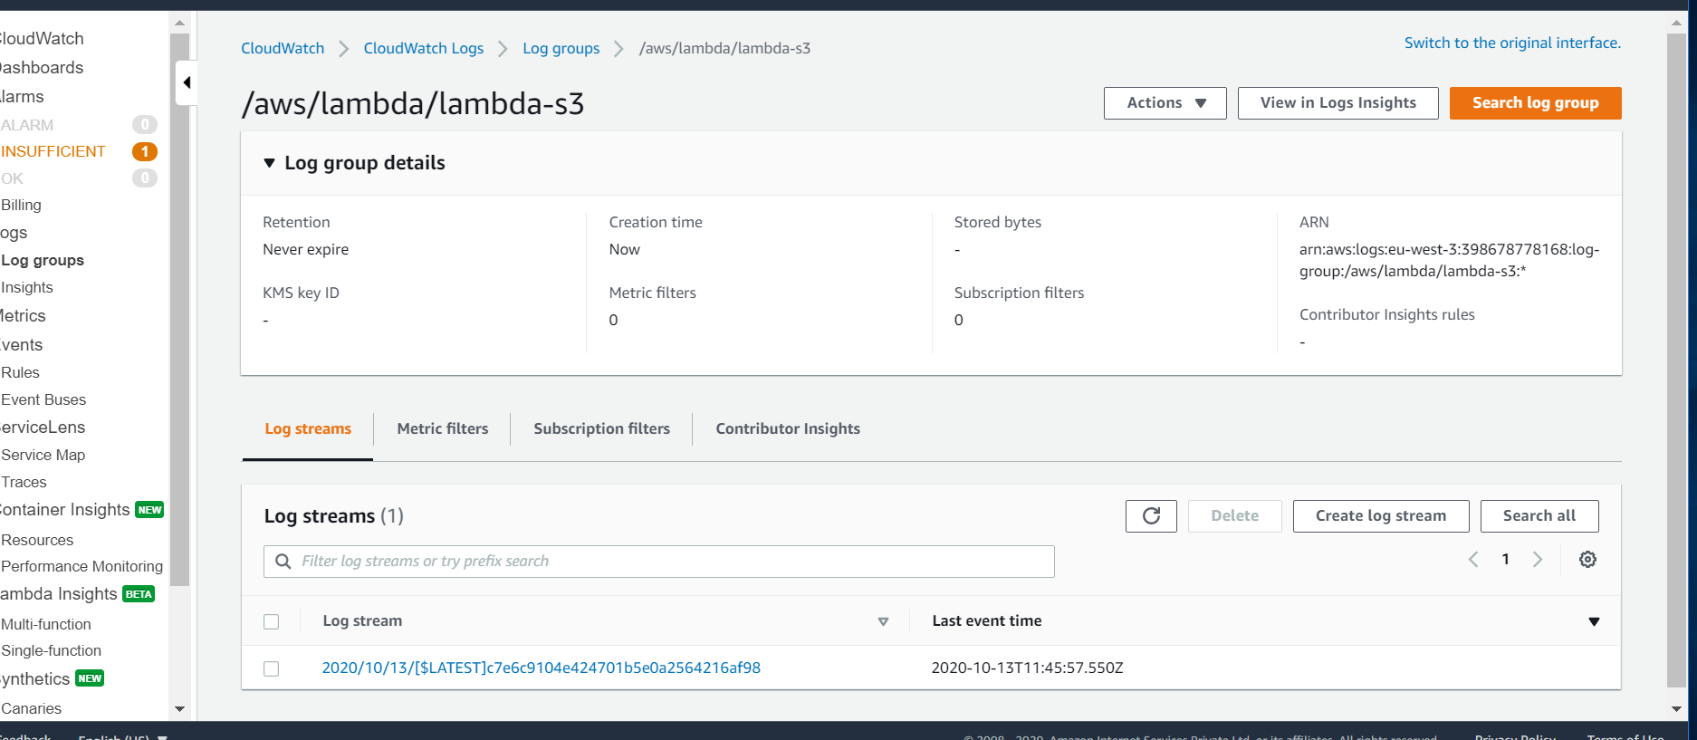

**Asynchronous invocation**

![Machine generated alternative text:
CloudWatch 
Dashboards 
Alarms 
ALARM 
INSUFFICIENT 
OK 
Billing 
Logs 
I Log groups 
Insights 
Metrics 
Events 
Rules 
Event Buses 
ServiceLens 
Service Map 
Traces 
0 2008 - 2020, 
CloudWatch ) CloudWatch Logs Log groups 
Try CloudWatch Logs Insights 
/aws/lambda/lambda-s3 
2020/10/13/6 LATESTJc7e6c9104e424701 b5eOa2564216af98 
Switch to the original interface. 
Try Logs Insights 
Create Metric Filter 
Custom 
x 
CloudWatch Logs insights allows you to search and analyze your logs using a new, purpose-built query language. To learn more, read the AWS blog or 
visit our documentation 
Log events 
Q 
Filter events 
Imestamp 
: : 57.548+as : 
: : 57.549+as : 
Records 
'eventVersion' . 
' userldentity ' 
( ' principalld' • 
No older events at this moment. Retry 
START Requestld: c2f16cc1-12ss-4a82-gga8-S731f1eaee3f version: 
SLATEST 
' awsRegion ' 
'eu-west-3' 
1m 
Actions 
30m 
12h 
Records 
eventVersion ' 
' eventSource ' 
aws:s3' 
' eu-west-3 ' 
'event Time • : 
eventTime ' 
eventName 
' 2e2e-1a-13T11 
ObjectCreated : Put ' , 
x-amz-request-id'• 
s3SchemaVersion . 
eventName... 
Copy 
' eventSource 
'aws:s3' 
: AIDAVZUY3ME4FHZ8JTCSJ 
' awsRegion ' 
' responseE1ements 
' requestparameters 
sourceIPAddress 
'CDe4FEEIDF72A9A8' 
x-amz-id-2' 
' F qm/coa6VNEhn3 
'configurationld' 
' invokeLambdaOnNewObject ' , 
' bucket ' 
: saurabh-s3-events-denvo-ne1,' ' ) , 
object ' 
key 
ndex. htm 
Container Insights 
Resources 
Performance Monitoring 
Lambda Insights 
Multi-function 
Single-function 
Synthetics 
' saunabh -s? -events-demo-new ' 
' ownerldentity 
principalld'• 
' size 
' eTag' 
' c4eaee7dc3cg2ebd6egga4yggsc8ee37 ' 
178, 
Terms of Use 
' AURISH8P6M4VH ' , 
arn 
' sequencer' 
ms Memory Size: 128 MB Max Memory 
sed : 
2828-1e-13T17 : : 57. sse+as : 
2828-1e-13T17 : IS : 57. sse+as : 
END Requestld: c2f16cc1-12ss-4a82-gga8-S731f1eeee3f 
REPORT Requestld: c2f16cc1-12ss-4a82-gga8-S731f1eaee3f Duration: 1.62 ms Billed Duration: lee 
No newer events at this moment. Auto retry paused. Resume 
Privacy Policy 
Canaries 
Feedback 
English (US) 
Amazon Internet Services Private Ltd. or its affiliates. All rights reserved. ](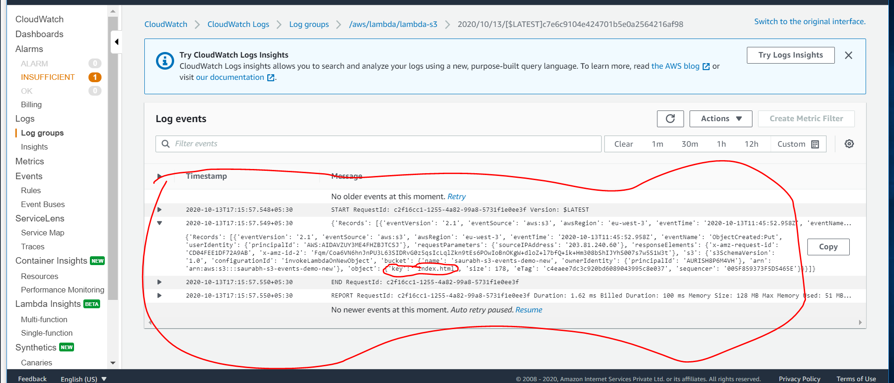)

**Lambda Event Source Mapping**

**Lambda need to ask some services for data that means lambda poll these services**

**Note: )Lambda read data from kinesis then internally Event Source mapping is created which is responsible to poll data and getting the result back from kinesis then it will invoke lambda**

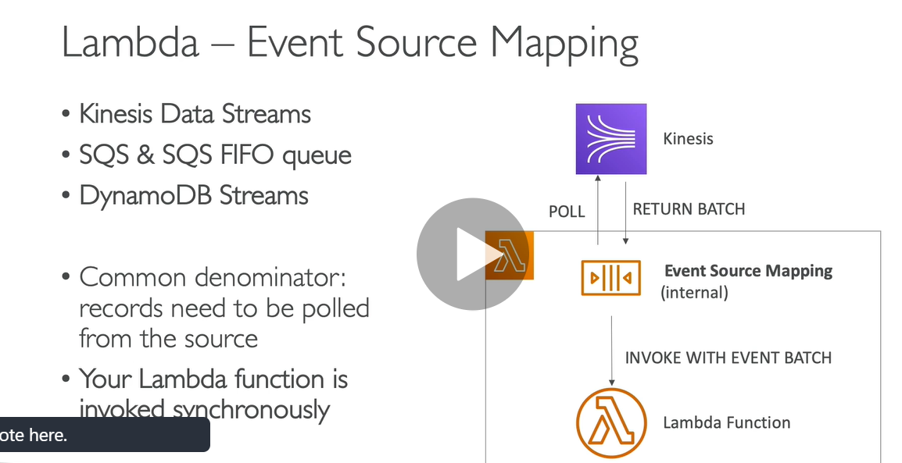

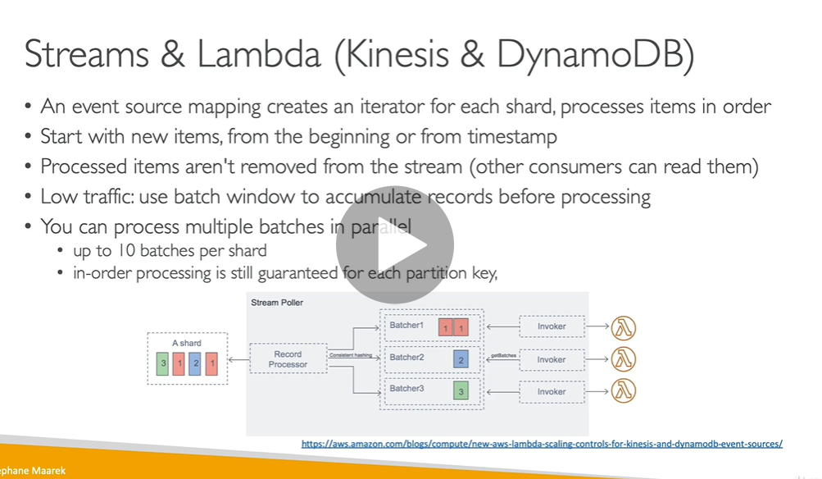

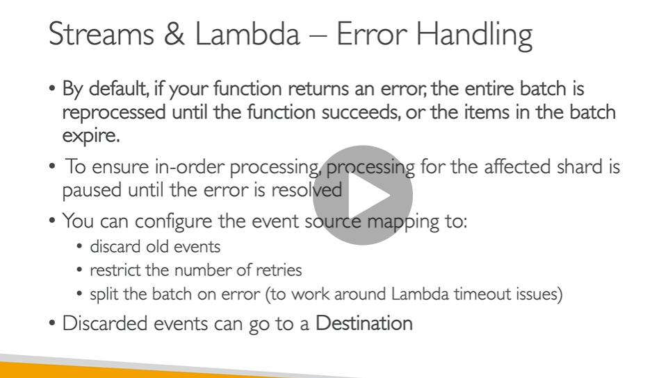

**Note: DLQ for lambda is only work for asynchronous**

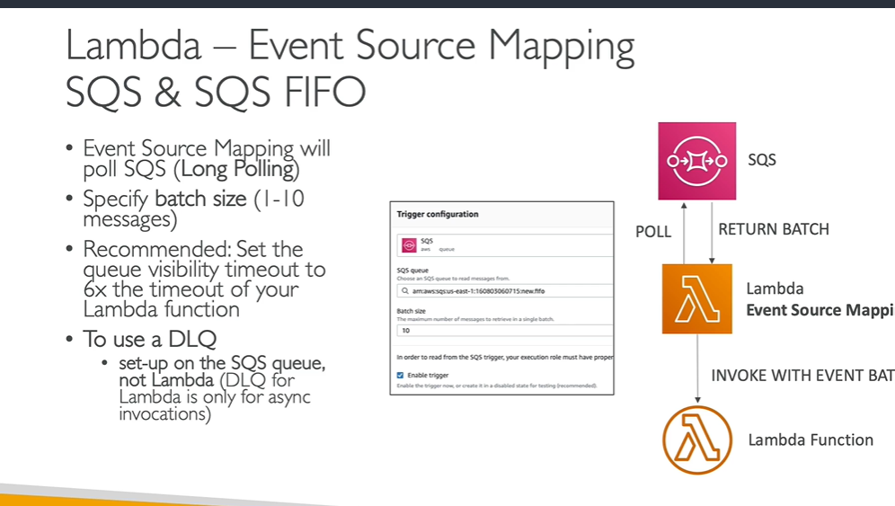

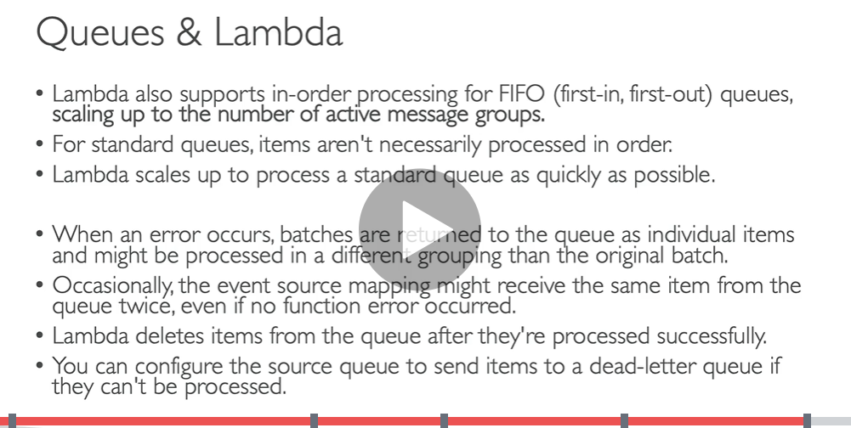

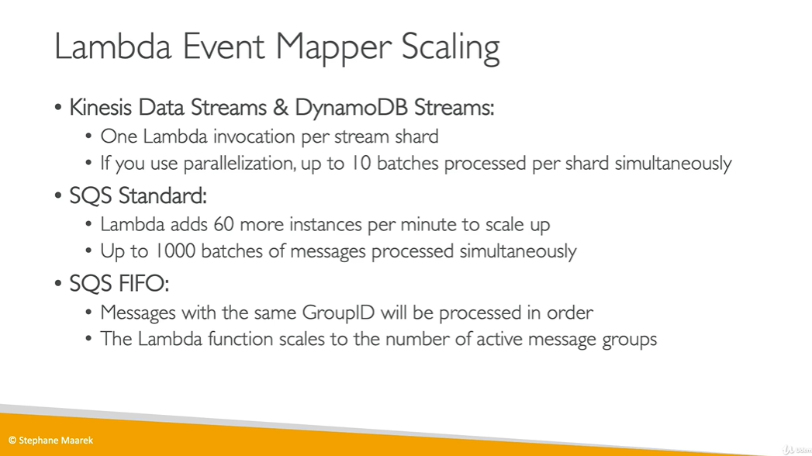

**Lambda event source mapping hands on (SQS)**

**Note : first create lambda**

**then service**

**attach service with lambda**

**do something in service**

**then check using cloudwatch lambda function invoke or not**

**Step1) create function**

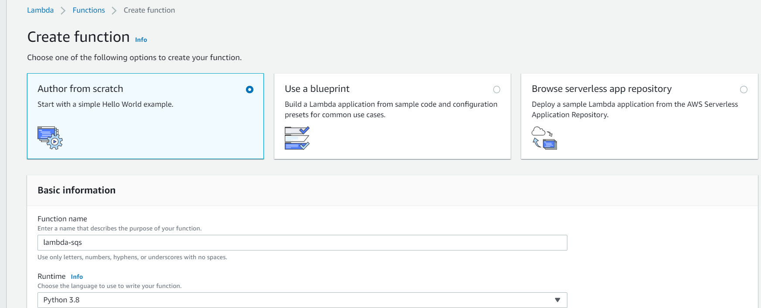

**Step 2) create queue . This is the queue where lambda function will read it**

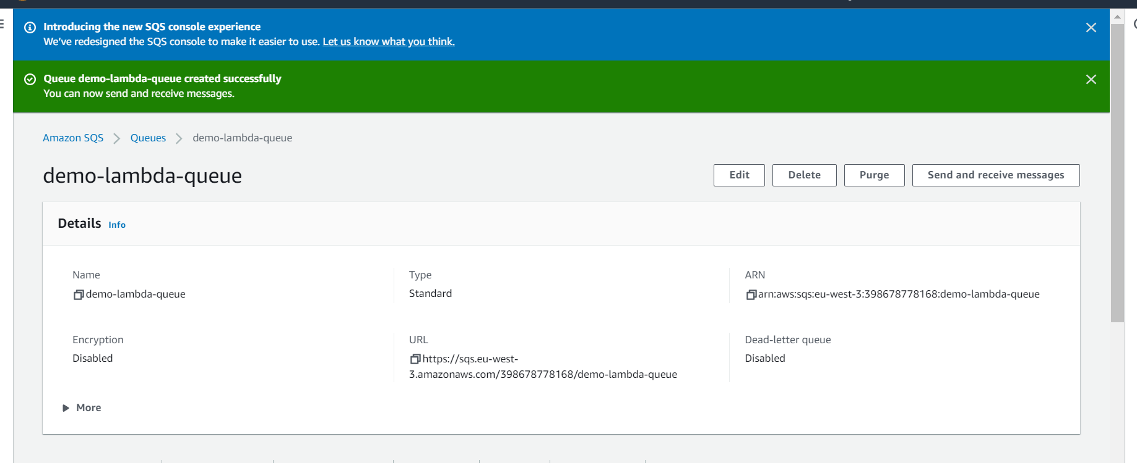

**Step 3) In lambda function need to add trigger**

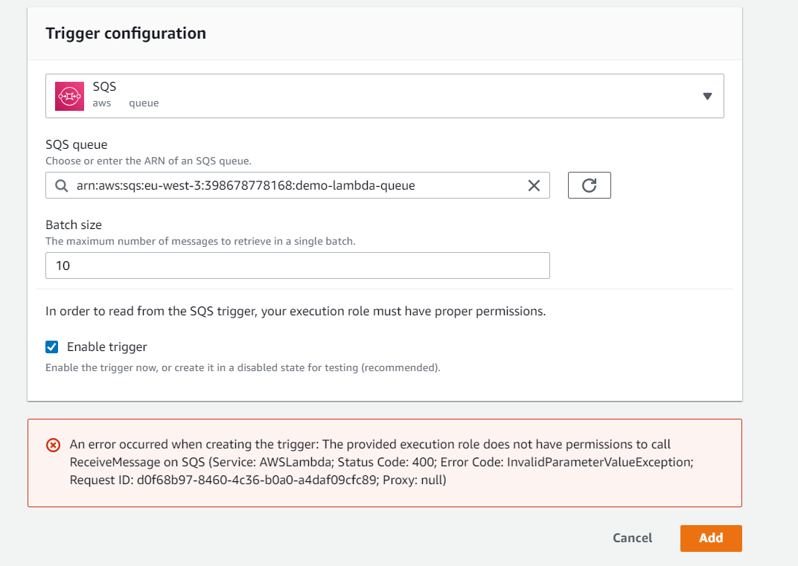

**Need to add permission**

**Click on role**

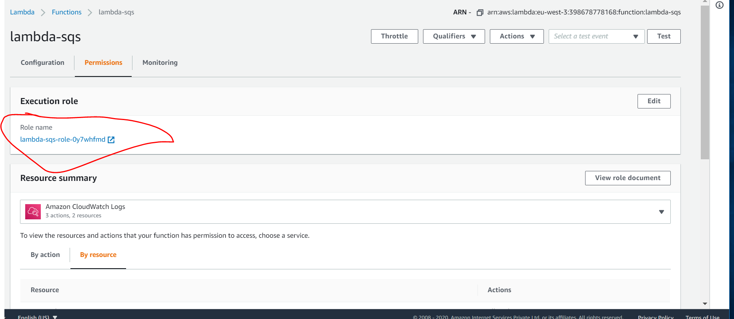

**Attach a policy**

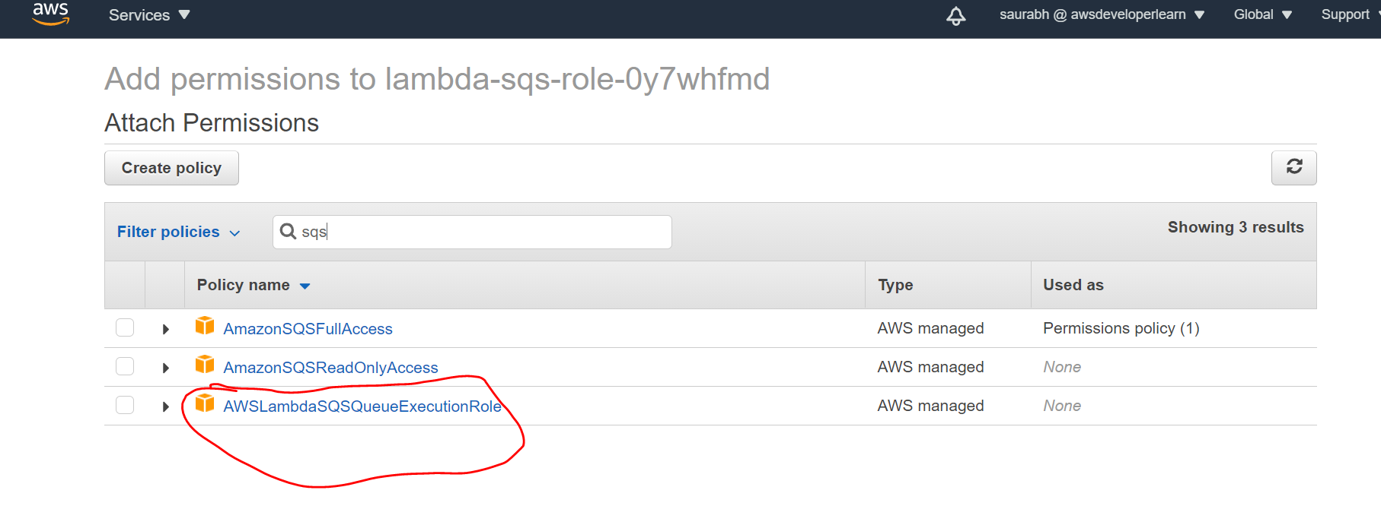

**After attaching policy**

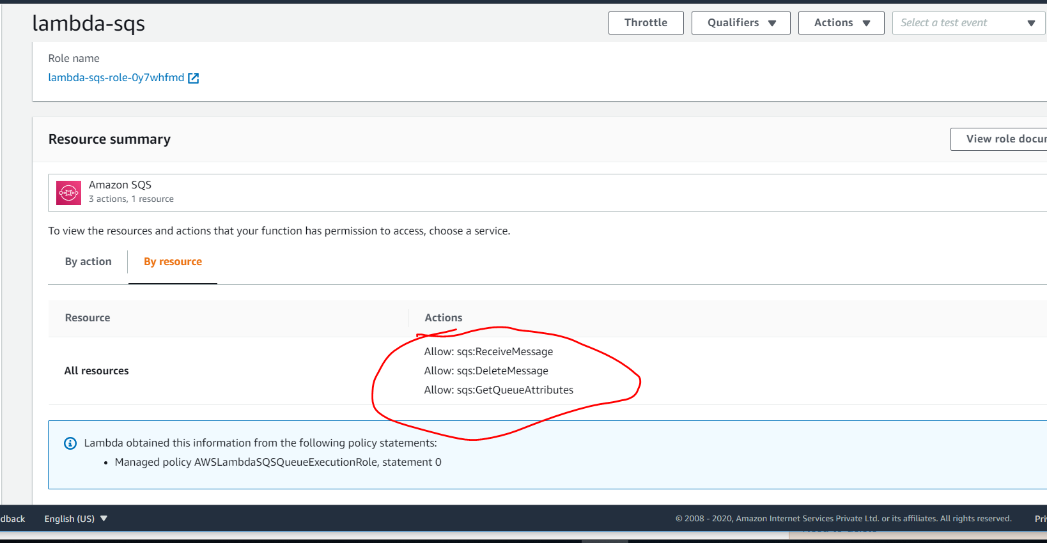

**For some service we can trigger it and attach to lambda function**

**Now lambda function can be trigger by SQS**

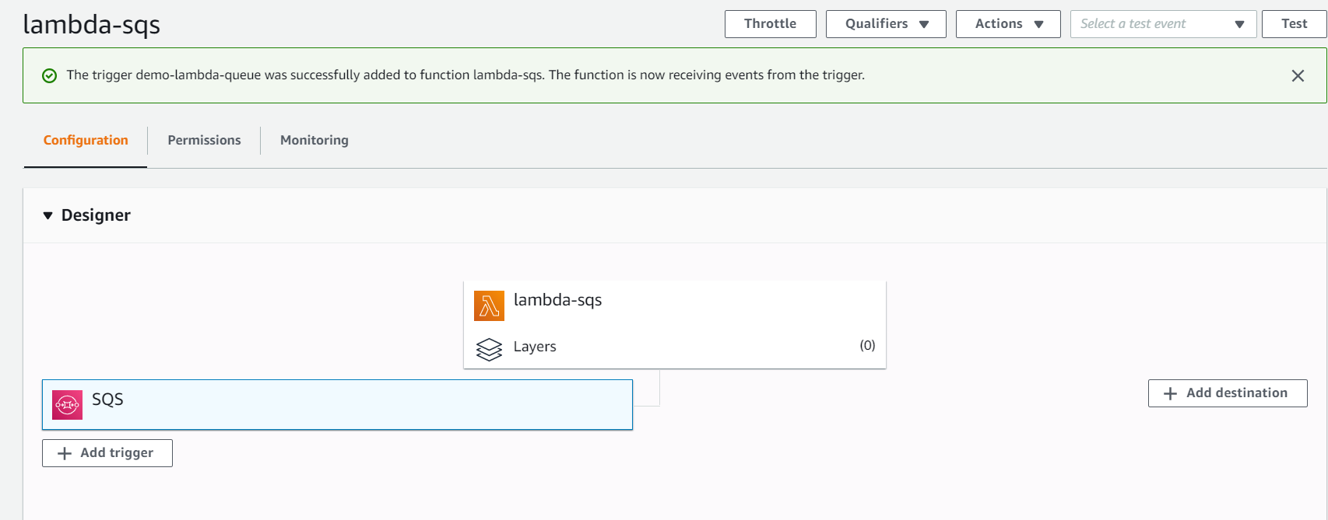

**Change lambda function**

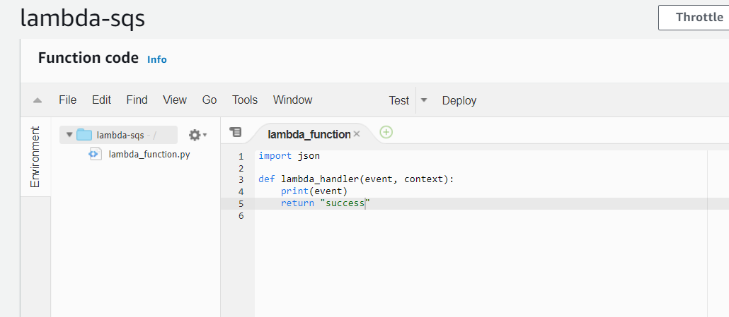

**Send message in SQS**

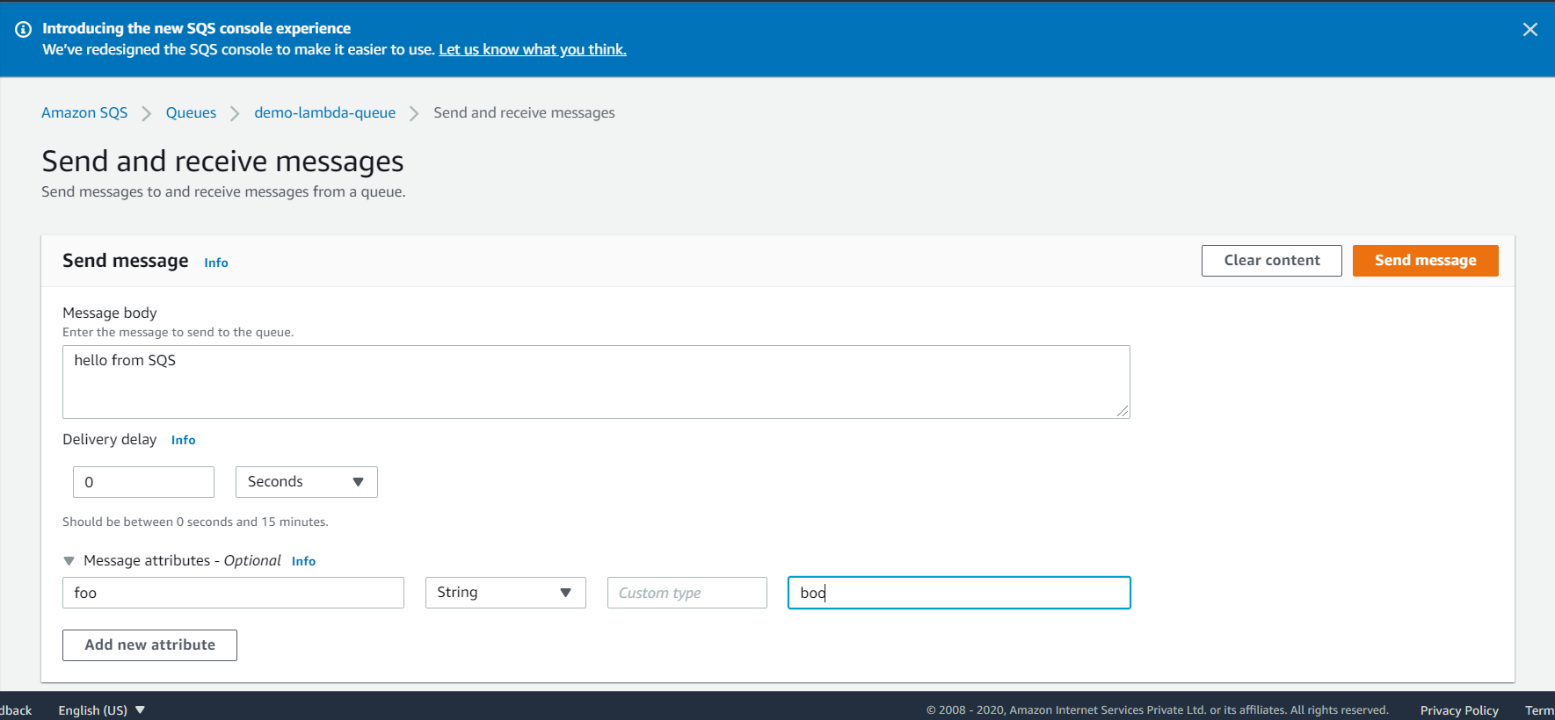

**It show SQS trigger lambda function**

![Machine generated alternative text:
CloudWatch ) CloudWatch Logs Log groups 
Try CloudWatch Logs Insights 
/aws/lambda/lambda-sqs 
2020/10/13/L$LATESTP67e203071 e449a 1 b8e33373b6045f03 
Switch to the original interface. 
Try Logs Insights 
Create Metric Filter 
Custom 
x 
CloudWatch Logs insights allows you to search and analyze your logs using a new, purpose-built query language. To learn more, read the AWS blog or 
visit our documentation 
Log events 
Q Filter events 
Timestamp 
: 48 : 22.675+as : 
: 48 : 22.676+as : 
Records 
'messageld'• 
Message 
No older events at this moment. Retry 
START Requestld: cd46eba7-3bgg-saee-adb1-scf8a6da6aba version: SLATEST 
Records 
•messageld' 
' 27e86d4a -ddf4-4fbf-baa6- 3e12B29436a2 ' , 
' receiptHandle ' 
' 27e86d4a - ddf4-4fbf 3e12a29436a2 ' , 
' receiptHand1e ' 
1m 
Actions 
30m 
12h 
' AQEB3cehSPDAx,' KTXUQpDpygfVewgczsq r-bKspgbcLGEADaKzv1jxt... 
Copy 
' SentTimestamp ' 
' AQE8JcehSPDAx/KTXlJQpDpygfVewgczsqFbK8P9bc 
METnpQIKcs3zizQYa/7xiApsw0673xxmfzoX3spb182szu6eigf2vM1yaKYgPtDzzbLgEGuYsyeWkAoSB7Kq+ju8NXXLRgn7B 
SMIMPKa1datVSdSYT/i1ZZL/ieEK2C4edOqxfpdOSeYC9YFHDELYRY2a1e1rSFoRh1ZIR8iCanbMSFvoi8Few 
'body' • 
A4K/gdvseKW28T4t+FnpUMdVA8p1n1wuBoexpvwNsBnc:hHaucd6xN/smsxvRYS 
e o from S S 
' attributes 
ApproximateReceiveCount ' 
• 102591saue2 ' 
'Senderld': 
'binaryListVa1ues 
eventSourceARN ' . 
aws:sqs 
: 48 : 22.677+as : 
: 48 : 22.677+as : 
' AIDAVZUY3ME4FHZBJTCS3 ' 
' ApproximateFirstReceiveTimestamp ' 
' 16a2sg 
messageAttributes 
('foo' 
l' stringValue 
boo 
' stringListValues 
'dataType 
'String'))• 
' mdSOfBody ' 
' 64efgeefd2cfee6fbcS2need7e91S17 ' , 
' md SOfMessageAttributes 
' sgdfecegsf4f68fc2egce63ea22SS74f ' , 
eventSource 
arn : aws : sqs : eu-west- 3 : 398678778168 : demo-lambda-queue ' 
' awsRegion ' 
'eu-west-3')l) 
lee ms Memory Size: 
128 MB Max Memory Used: 
Sl MB... 
END Requestld: cd46ebe7-3bgg- Saee-adbl- Scf8a6da6aba 
REPORT Requestld: cd46eba7-3bgg-Saea-adb1-Scf8a6da6aba Duration: 1.36 ms Billed Duration: 
No newer events at this moment. Auto retry paused. Resume ](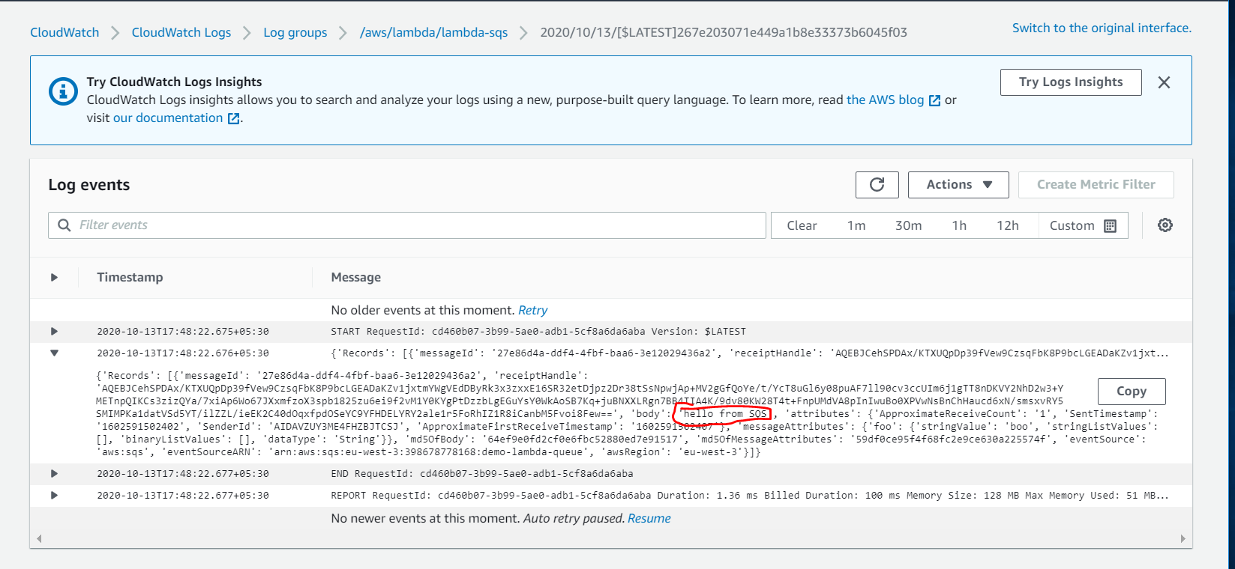)

**It showing message is successfully processed by lambda and then deleted from queue**

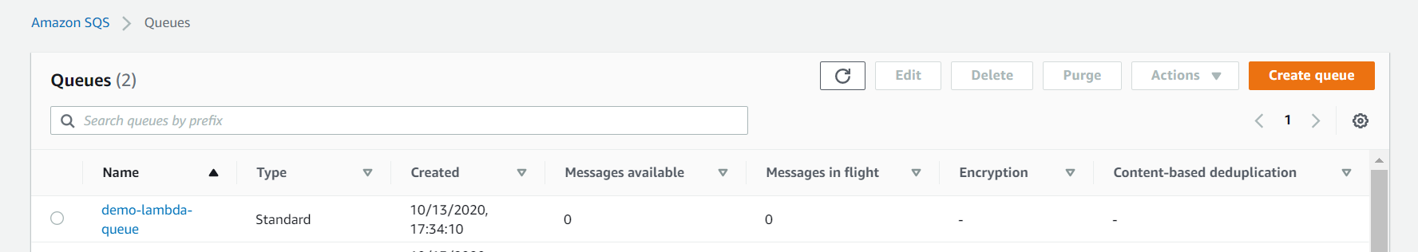

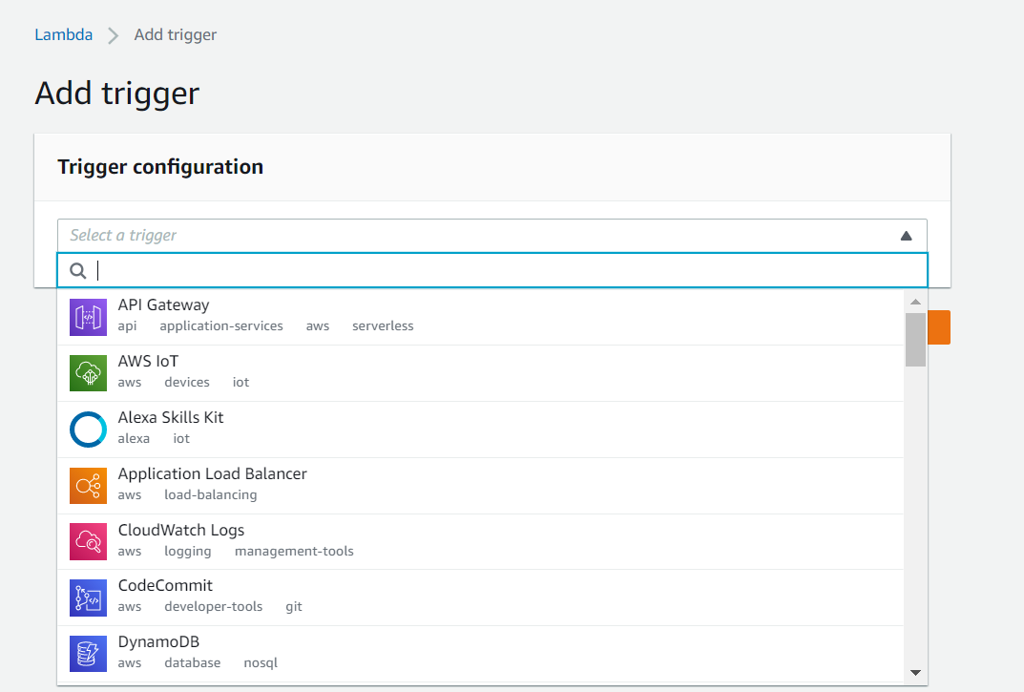

**Lambda Destination**

**Note: it very tough for asynchronous call to see whether it succeed or not so idea is that to send result of asynchronous to destination**

**Note: destination allow both successful and failure while DLQ allow only failure**

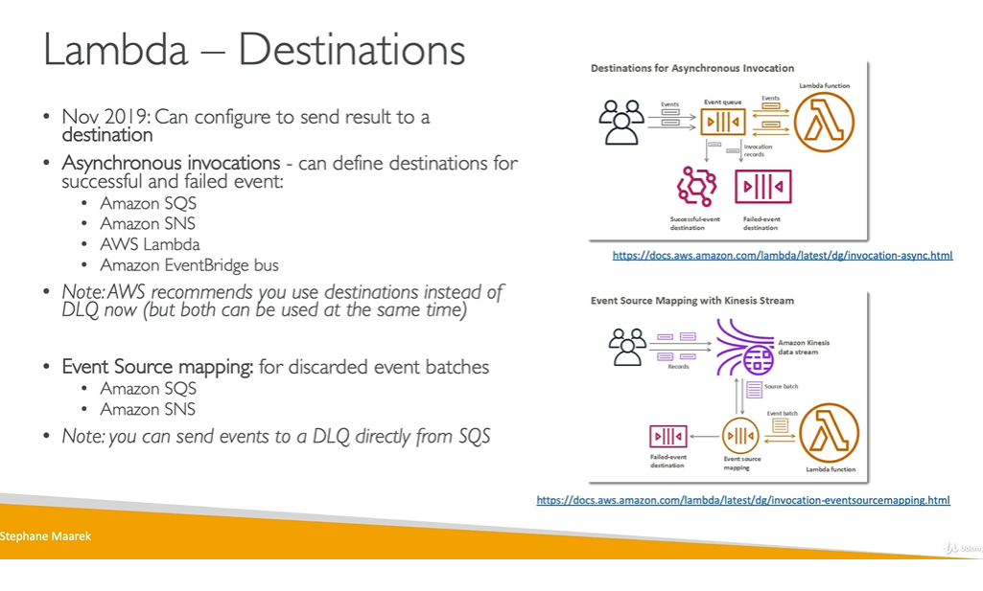

**Lambda destination hands on**

**Step1 ) click add destination**

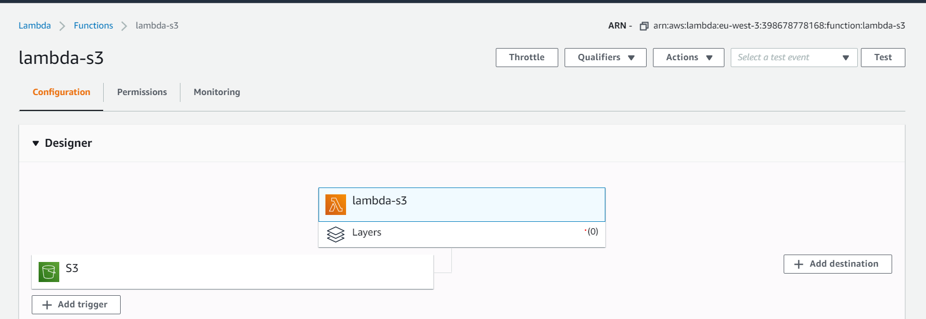

**Step 2) create both success and failure SQS**

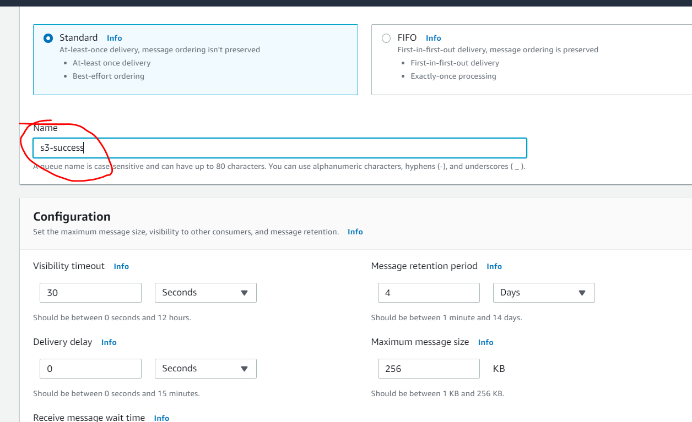

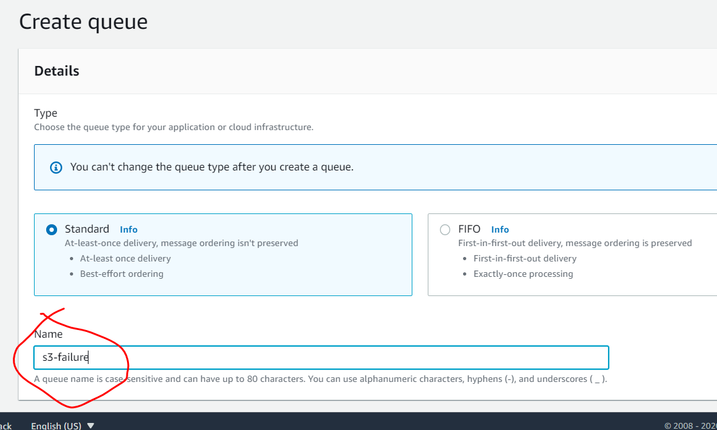

**Step 1 continue**

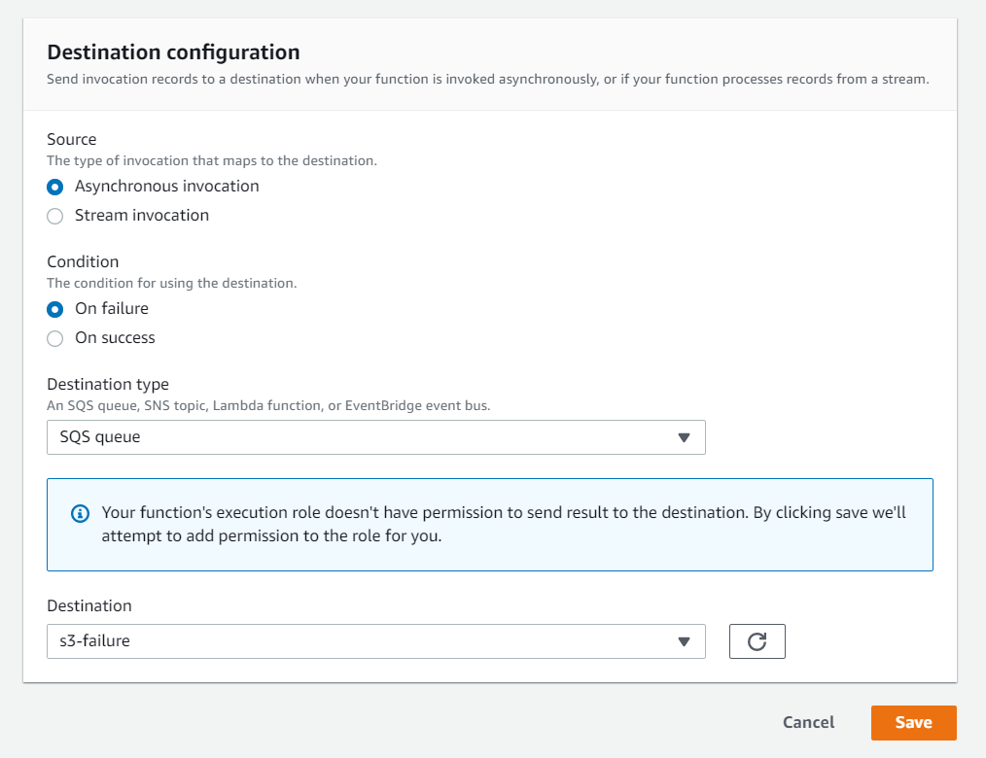

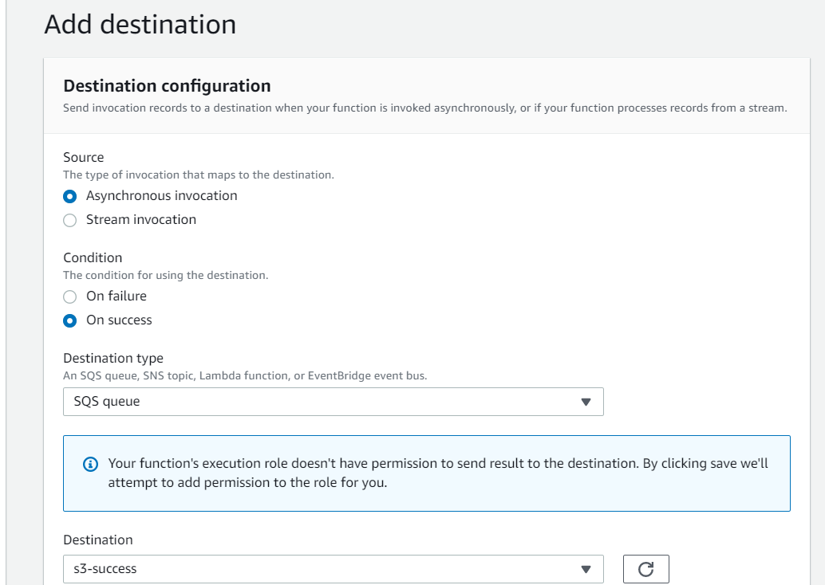

**Now two destination we have for failure and success**

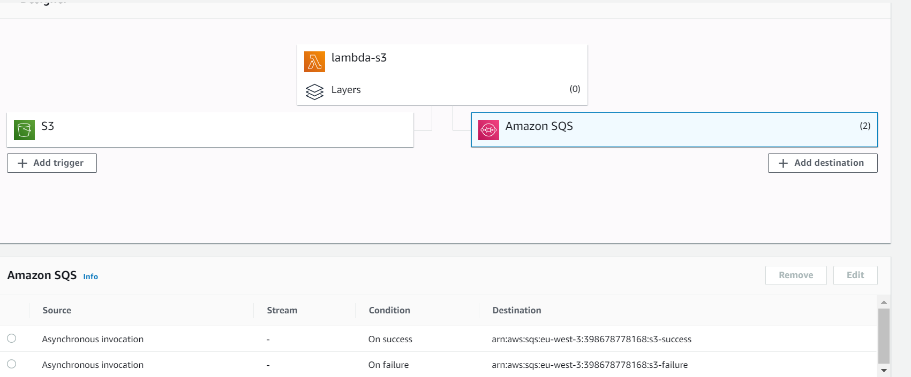

**Upload a file in s3**

**One message came in success**

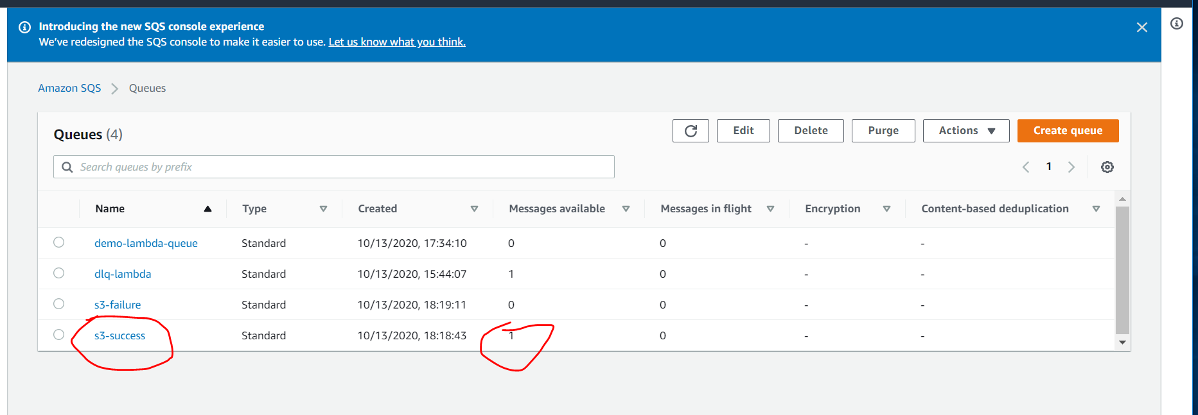

**Raise exception in code**

**Asynchronous so message will come after three reties**

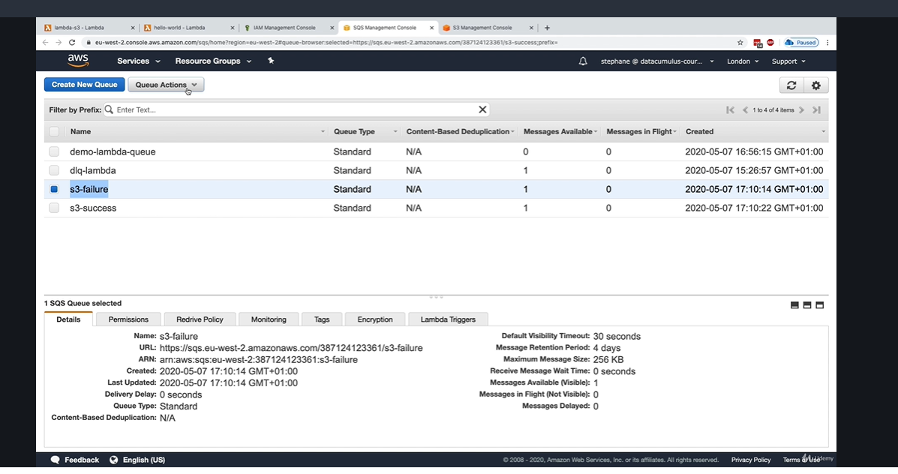

**Lambda Permission : IAM Roles and Resource Policies**

The AWS::Lambda::**EventSourceMapping** resource creates a mapping between an event source and an AWS Lambda function. Lambda reads items from the event source and triggers the function.

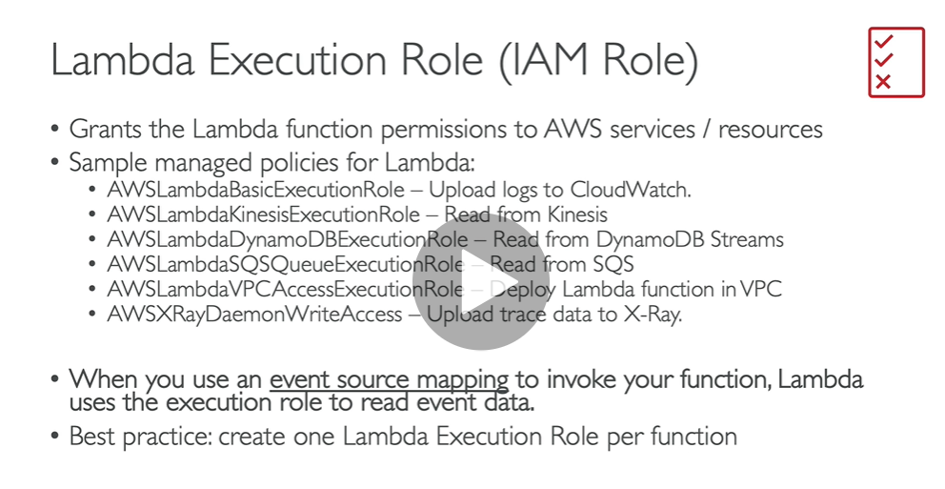

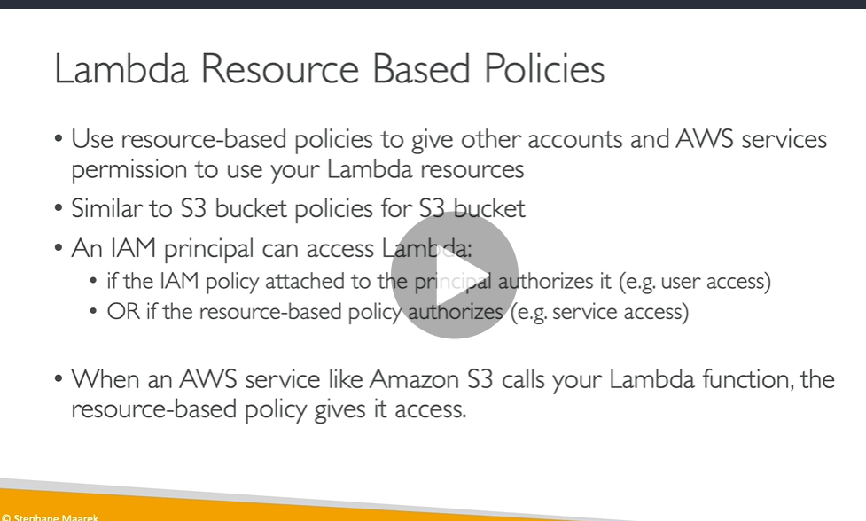

**Lambda invoking SQS so it is not a resource based policy**

**Lambda environment Variables hands on**

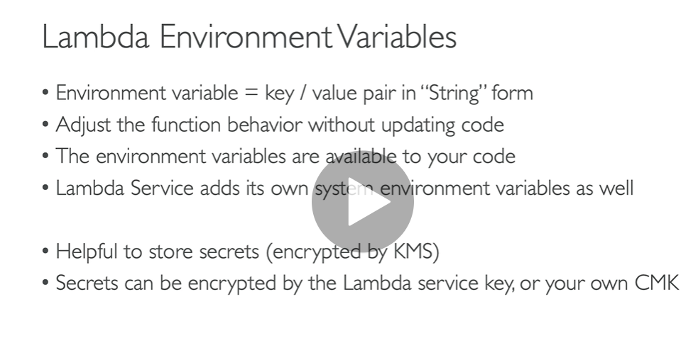

**Hands on**

**Pass environment variable to lambda function**

**Step:**

**Create function**

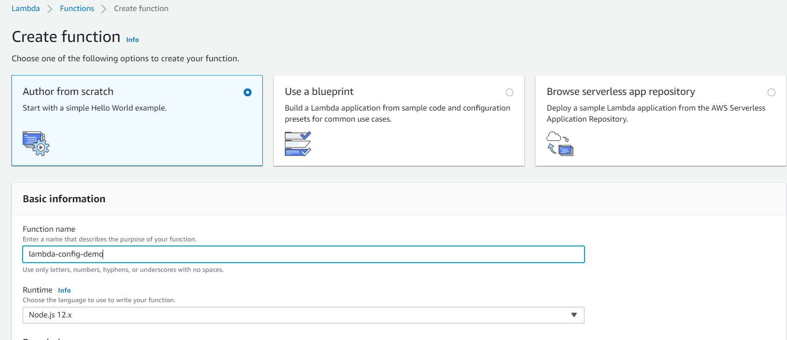

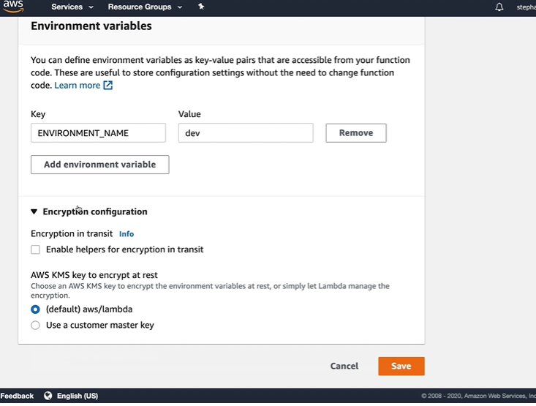

**How to retrieve it**

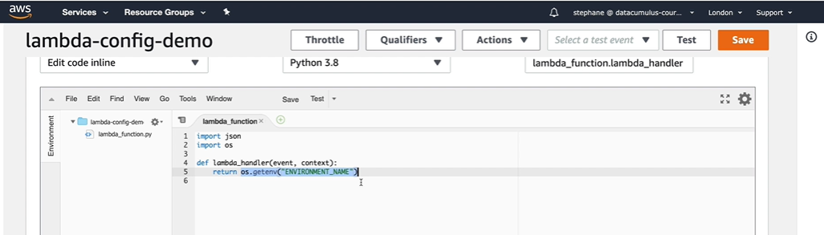

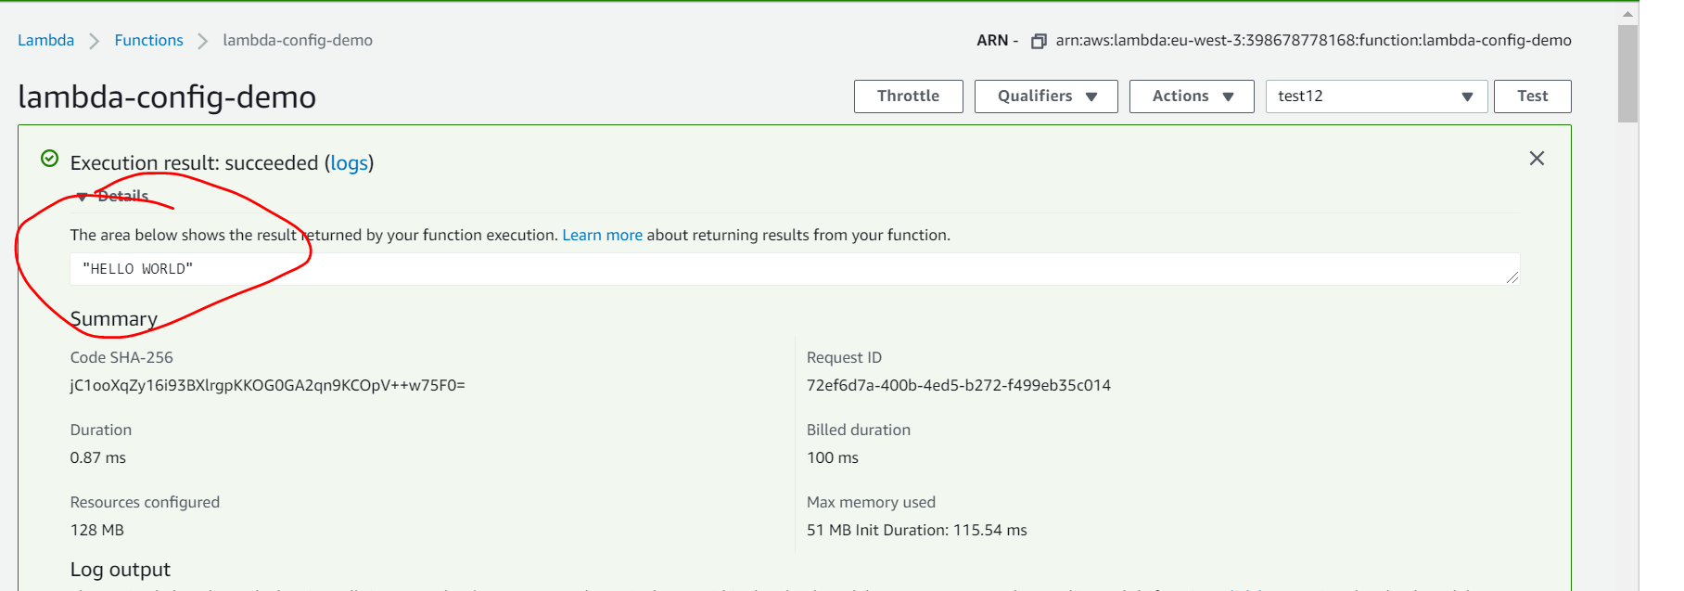

**Lambda monitoring and xray tracing**

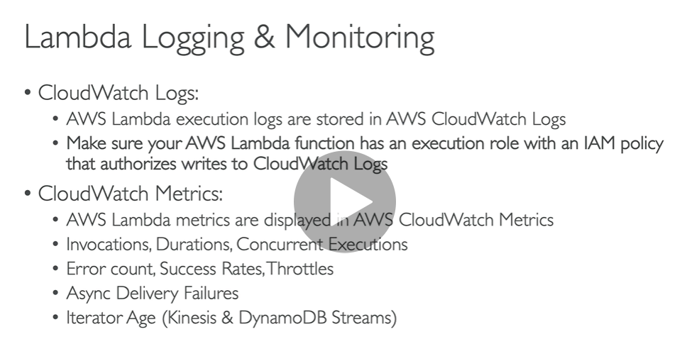

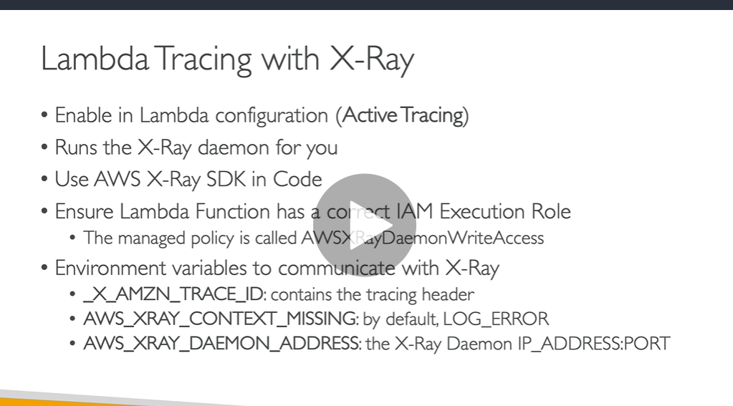

**To enable traces with x rays**

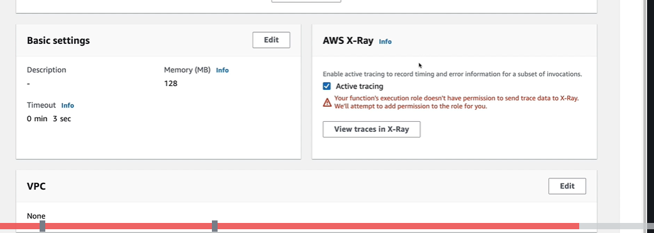

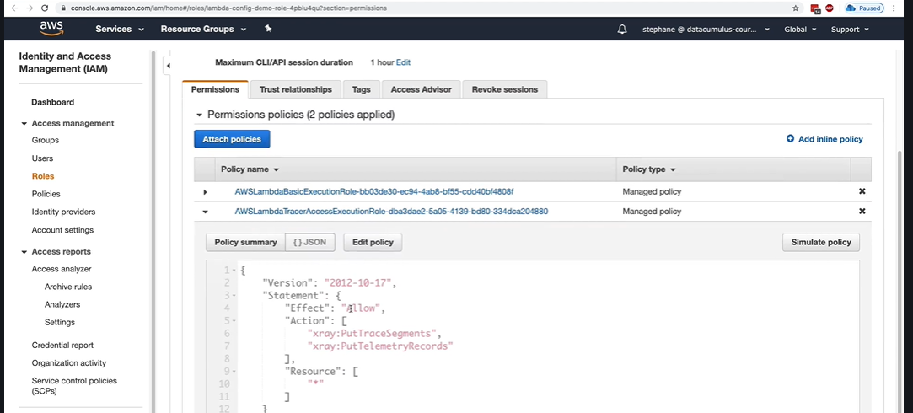

**Lambda in VPC**

**Important : lambda function is launched outside VPC**

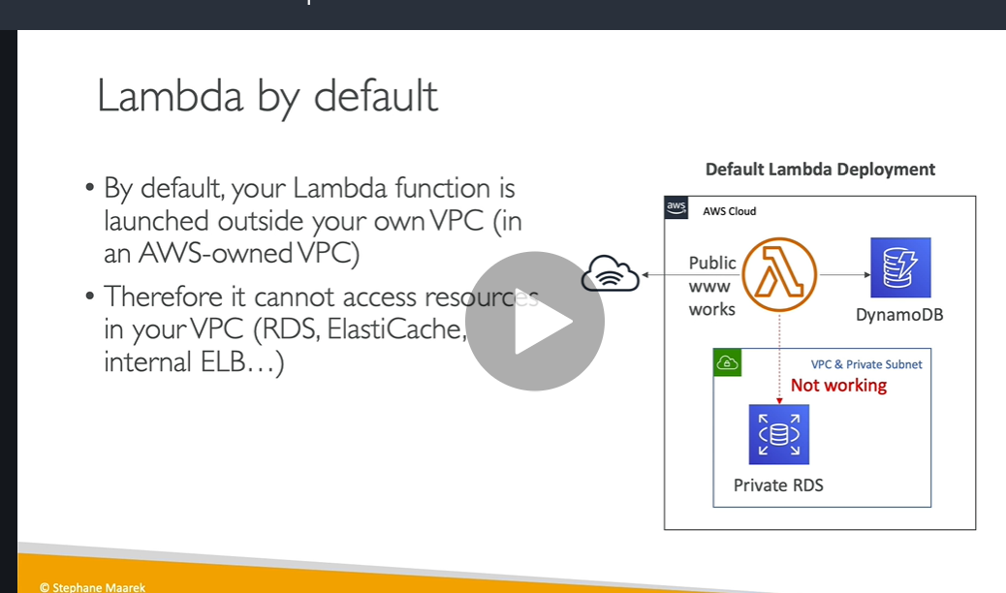

**Solution: we can deploy lambda in VPC**

**Note: to access RDS lambda will go through ENI(elastic network interface) which will created internally**

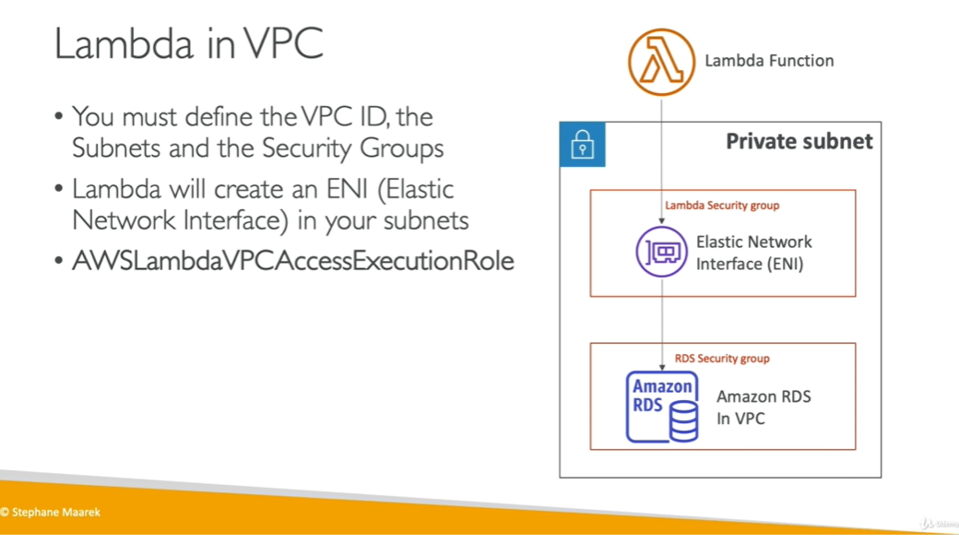

**Important**

**All these configure through route tables:**

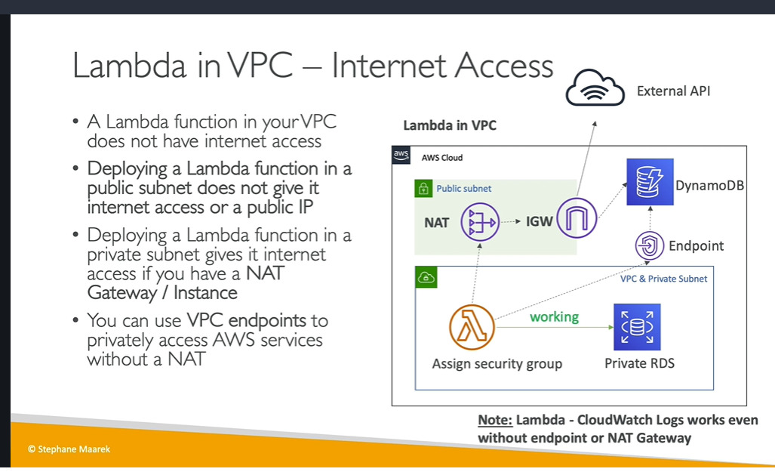

**Hands on**

**Step 1) create function lambda-vpc**

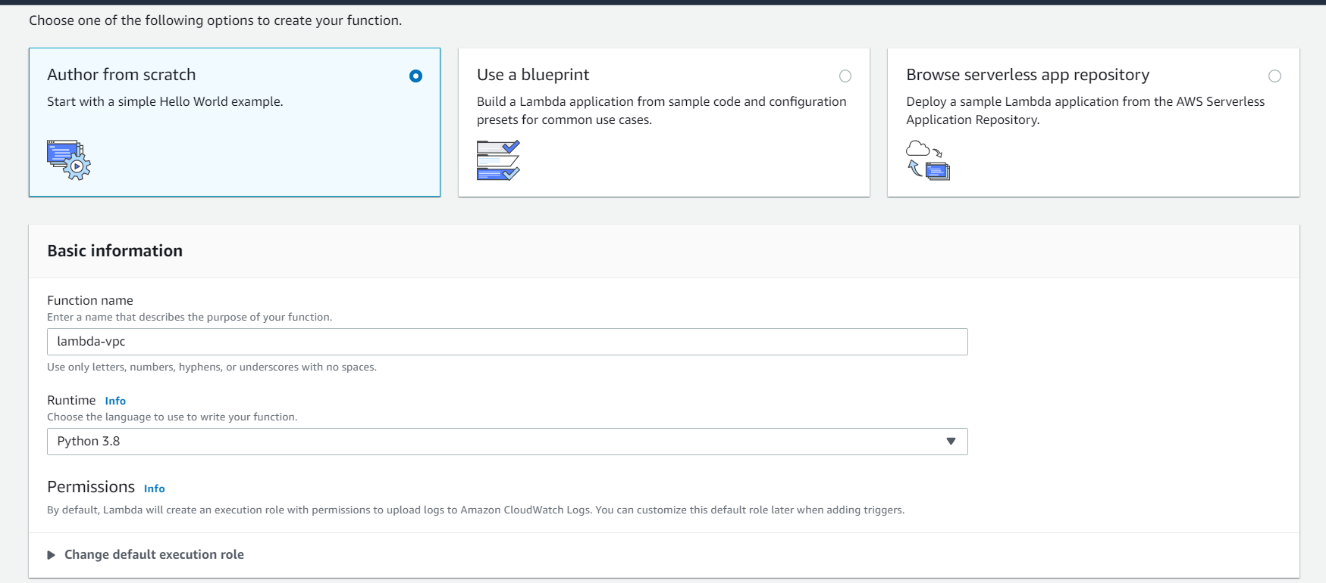

**Step 2**

**Click on vpc and edit**

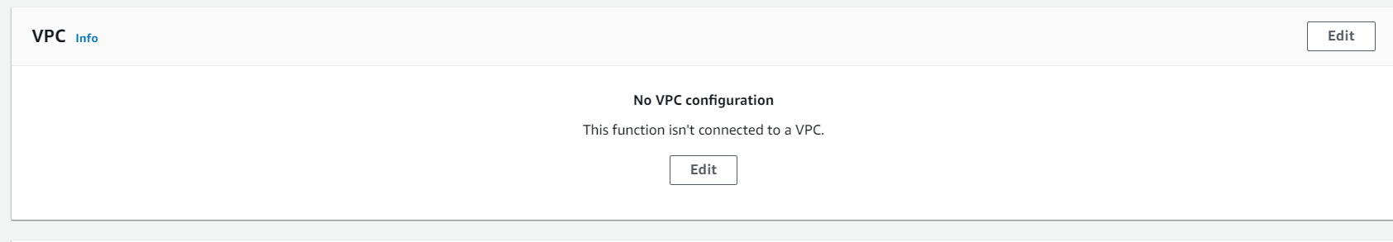

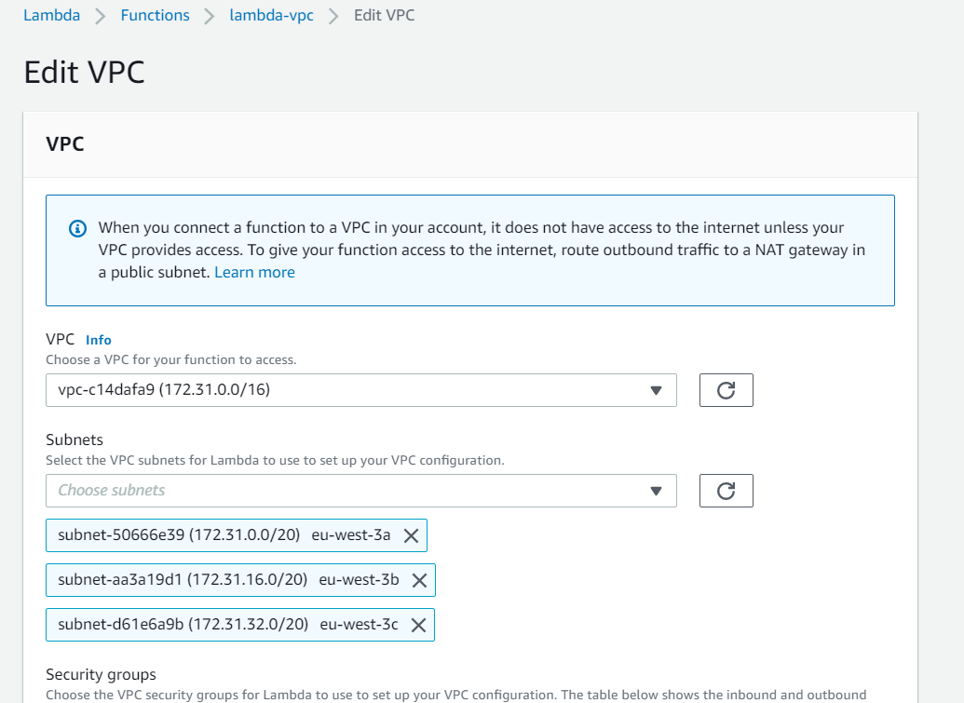

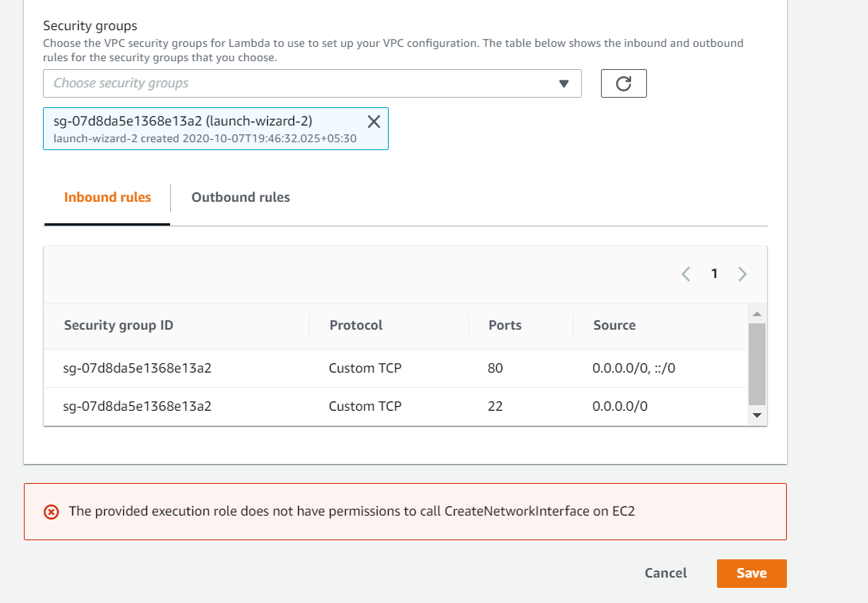

**Attach policy to create ENI**

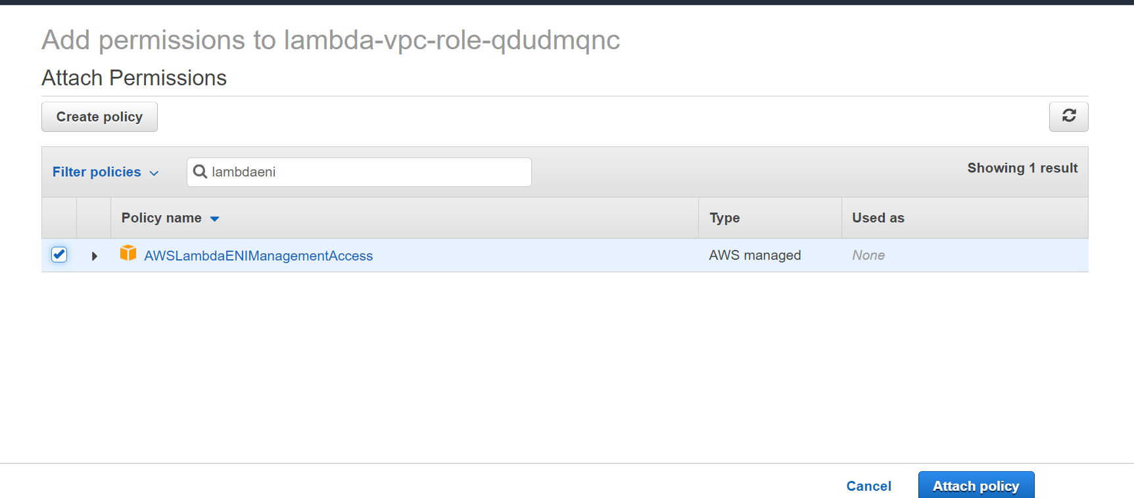

**Now this lambda is deploy in VPC and have access to EC2 and RDS database**

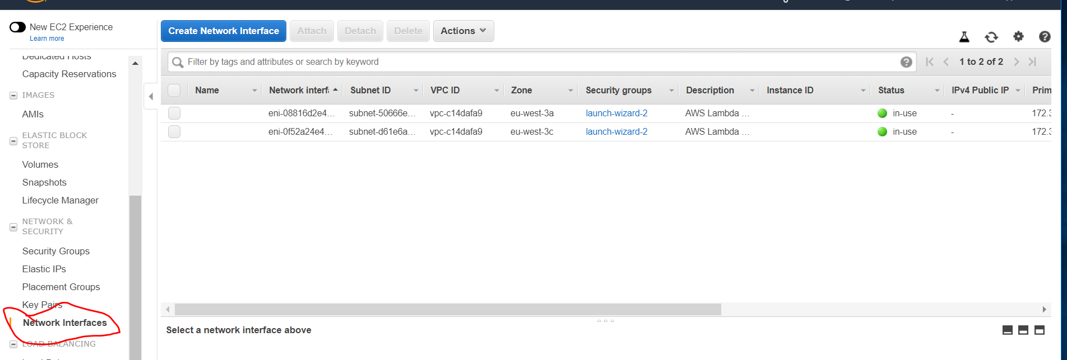

**Lambda function Performance**

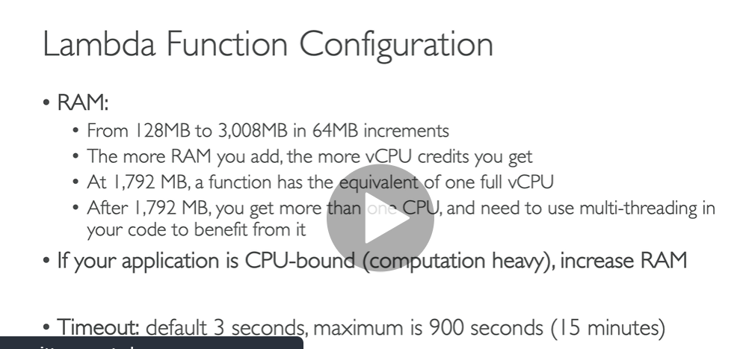

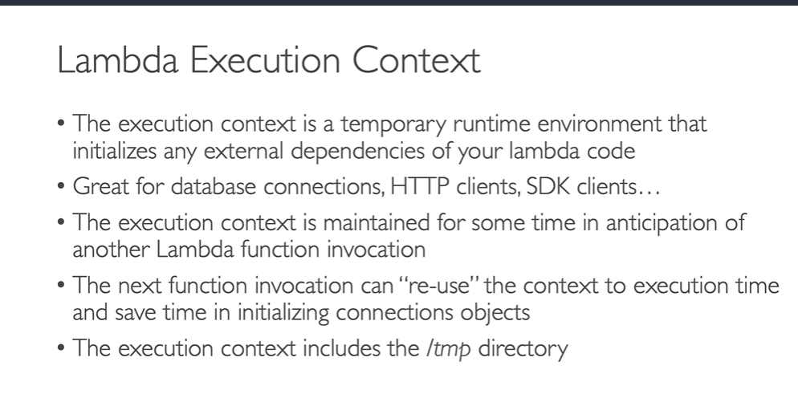

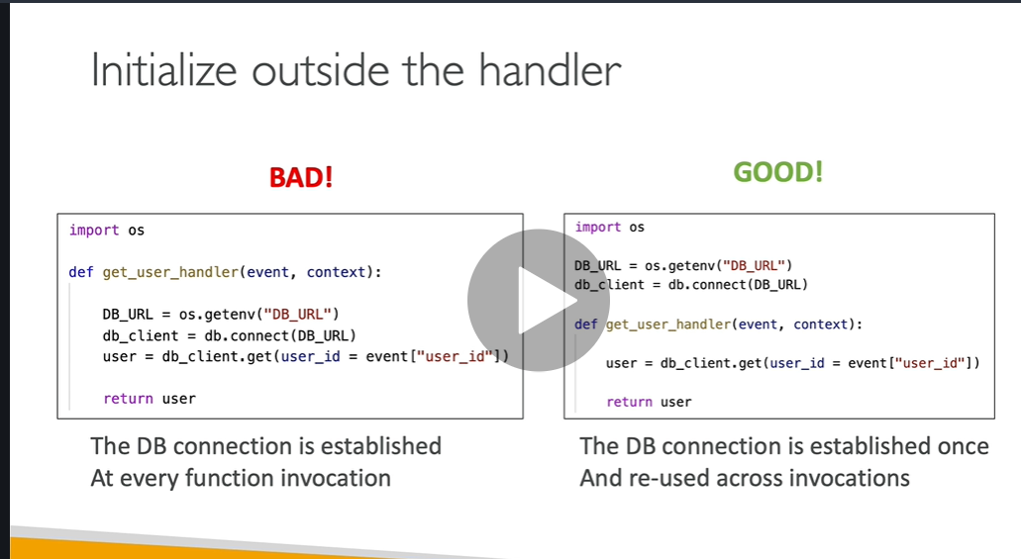

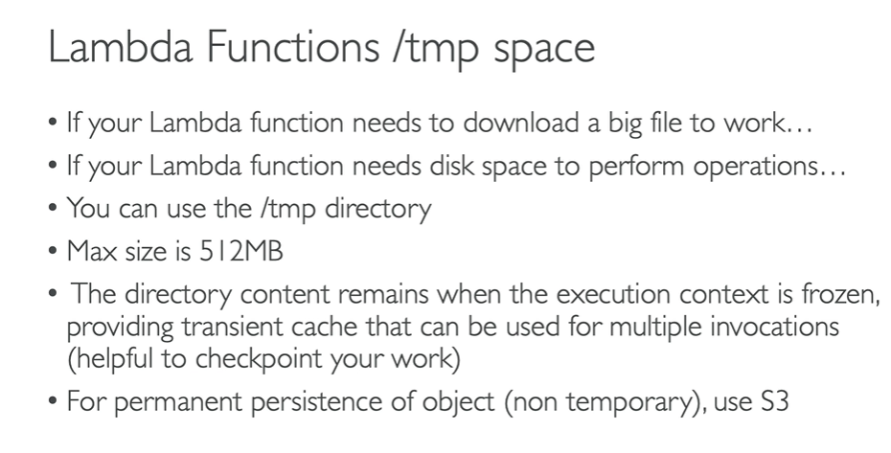

**Hands on**

**We can set memory and timeout ( default 3sec and max 15 minutes)of lambda function**

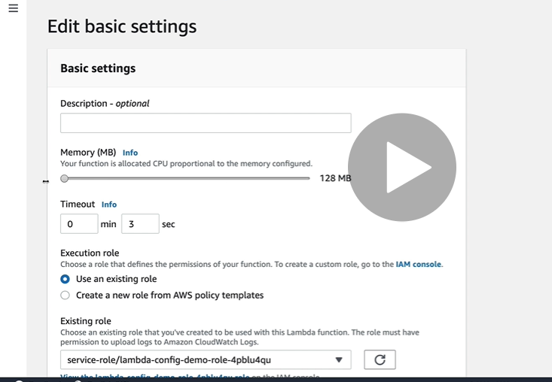

**Sleep 5 second**

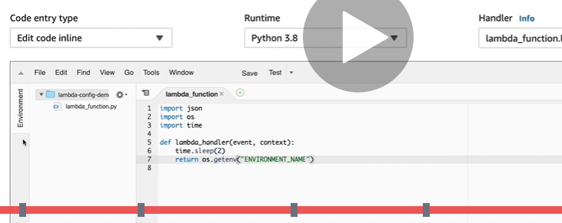

**This is directly linked to timeout**

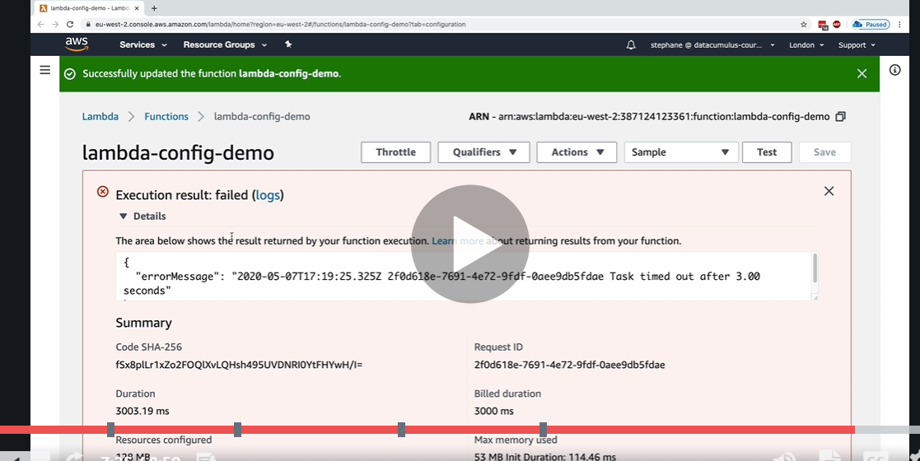

**Change timeout to 6 second**

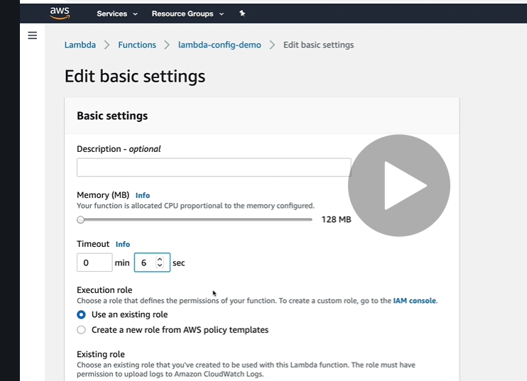

**Now the execution is successful**

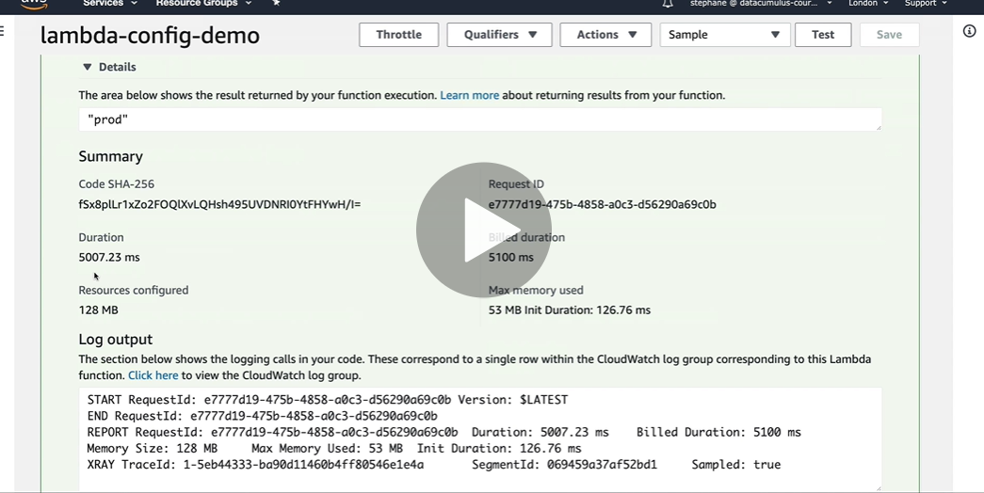

**As per function we can set timeout setting**

**Lambda Concurrency**

**Note : for each lambda function we can set limit( means upto this lambda function can scale) if it exceed it will throw a throttle**

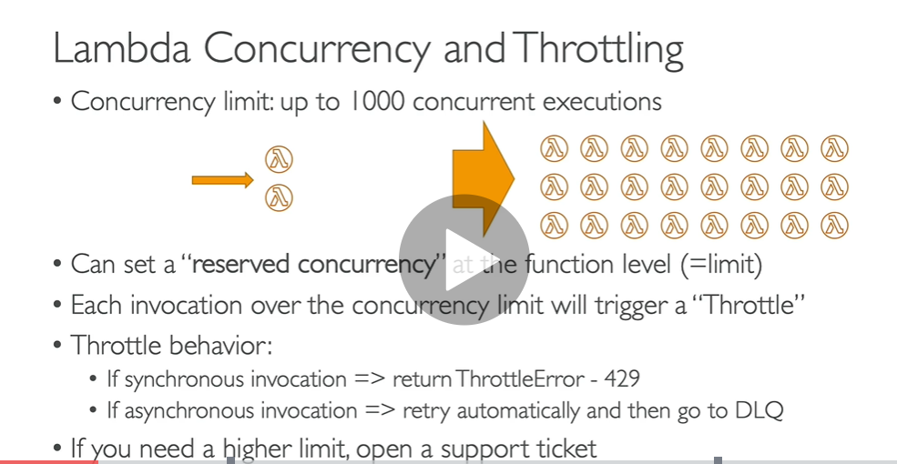

**Note :**

**If one function goes over limit other function can get throttle**

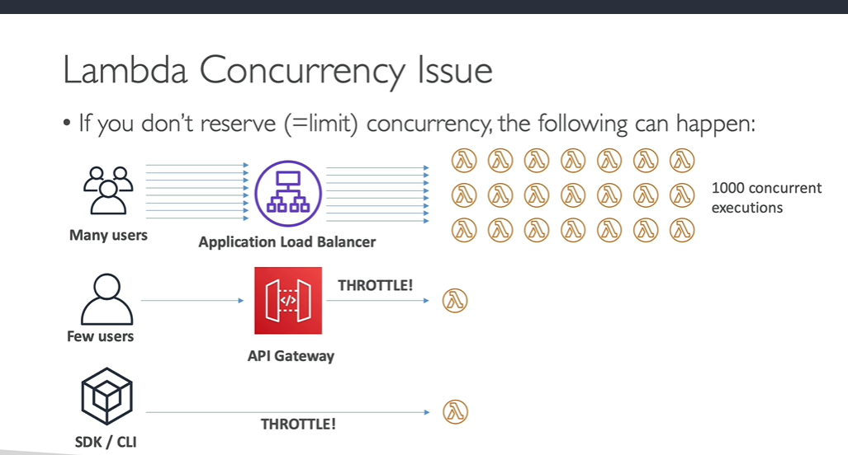

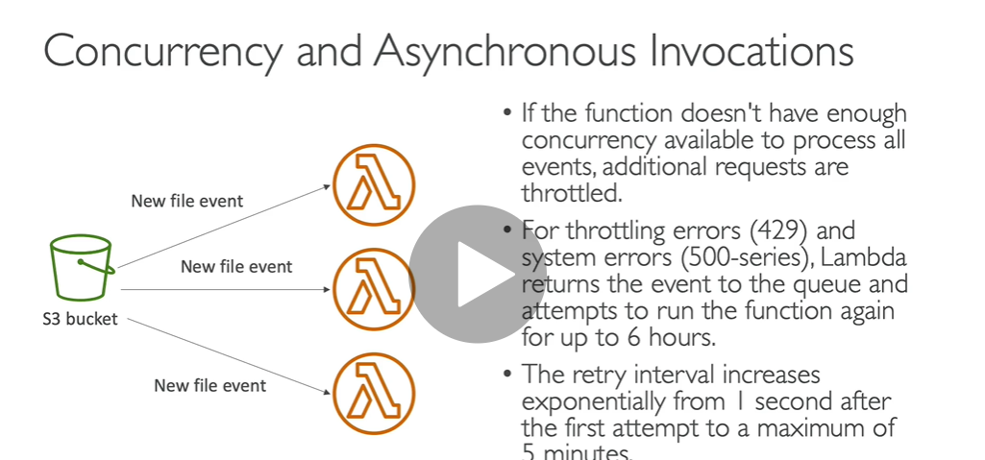

**AWS** can drop the container after a period of inactivity, and your function becomes inactive or **cold**. A **cold start** happens when you execute an inactive Lambda function. The execution of an inactive Lamda function happens when there are no available containers, and the function needs to **start** up a new one.

This article describes **AWS Lambda**—the dynamically scaled and billed-per-execution compute service. Instances of Lambdas are added and removed dynamically. When a new instance handles its first request, the response time increases, which is called a **cold start**

**Concurrency** is the number of requests that your function is serving at any given time. When your function is invoked, **Lambda** allocates an instance of it to process the event. ... As your function scales up, this causes the portion of requests that are served by new instances to have higher latency than the rest.

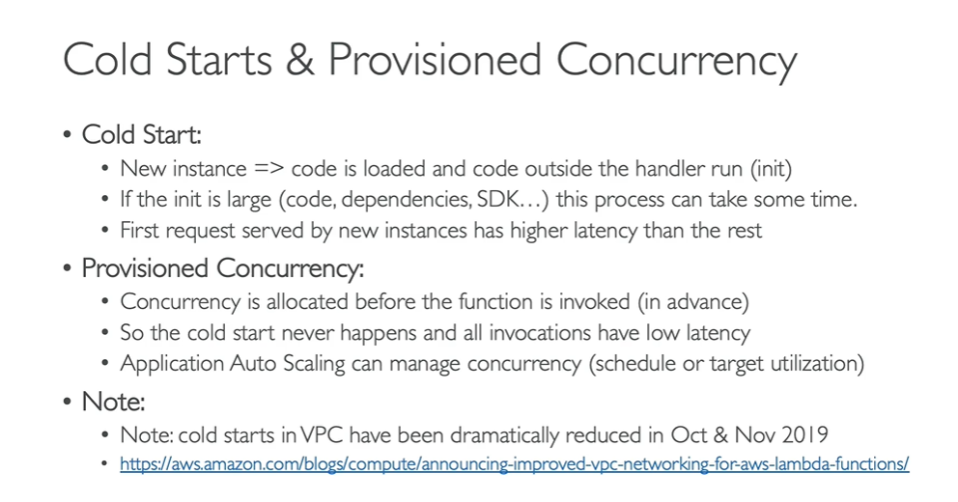

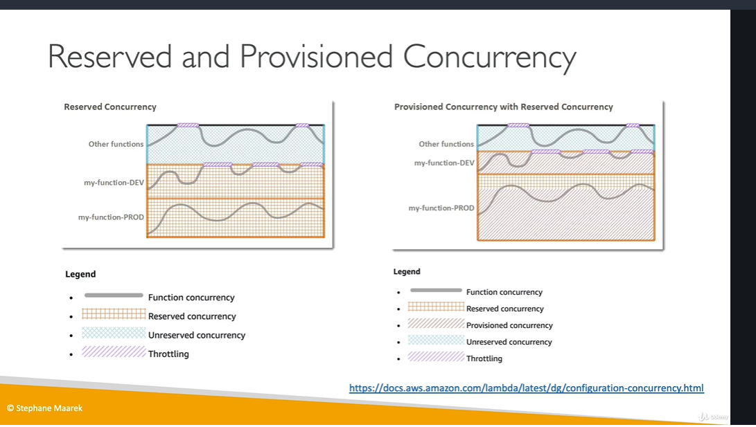

Lambda Concurrency hands on

Each account has a concurrency limit in **Lambda**. This limit specifies the number of **function** invocations that can be running at the same time. When the concurrency limit is hit, **Lambda** will not invoke a **function** and will **throttle** it instead

**Means maximum 20 concurrent execution of this function can happen**

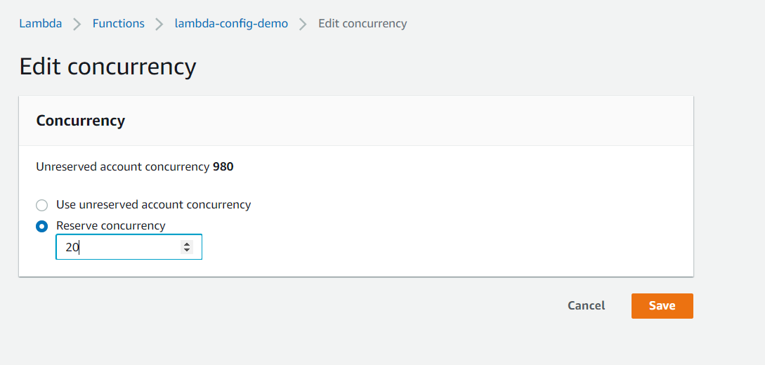

Lambda Function Dependencies

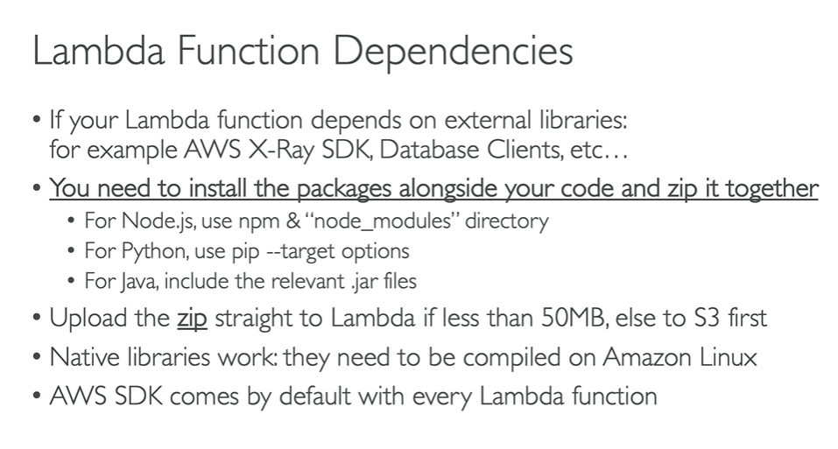

**Hands on**

**step 1)Create function**

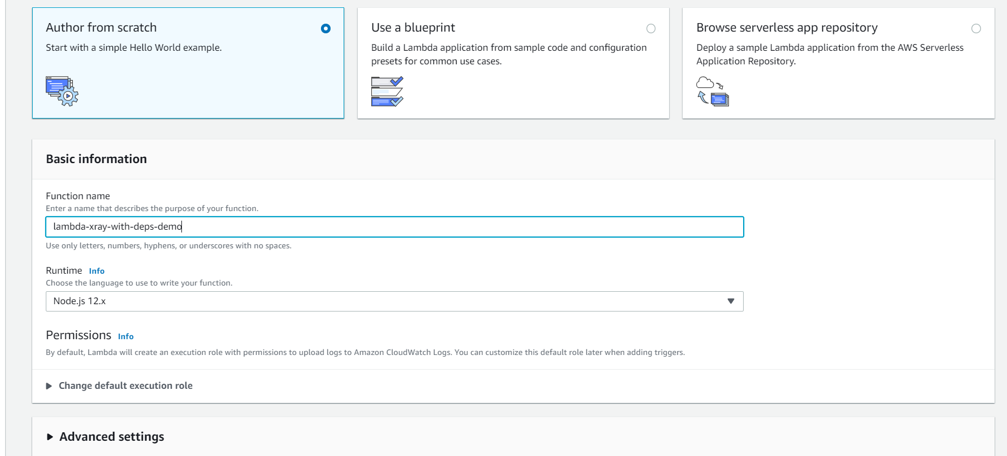

**Step 2) lambda function is created we need to upload code(zip file)**

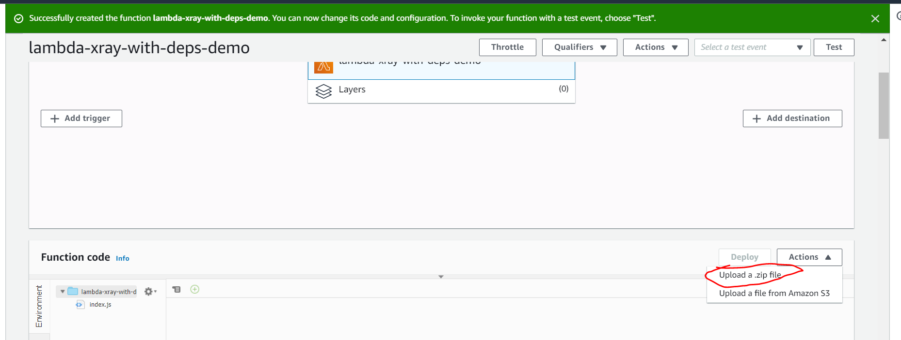

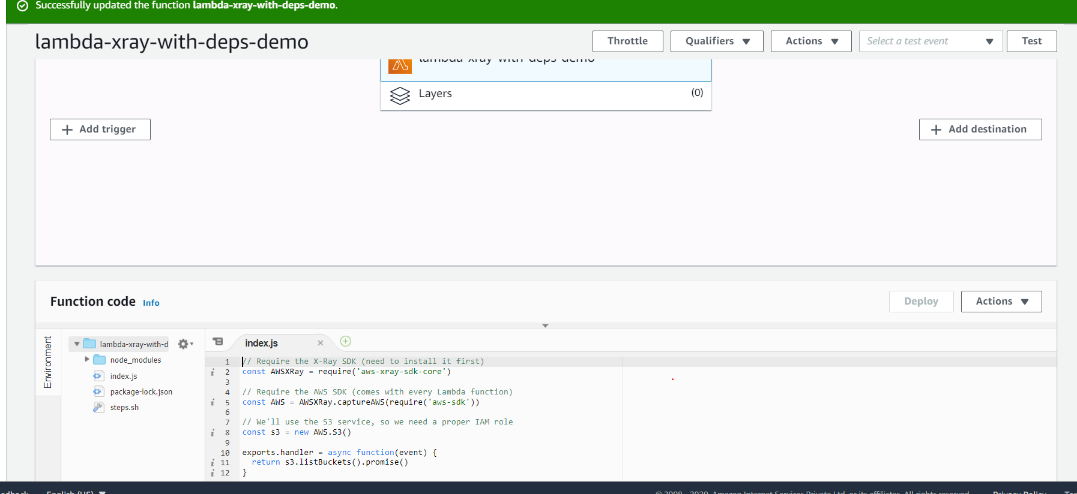

**From above code we need to give access to xray and s3**

**notes: enable xray**

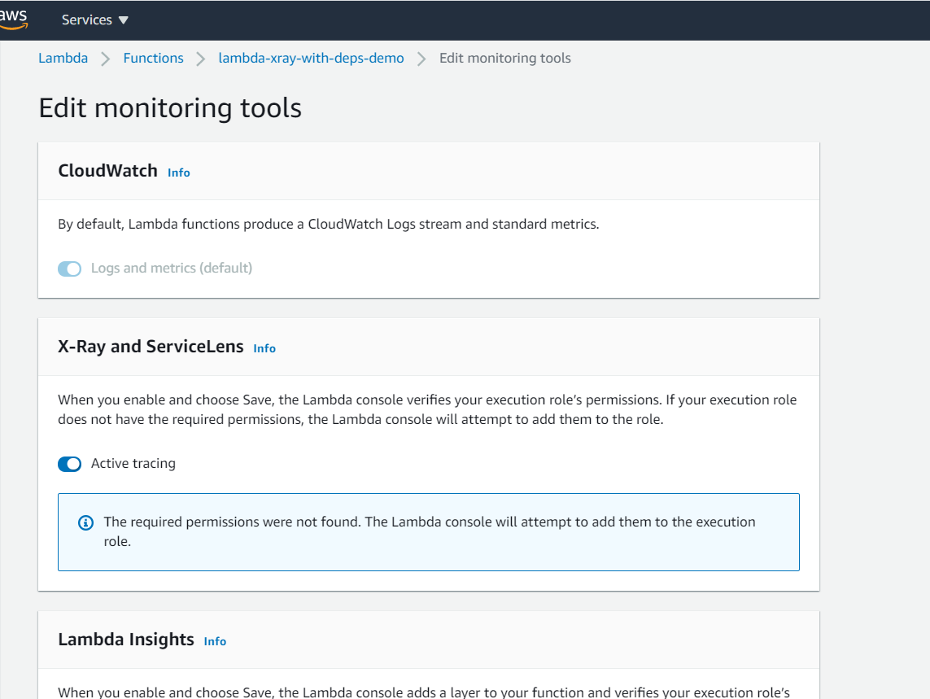

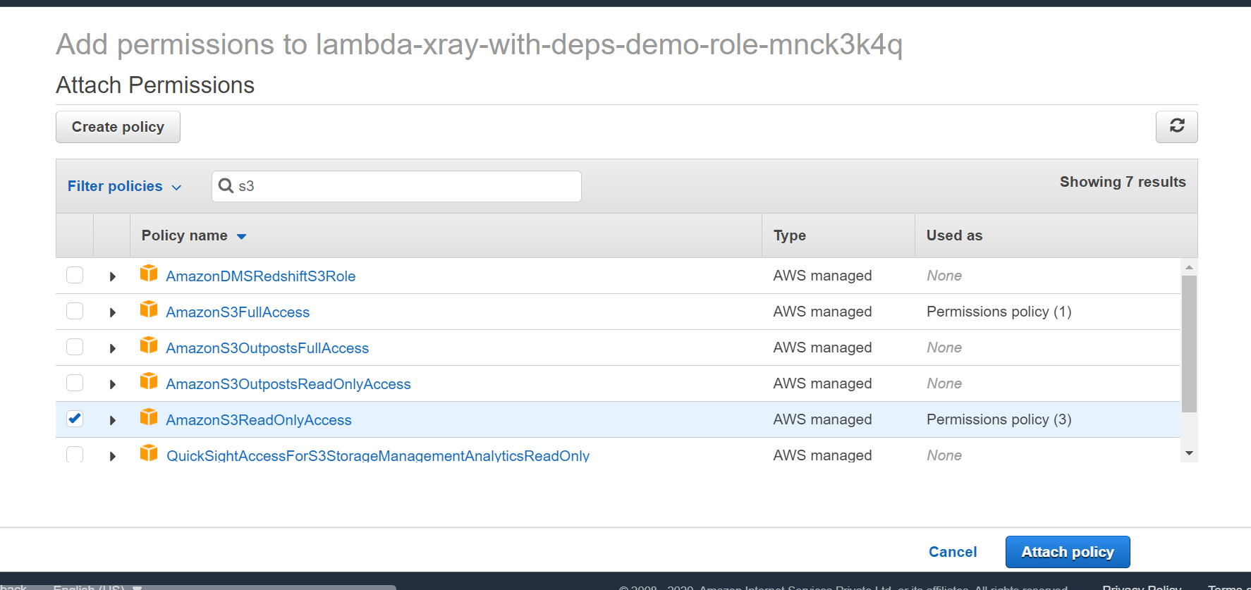

**In permission tab we can check what access we have**

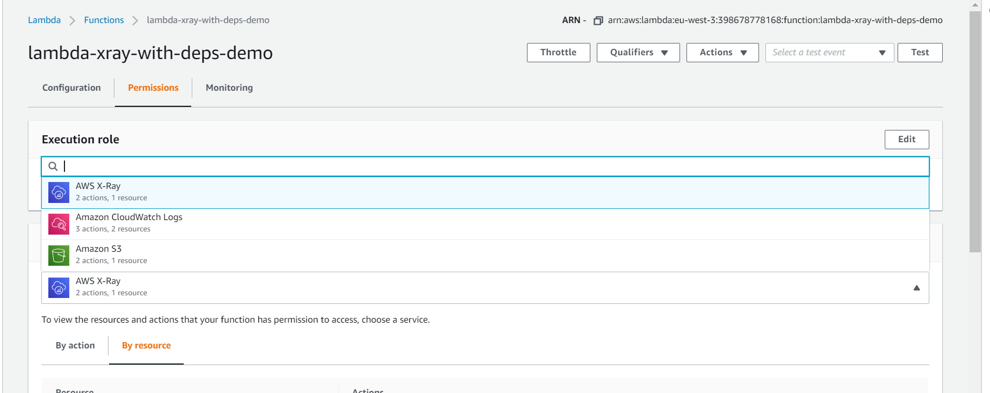

**Getting list of all bucket**

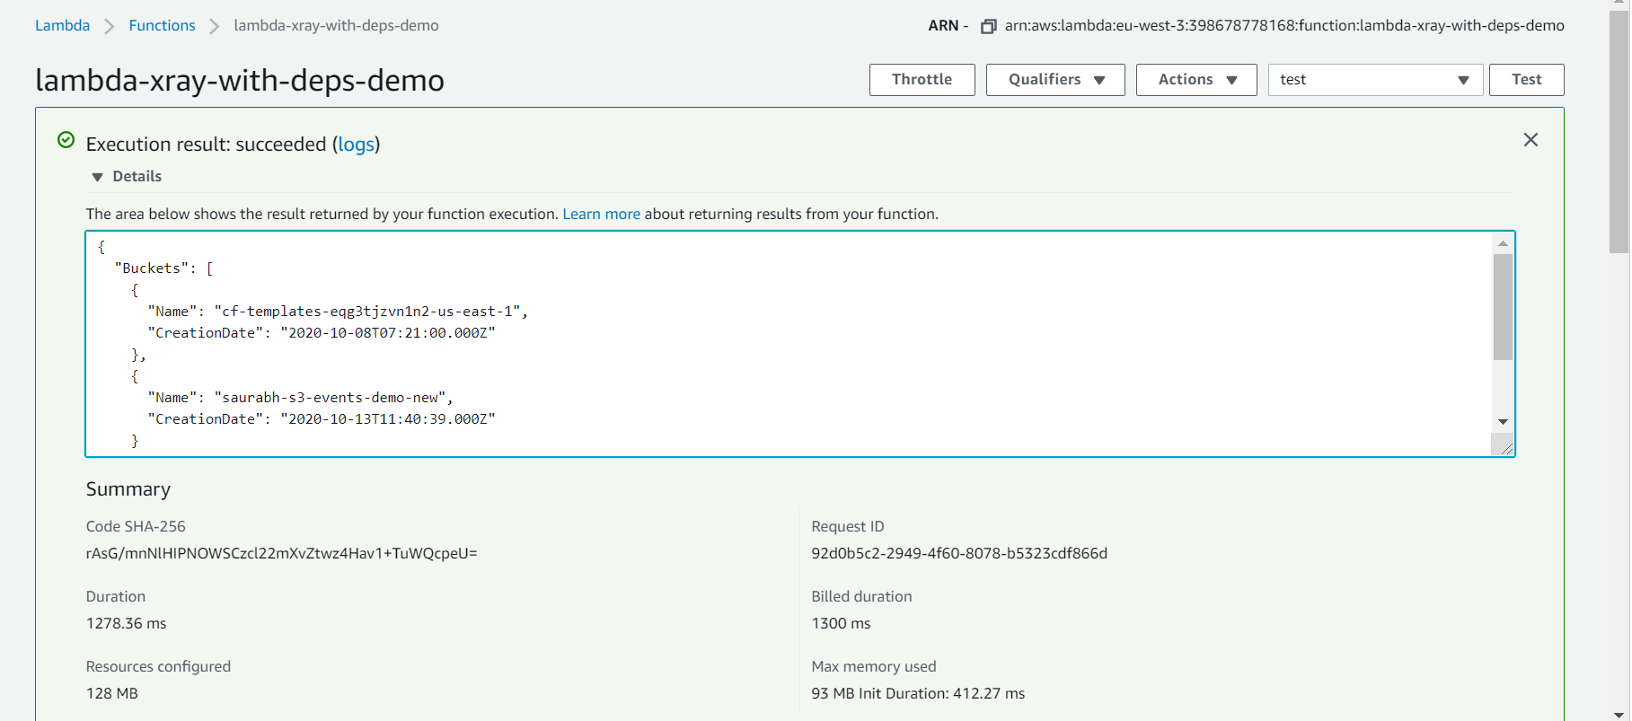

**Xray graph**

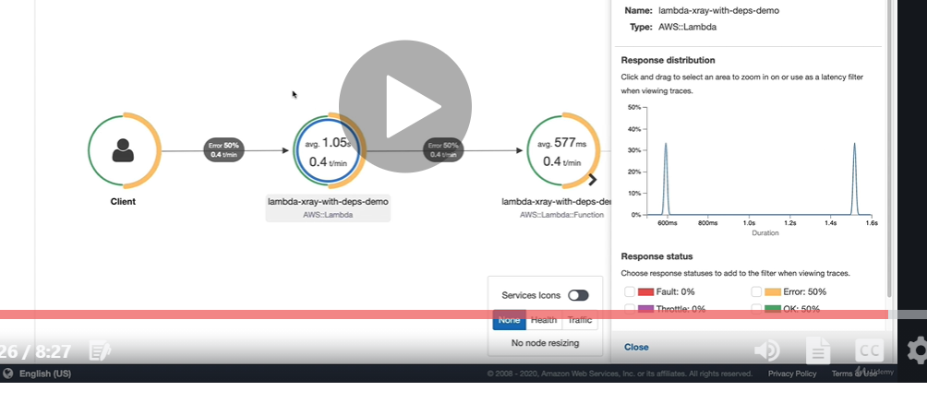

**Lambda and cloudformation**

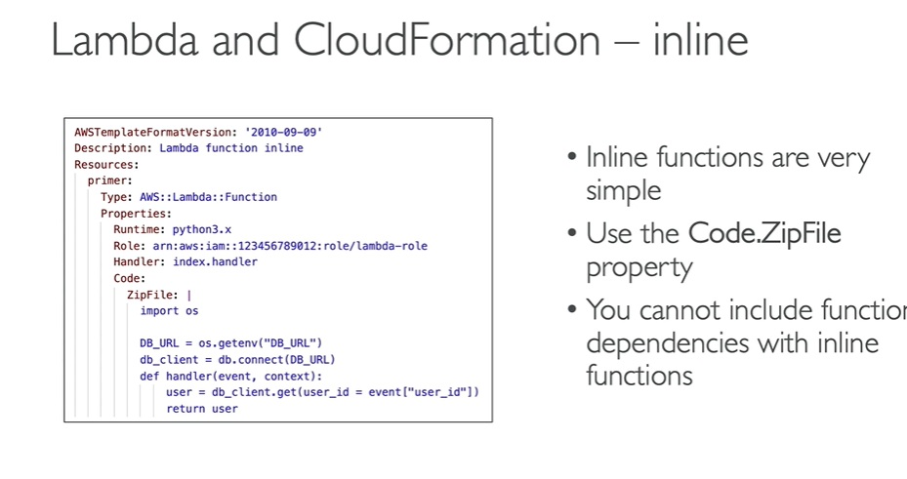

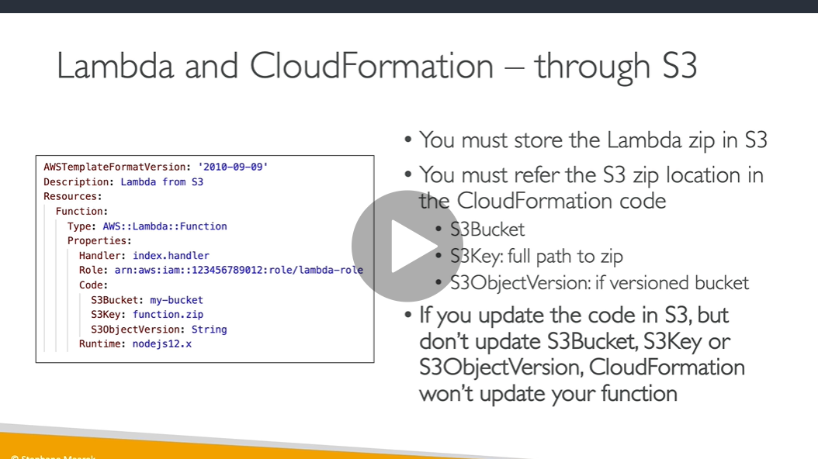

**Lambda will upload in s3 and from there cloudformation will pick up**

**Note : cloudformation can do all the configuration of lambda**

**Demo :**

**Step 1) create bucket and enable versioning**

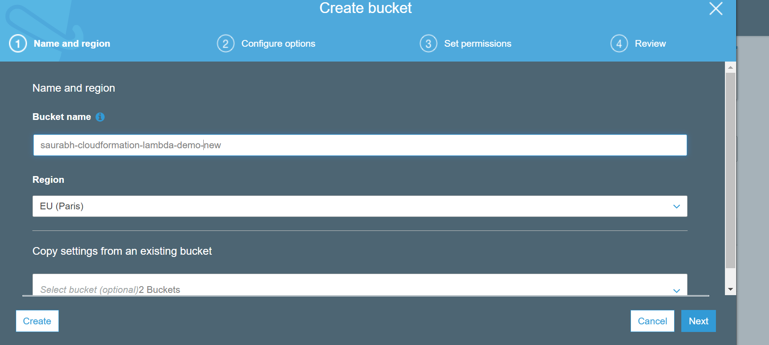

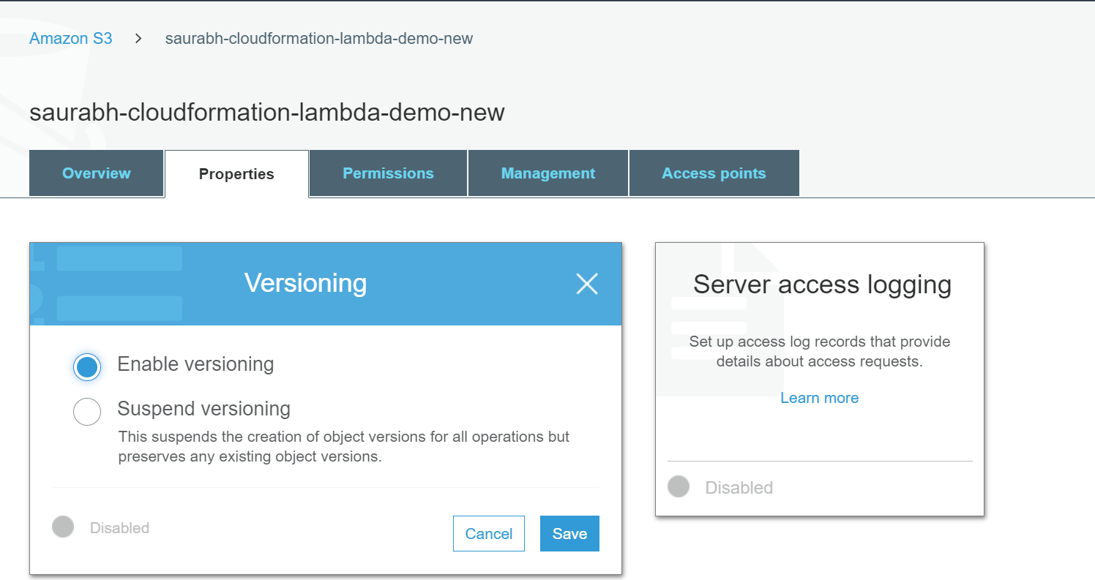

**Upload function code in s3**

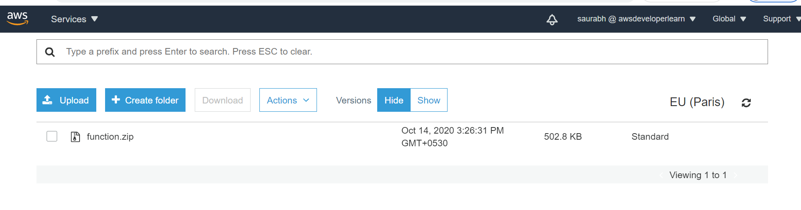

**Step 2) go to cloudformation ) upload-lambda-xray**

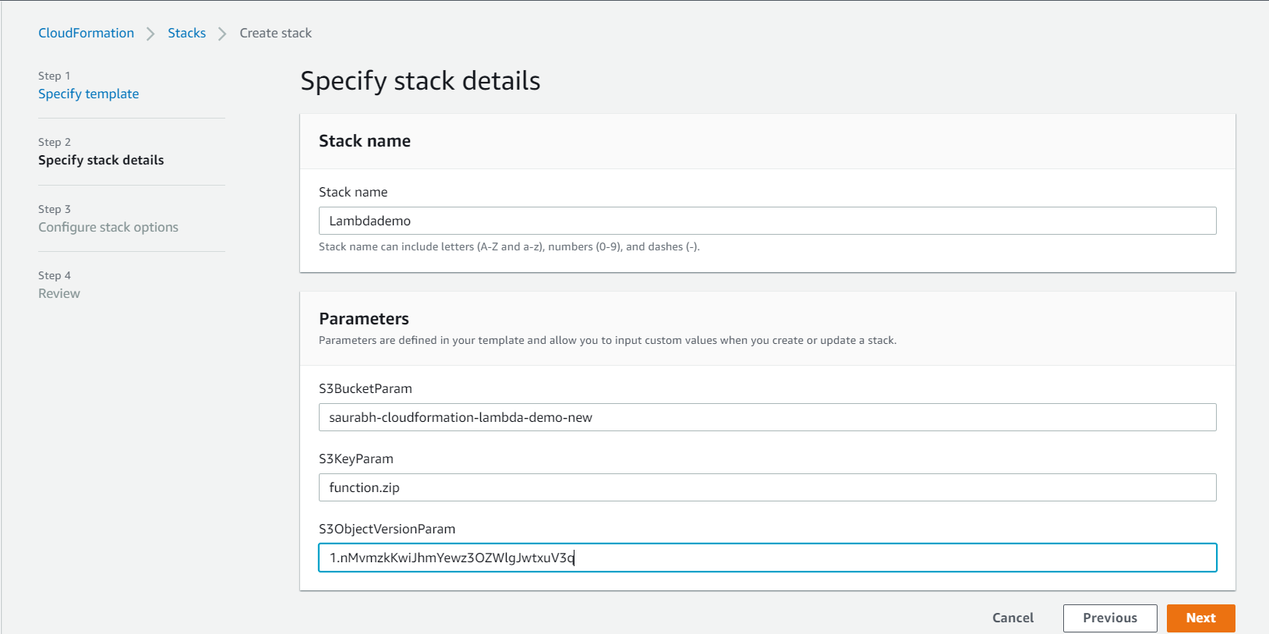

**Acknowledge to create IAM role for cloudformation**

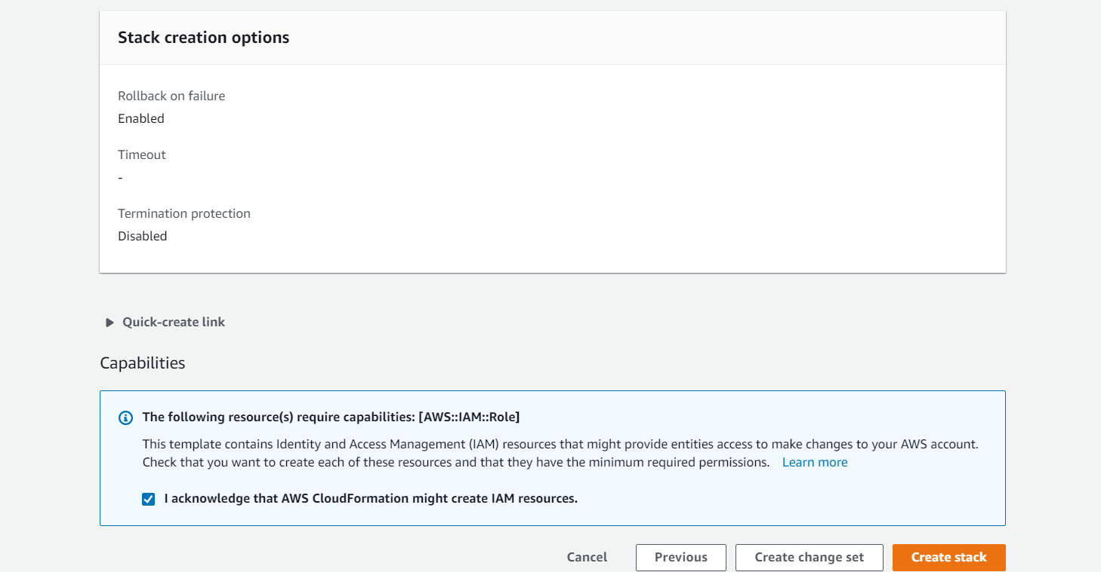

**Step 3) below lambda function is created by cloudformation**

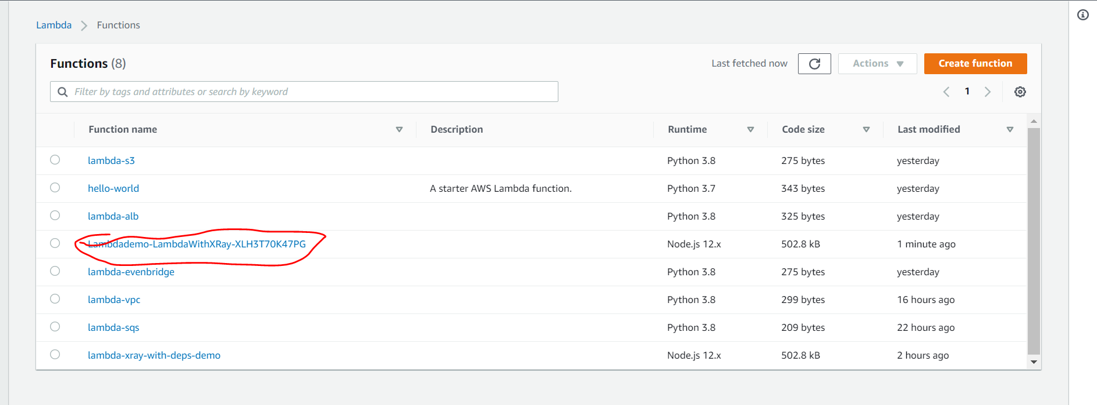

**Test the function we will see entire bucket**

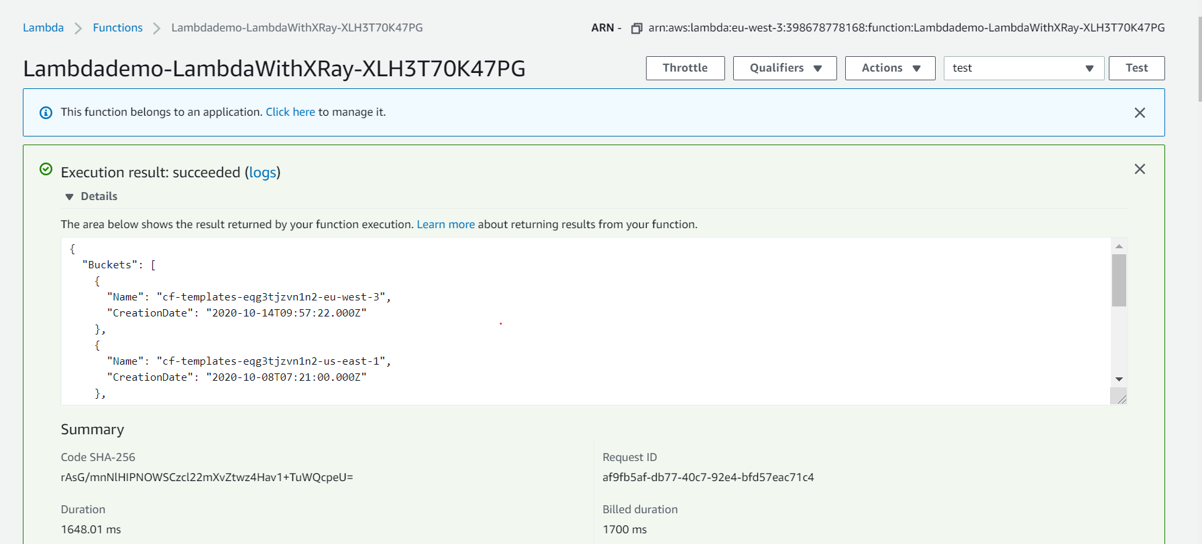

**Lambda layers**

**Note : packaging our dependencies in layer and reuse them using lambda function**

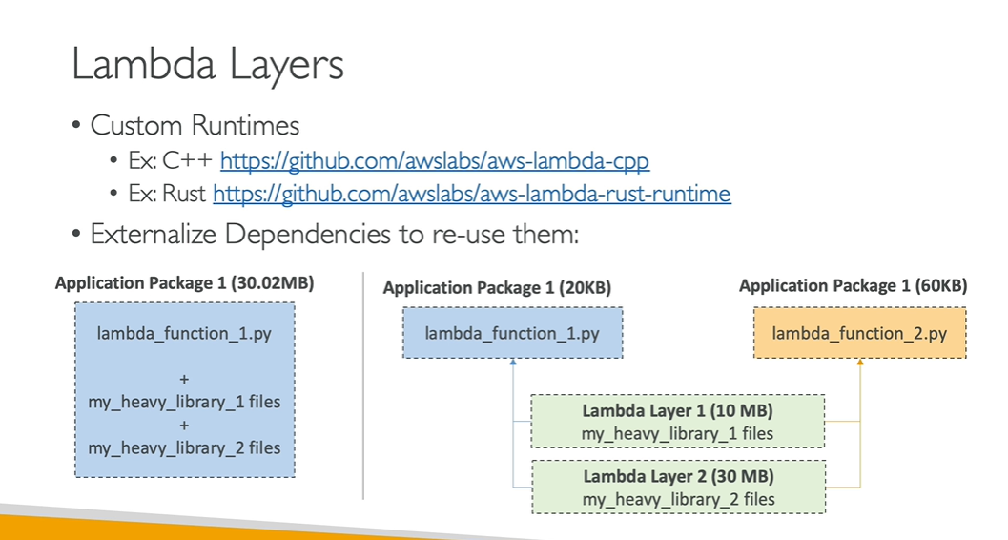

**Hands on**

**Step 1) create function**

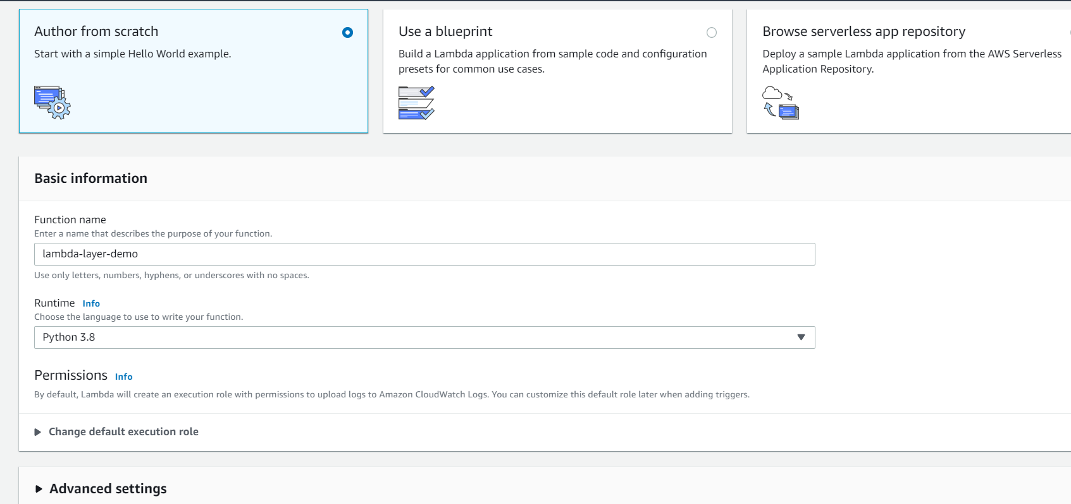

**As of now it is showing 0 layer**

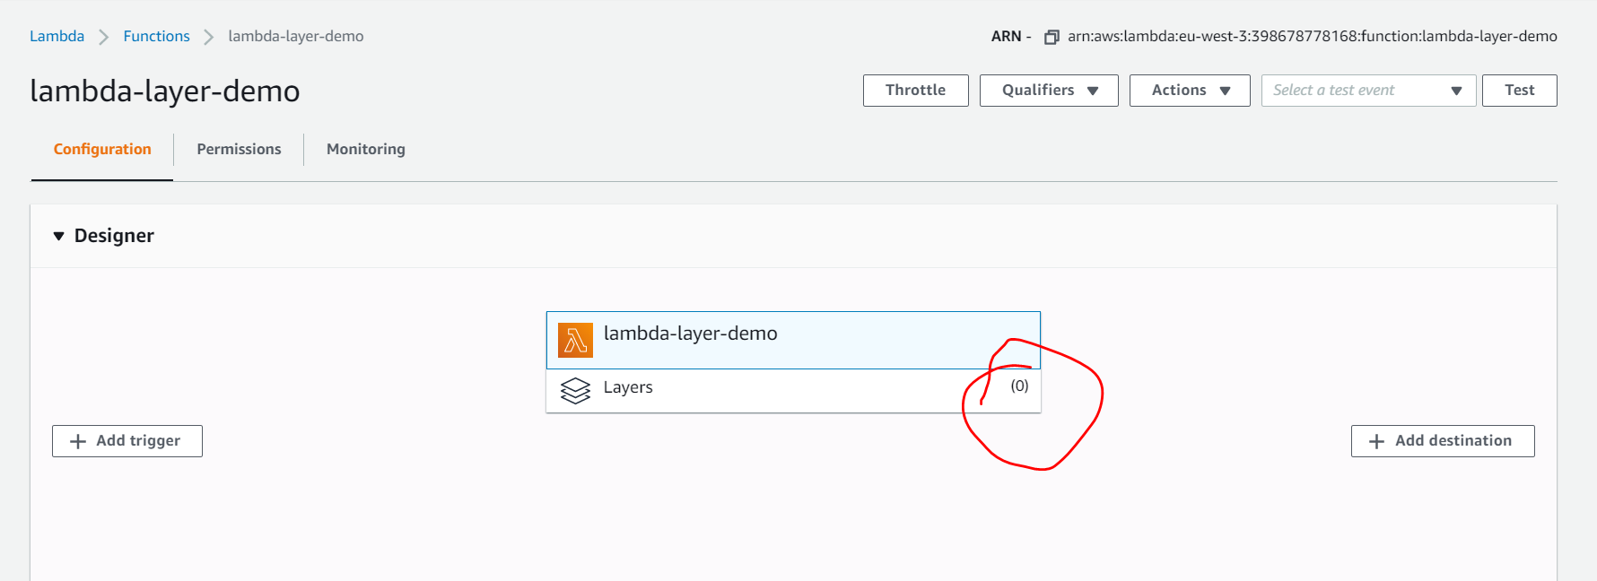

**Click on add a layer**

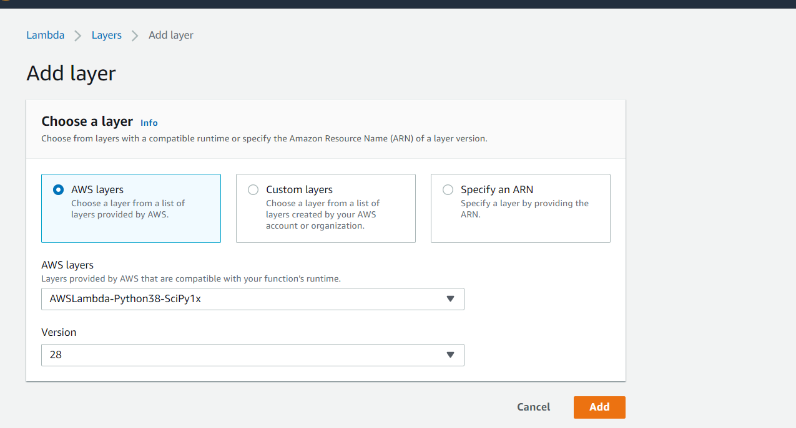

A **layer** is a ZIP archive that contains libraries, a custom runtime, or other dependencies. With **layers**, you can use libraries in your function without needing to include them in your deployment package. **Layers** let you keep your deployment package small, which makes development easier.

Search by aws blog python scipy layer in google

<https://aws.amazon.com/blogs/aws/new-for-aws-lambda-use-any-programming-language-and-share-common-components/>

Replace the code in lambda function

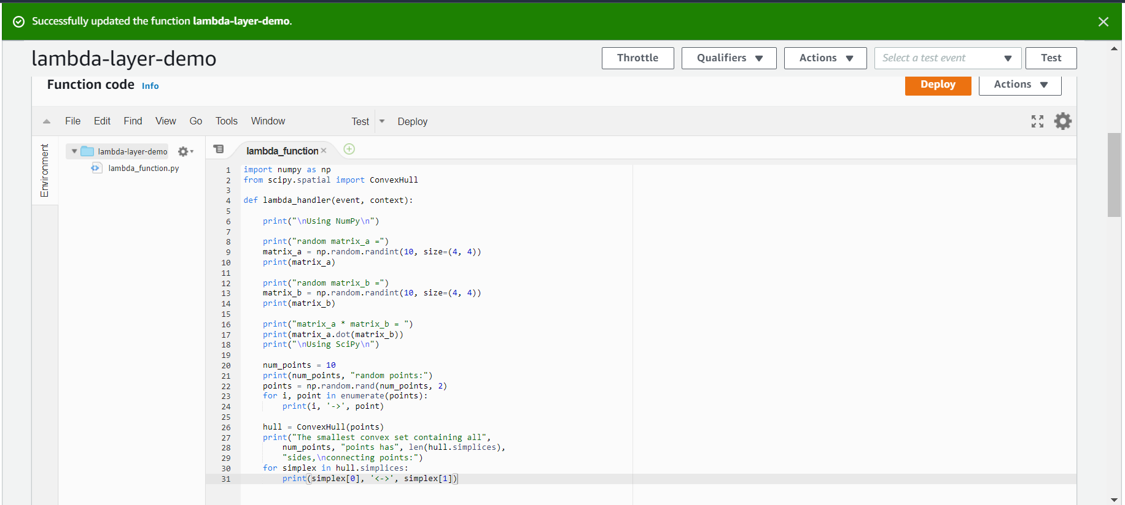

**We havent upload zipfile using layer we upload external dependencies**

**Success**

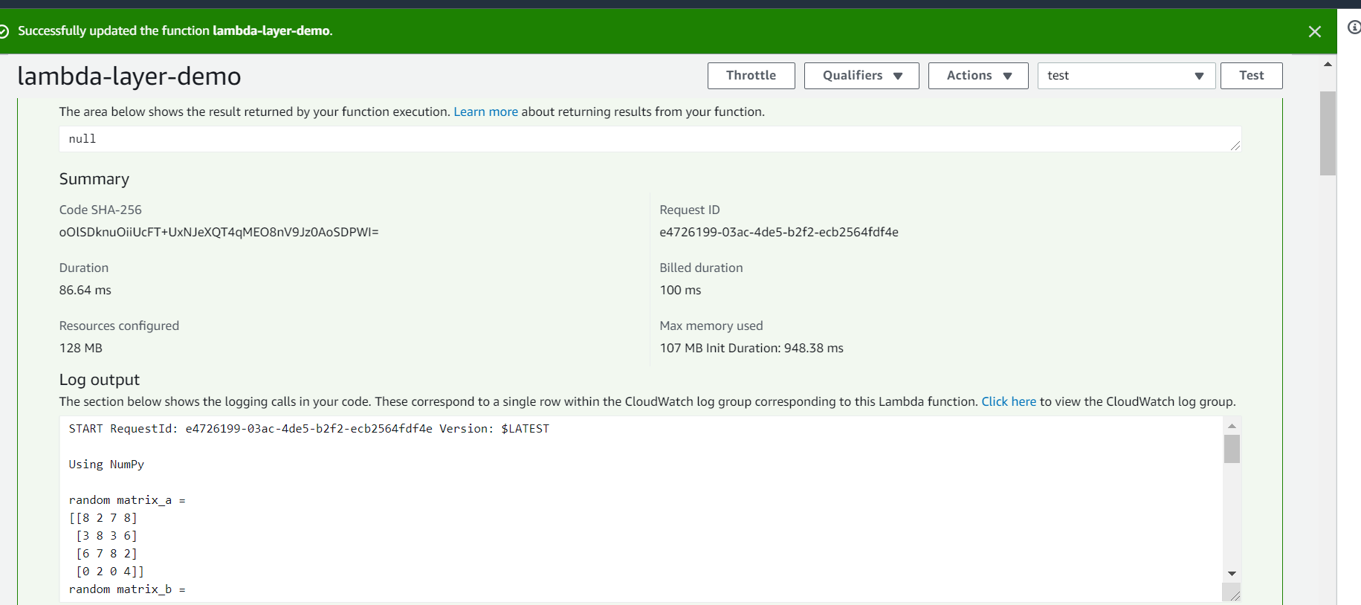

**Lambda version and aliases**

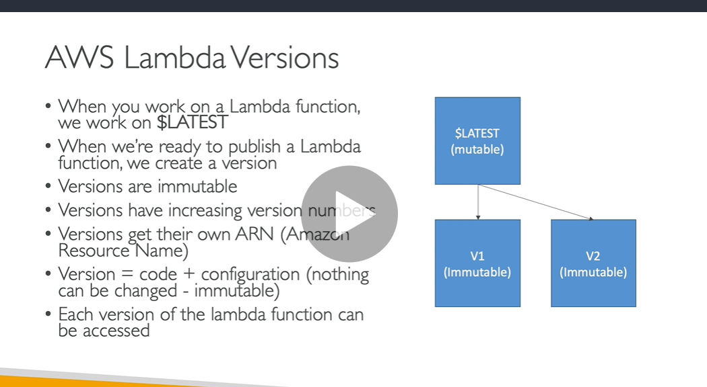

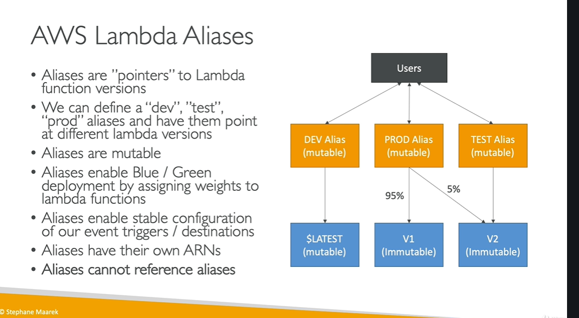

**Hands on**

**Step 1) create function**

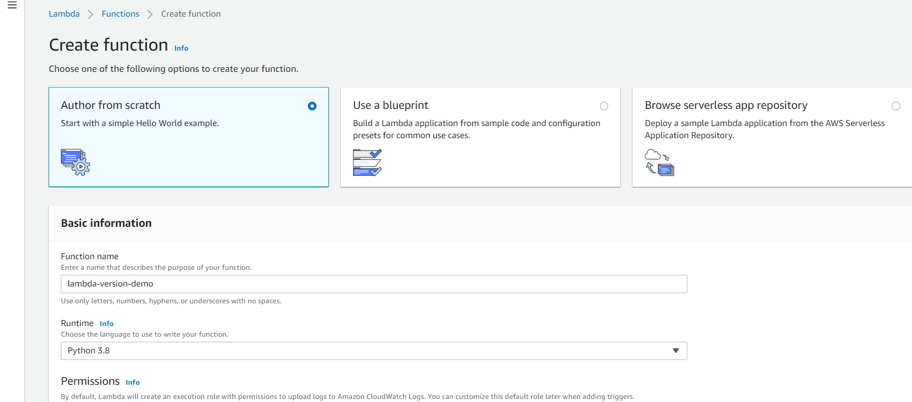

**Idea is that : create multiple version of function or how or how we cannot modify of our function and finally create aliases to point to them**

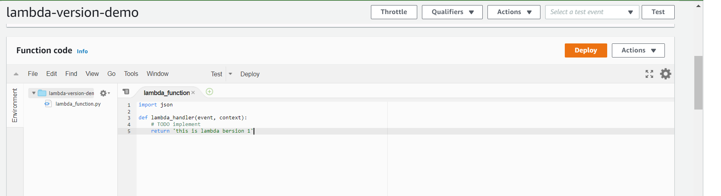

**After testing**

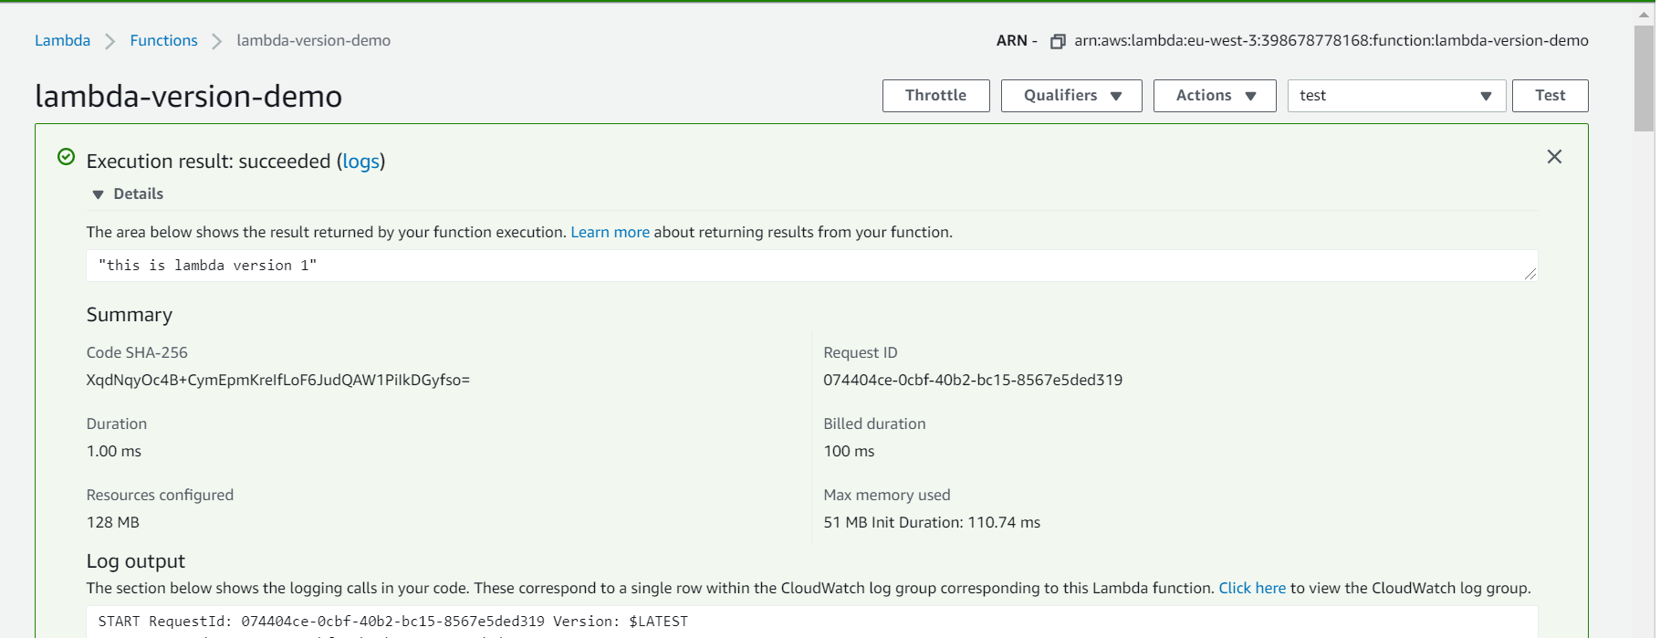

**Currently we have latest no aliases**

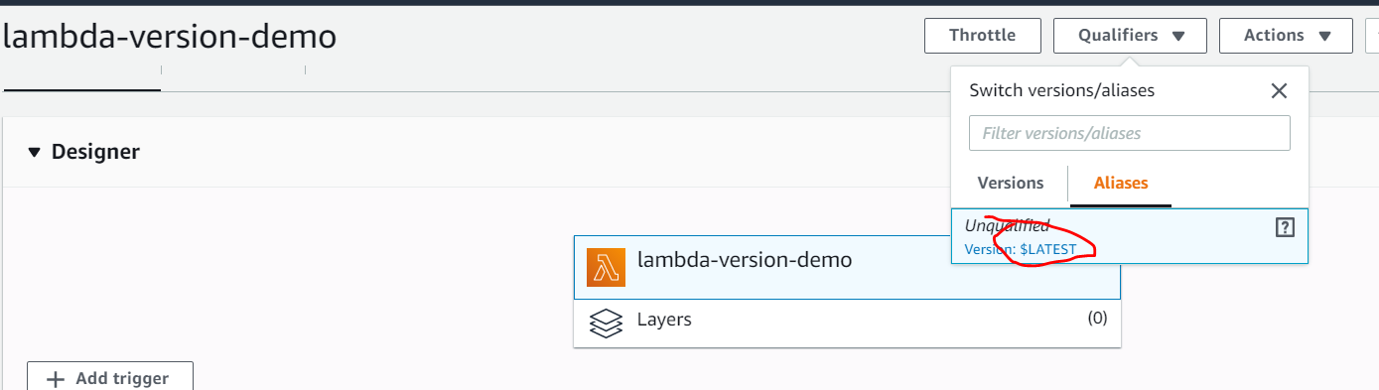

**Click on publish new version**

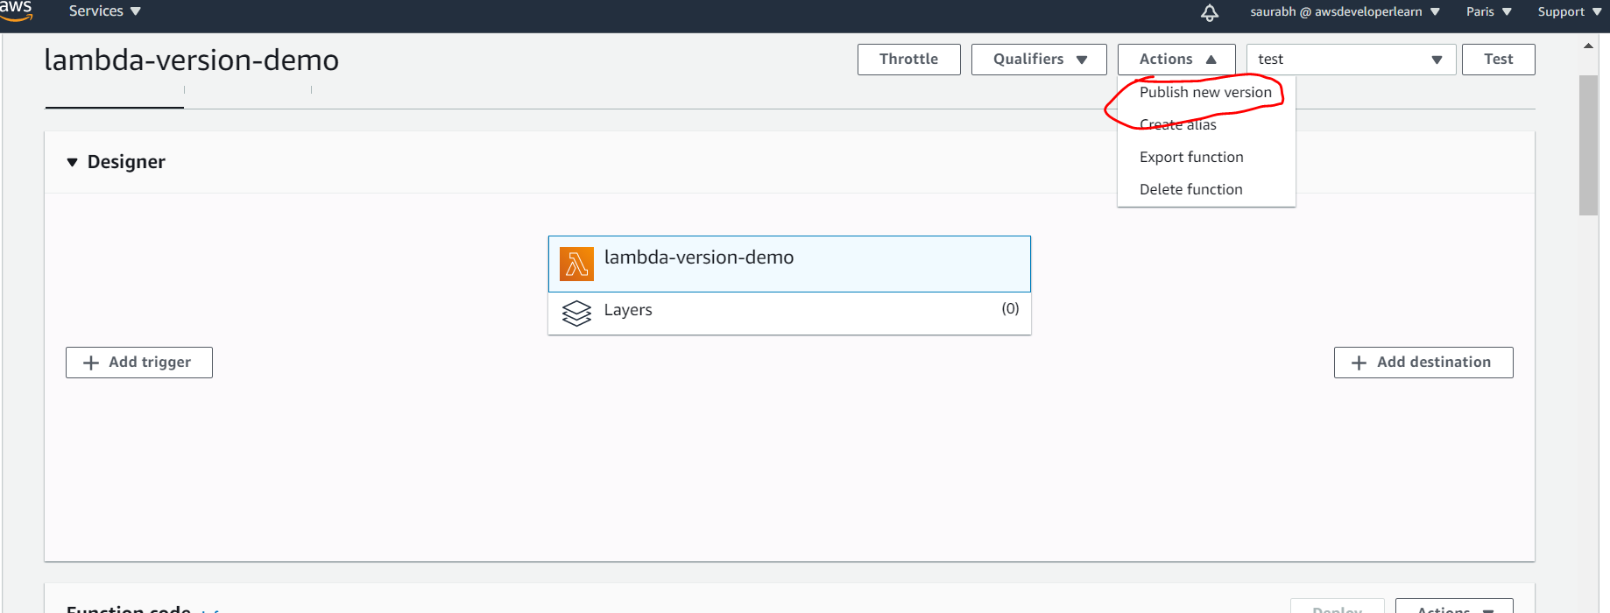

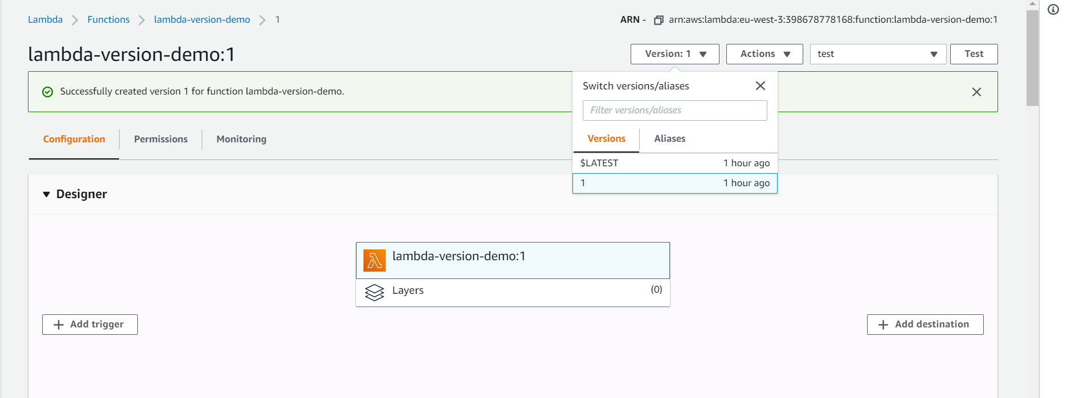

**Note : we cant edit code now**

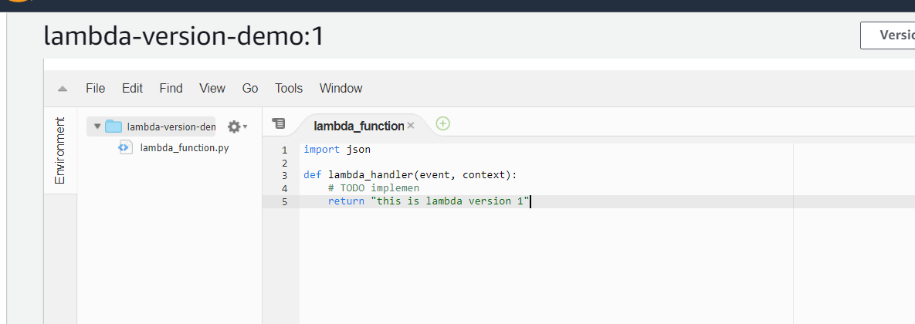

**Note : everything in version is immutable we can change only in latest**

**Play with alias**

**:**

**Note : create alias which will point to version**

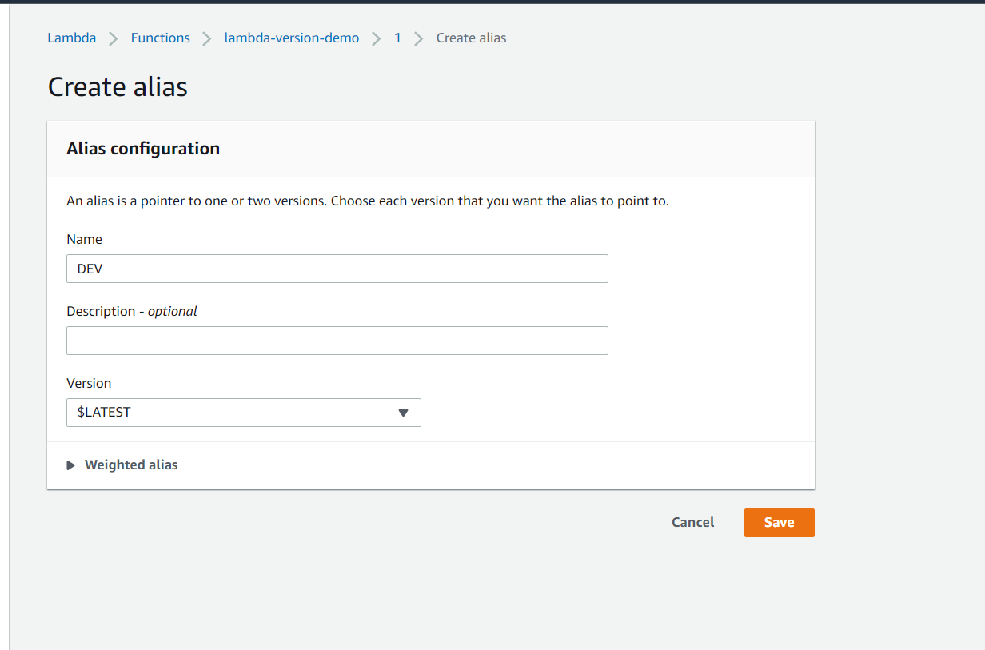

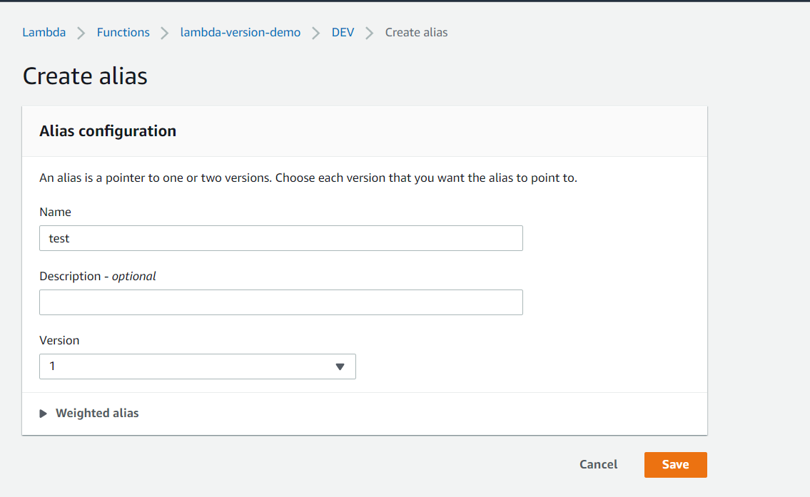

**Note : with one alias we can test two version**

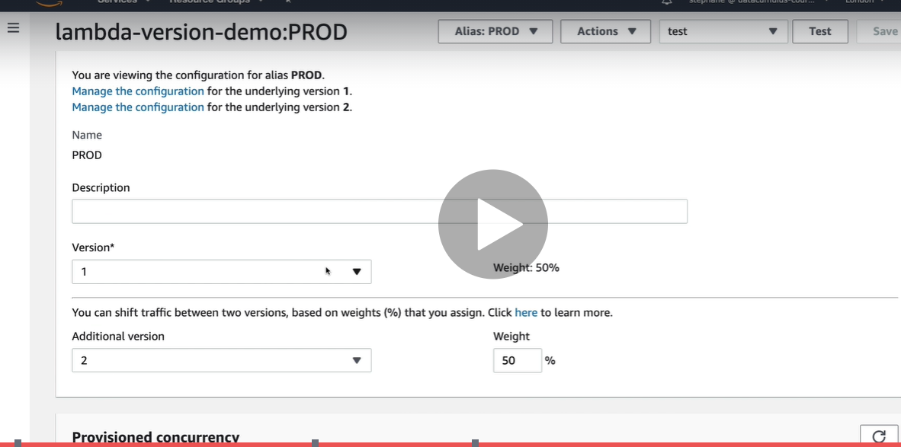

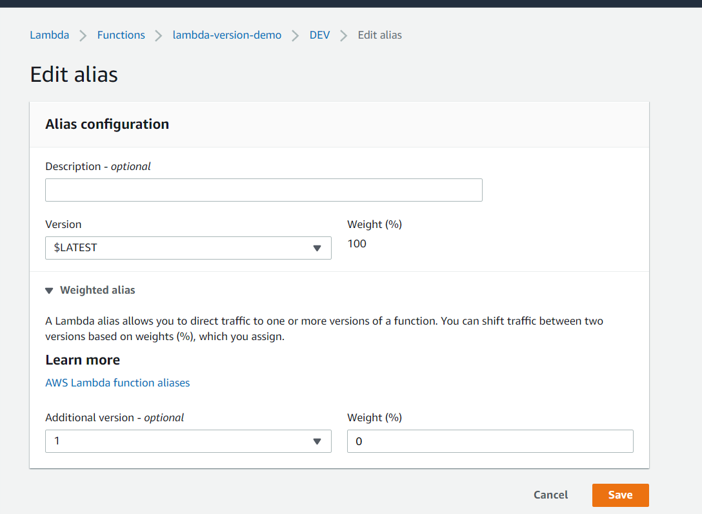

**Lambda and code deploy**

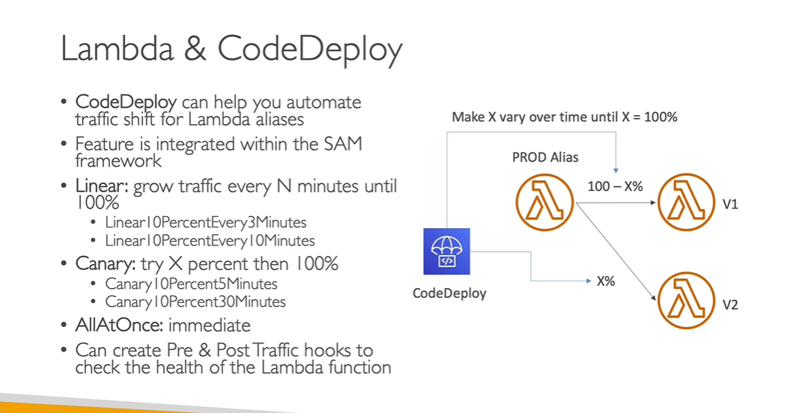

**Note : From alias we are moving traffic from version v1 to v2 using codedeploy**

**Lambda Limit**

